**Funeral and Memorial Service Information  
Rockwood-Stone Pastoral Charge  
The United Church of Canada**



rockwoodstoneuc@gmail.com 519-856-4160 – Church Office

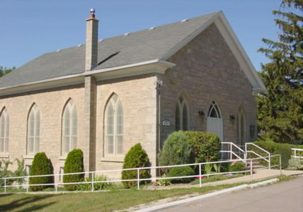

**Rockwood United Church**  
119 Harris St., Rockwood

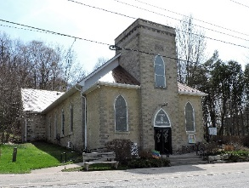

Stone United Church  
5370 Fourth Line, Guelph-Eramosa

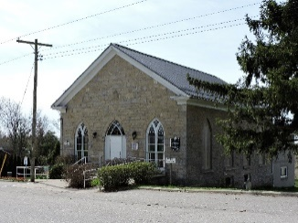

*We place our hope in God.*

*We sing of a life beyond life and a future good beyond imagining:   
a new heaven and a new earth, the end of sorrow, pain, and tears, Christ's return and life with God, the making new of all things.*

*We yearn for the coming of that future, even while participating in eternal life now.*

*From A Song of Faith: A Statement of Faith of The United Church of Canada L'Église Unie du Canada © 2006.*

***Introduction***

Our faith teaches us that God is with us in life, in death and in life beyond death. Funeral and memorial services are a time to recall the miracle of life, to give thanks for the life of the deceased, and to mourn the loss. Our Biblical stories invite us to hear God’s Word of hope, in the midst of our emotions of grief, anger, denial, guilt, lament, resignation, thanksgiving, and trust.

***Our Churches***

Rockwood United Church is located at 119 Harris Street in Rockwood. Founded in 1867, it accommodates 175 people in the pews.

Stone United Church is located at 5370 Fourth Line (just south of Wellington County Road 124). Built in 1862, it accommodates 110 people.

Our Church Family is happy to provide food and host fellowship following the service in celebration of the life of your loved one for funerals held in our churches.

You are always welcome to join us for Sunday worship to hear God’s Word of love and hope and to be supported by our church families in your grief. Sunday services are at 9:45 am at Stone and on Zoom and at 11:15 am at Rockwood. During the summer and on special occasions, information about service times and location is available at [www.rockwoodstoneunitedchurches.com](http://www.rockwoodstoneunitedchurches.com), through the church office and is posted at both churches.

Both churches are wheelchair accessible.

***Our Faith***

There are many ways to remember a loved one. When we choose to have a religious service, we are remembering the love we shared and the hope we have that Jesus Christ once and for all destroyed the power of death. Through word, scripture, prayer, song and silence, we remember that nothing can separate us from the love of God.

***Our Minister***

Our Minister Reverend Heather Leffler can be reached at 519‑265‑7385 or at hleffler@rogers.com. When you have a date for the service, she will meet with your family to plan worship. The service will include prayers, scripture, songs if you choose and a reflection, as well as memories of your loved one.

While we are Christian churches, our minister will help you plan your service to be sensitive to family and friends of other faiths or those who do not have a faith. Readings from other traditions often fit well into the service.

***Who may participate in the service?***

Family and friends are welcome to share in remembrances, sing or play an instrument, share a poem or other reading. Heather will guide you in choosing scriptures and shaping the service.

***What kind of music can we use in the service and who will play it?***

Our organists are available to provide music for you. If you would like them to play, please advise the minister as soon as possible and she will contact them.

You may bring music to play as well. The music you choose should help us remember your loved one and worship God. Read the words of your favourite songs to be sure they share what you intend them to.

***May we bring pictures and symbols?***

You are welcome to bring pictures and other symbols of your loved one’s life to display in the church. You may want to prepare a picture or slide show of memories to project before the service.

***Should we go to the cemetery?***

The committal is an important part of marking the end of life. There is no right or wrong time for it to take place.

A family might choose to have a private committal before the service or on another day.

A committal may take place between the service and the time of fellowship, or you might choose to meet with friends and family and then have the committal.

Your funeral director will know the times the cemetery is open and help you in planning.

***Will the church provide food for the time of fellowship?***

At Rockwood, families may choose from:

Menu: four kinds of sandwiches, pickles, vegetables, fruit, sweets,  
tea, coffee and juice

Menu: cheese, crackers, fruit, tea, coffee and juice

Special dietary requests can be accommodated.

At Stone, the church will provide:

Menu: cheese, crackers, loaves or breads, tea, coffee,   
juice and water

Contact the office for the price per person.

***Are there other costs?***

Please plan for the following costs which can be paid through the funeral home or paid to the individuals as follows:

minister – $300  
organist – $150  
caretaker – $100  
use of church – $250 – paid to church treasurers

***Grief***

*Psalm 34:18 The Lord is close to the broken-hearted and saves those who are crushed in spirit.*

Grief is something everyone experiences at some point in their lives, it's part of our human experience and yet it's a time when many people feel terribly alone as friends and family find it hard to talk or hurry you back to "normal". Don't walk in darkness: our church families and would welcome the opportunity to support you even if you feel lost, angry, numb or confused.

As well as regular services, you are welcome to join our Men's Coffee Connection or Women's Tea and Talk on alternating Thursday's at 10:00 am at Rockwood. For other activities, see our web site at [www.rockwoodstoneunitedchurches.com](http://www.rockwoodstoneunitedchurches.com).

***What if we still have questions?***

Feel free to contact our minister Heather Leffler at 519‑265-7385 [hleffler@rogers.com](mailto:hleffler@rogers.com) or our church secretary at 519‑856-4160 [rockwoodstoneuc@gmail.com](mailto:rockwoodstoneuc@gmail.com), if you have questions.

*RS-Funeral Brochure 2022-11-09*