Contemplation and Conversation: 3rd Sunday of Advent, December 13, 2020

Scripture: John 1:6-8, 19-28 https://www.biblegateway.com/passage/?search=John%201%3A6-8%2CJohn%201%3A19-28&version=NRSV
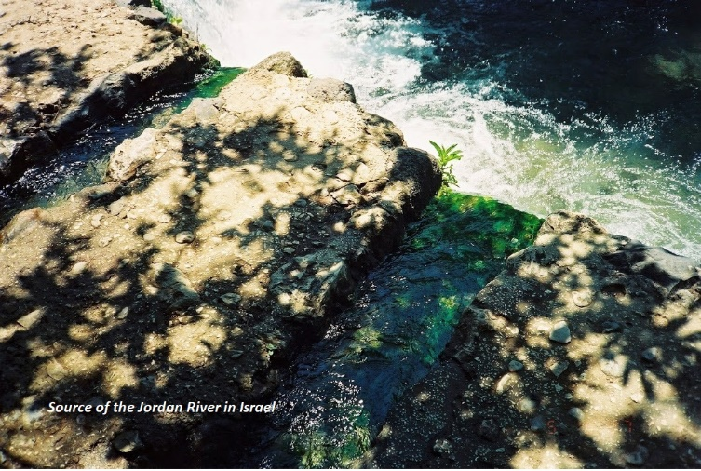
Contemplation and Conversation: How does knowing Jesus help you find joy?
From Rev. Heather Leffler:
John was the son of Zechariah, a priest, and his wife, Elizabeth. Elizabeth had long since given up having a child when she became pregnant. What a joy to have conceived a child! Zechariah was struck dumb and could not speak during her pregnancy. How did they share their joys and fears?
Maybe it was being born of older parents, but John grew up quite eccentric. Dressing in camel hair and eating wild honey and locusts (beans or insects it was a curious diet), John’s life was not easy. He was outspoken and drew the attention of church leaders and government officials. John wasn’t concerned because he was confident in his call. He knew he was the one who was to prepare the way for the Messiah.
Each of us in our own way is called to do the same. As followers of Jesus, we are called to share the good news of Jesus with others. It is easy for me to go to church (even on Zoom), study the Bible, participate in Outreach projects and other activities. What is much harder is to tell people who know nothing about God, Jesus and the Holy Spirit what it means to be a Christian.
I was grateful for the Apostle Paul’s words in 1 Thessalonians 5:16-18 today. “Rejoice always, pray without ceasing, give thanks in all circumstances; for this is the will of God in Christ Jesus for you.” Following Jesus means knowing God is with me. Praying for myself, others and creation and remembering to give thanks throughout my day, reminds God is always with me. When I give thanks, I look for the gift in my life, I find glimpses of joy no matter what is happening. My prayer is that knowing Jesus you too will find joy in knowing Jesus.

Whether you are at home trying to help slow the spread of the virus,
working to help care for those who are impacted most by COVID-19
or working to keep some normalcy in this time,
may you know God’s deep and abiding love in your life.
Know you are a valued part of our Rockwood and Stone United Church families.

Further Conversation … Would you like to talk more about today’s reflection? Email Heather at hleffler@rogers.com. Following worship next Sunday, she will invite others to join you in a Zoom break out room to share in further conversation.

United Church of Canada

Moderator Richard Bott
When Advent was introduced, it, like Lent,
was a penetential season,
a time of fasting and reflection,
on the state of one's life
as a disciple of Jesus, Christ.
But it was known that
people needed a break in their fast,
a little celebration,
a taste of the great feast that was planned.
And so came Gaudete Sunday,
a day of Joy,
just before the solstice
would wrap it's arms around the globe.
-
Fill me with your Gaudete, God!
In these months of living differently,
I need a break -
not from those things that keep
my neighbours and me safe -
but from the weight that has settled
on my shoulders,
in my back,
pulling my heart, heavy.
Sing with me, my God,
"Joyful, Joyful, we adore you," and,
"Joy is in this place," and,
"I've got the joy, joy, joy, joy,
down in my heart (WHERE?!)...";
feel with me, my God,
the amazing life of your creation,
the hope that it inspires,
the love that it invites;
dance with me, my God,
in the midst of this Adventide,
in spite of this Covidtide,
that my heart would be ready
to live love in its fullness...
to prepare myself to celebrate the Christ Child,
born, and coming again.
Oh, let me live Gaudete, my God!

A gift of belonging to a church is that the practice of gathering together for worship … to pray, sing, listen to scripture and share how God touches our lives – helps us grow in deeper relationship to God and each other. With COVID-19 keeping us at home and physically distant from our Stone or Rockwood families, we are missing each other. We are offering this practice of sharing beyond Sunday morning to deepen our connection. Each week you will be offered a picture, a scripture and a question for contemplation, as well as a short reflection for you to contemplate, have conversation with people in your life and/or join an online conversation on our Rockwood Stone Facebook page.

