Contemplation and Conversation: 4th Sunday of Advent, December 20, 2020
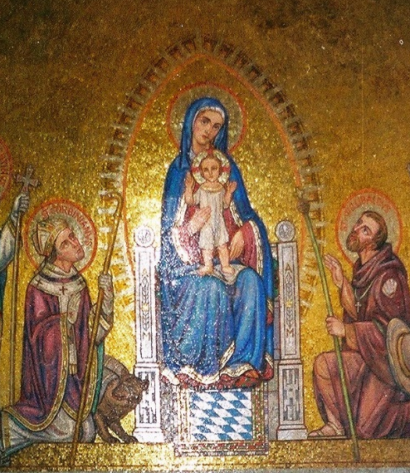
Scripture: Luke 1:26-38 https://www.biblegateway.com/passage/?search=Luke+1%3A26-38&version=NRSV
Contemplation and Conversation: How will you be with those you love at a distance? How will you prepare for the time when you can meet family and friends face to face?
From Rev. Heather Leffler:
In March, we never imagined we would spend the spring in lock down. With the reduction of COVID-19 cases in the summer, we enjoyed gardening, fresh fruit and produce and warm weather. There was more time for activities at home and much appreciated outdoor visits. As the case numbers have increased during the fall many people have been struggling. Now we know our Christmas will be very different with visits by phone or computer or in very small, socially distanced groups outdoors. As we wait for the premier’s announcement that we are returning to the grey lockdown, it would be easy to give in to anxiety and despair.
In Mary’s visit from the angel, I hear a word of hope. Mary’s first response was fear and confusion. She was a virgin and engaged to Joseph who would not look kindly on her pregnancy. She had no idea what it was like to be pregnant. Yet with the angel’s news that her cousin Elizabeth too was pregnant, Mary heard the assurance that God was with her. Whatever she had to face, she would not be alone, and nothing is impossible with God. Mary could focus on preparing for the birth of God’s son.
We may still have in nine months ahead of us before things start to really look like normal, but we have many reasons to be thankful and have hope. With vaccines already being distributed, we trust that an end of the worst of the virus is coming. In the meantime, we have found new ways to connect. As we settle in for a long winter, we can be thankful for the people and pets we live with, warm homes, ready access to food, lots of activities, and the many, creative ways we can connect online. Like Mary in her pregnancy, there will be times of confusion, anxiety, struggle and possibly illness, but we are not alone, and we will be together again. May you fell God with you in this time.

Whether you are at home trying to help slow the spread of the virus,
working to help care for those who are impacted most by COVID-19
or working to keep some normalcy in this time,
may you know God’s deep and abiding love in your life.
Know you are a valued part of our Rockwood and Stone United Church families.

Further Conversation … Would you like to talk more about today’s reflection? Email Heather at hleffler@rogers.com. Following worship next Sunday, she will invite others to join you in a Zoom break out room to share in further conversation.

From our Rockwood Stone Affirming Discernment Circle
Several years ago, I joined a pilgrimage that went from St. Ignatius College, Guelph to The Martyr’s Shrine, Midland. Since a family event prevented me from gathering with pilgrims on the first day, I arrived at Oustic Catholic Church on the second day with my tent, knapsack and a lawn chair at 6 am. The cowbell was calling everyone to get up. My gear was loaded in the truck and I was invited to have breakfast. Every morning after breakfast, there was an open-air mass and communion. I sat in my lawn chair in the back row, not knowing anyone. Pilgrims of the Catholic faith were invited to come forward for communion. Those of non-Catholic faiths were invited to come forward with their arms crossed across their chest. They would receive a blessing, but not communion. I felt very unwanted, unworthy even. Then the guitars started strumming and the singing began as communion proceeded. I could take part in the singing and harmonizing. This is where I was welcome. – Liz Guthrie

United Church of Canada – Moderator Richard Bott posted this on December 15, 2020 on Facebook https://www.facebook.com/ModeratorRichardBott
I wish I could sit down and write a note to everyone - adherent or member, lay or ordered, of whatever age and stage and place in their life - who is a part of The United Church of Canada.
I think I'd start off each note with the words, "Thank you."
Thank you for being a part of this part of God's love, alive in the world.
Thank you for all of the ways that you are part of your community of faith. Thank you for the ways you've shared of yourself - not just what you have, but who you are - as part of that group of Jesus' people. Thank you for the things that have been out front, and for the things behind the scenes, AND for the things that no one knows you've offered (well, except you and God.)
Thank you for sharing your time, and your abilities, and your resources; your thoughts and your feelings; your smiles, your tears, your frustrations, your joys; your quiet and calm, and your loud and moving.
Thank you for the ways you have lived your life as a justice-maker, a peace-bringer, an evil-resister, a creation-respecter, a world-mender, a lover, a servant, a beloved child of God, a disciple of Jesus Christ.
Thank you for loving God with all that you are.
Thank you for loving your neighbour
(and for being willing to accept their love.)
Thank you for all that you do,
but, even more than that,
thank you for being who you are.
Yes. Even the times when things get sticky, and frustrations surface, and relationships are fractured, and we have to work again to mend the community and the world - thank you for trying to be the best that God's love calls out of you.
Especially in this time of pandemic, in this world where the problems of our very human systems and institutions (the church included) are even more evident, and the challenge to be counter-cultural with even more radical hope, and radical grace, and radical hospitality, and overwhelmingly radical love can be daunting...
thank you.
Yes. If you are reading this... thank *you*.

From Zoom: If you signed up for your free Zoom Account, Zoom has made it easier to connect with family over the holidays. - Heather

COMPANY NEWS

#ZoomTogether: Celebrate the Holidays with Unlimited Meetings from Zoom
December 16, 20202 min read
COVID-19 has changed how we live, work, and celebrate in 2020, and like everything else this year, the holiday season doesn’t look the same. As a token of appreciation to our users during an extraordinary time, we’re removing the 40-minute limit on free Zoom accounts for all meetings globally for several upcoming special occasions.
Whether coming together on the final day of Hanukkah, celebrating Christmas, ringing in the New Year, or marking the last days of Kwanzaa, those connecting with friends and family won’t get cut short.
Here are the dates and times for unlimited meetings:
10 a.m. ET Thursday, Dec. 17, to 6 a.m. ET Saturday, Dec. 19
10 a.m. ET Wednesday, Dec. 23, to 6 a.m. ET Saturday, Dec. 26
10 a.m. ET on Wednesday, Dec. 30, to 6 a.m. ET on Saturday, Jan. 2
What do I need to do?
You don’t need to do anything to remove the limit — it will be automatically lifted during these designated times.
Go to https://blog.zoom.us/zoom-together/ for tips about using Zoom.

A gift of belonging to a church is that the practice of gathering together for worship … to pray, sing, listen to scripture and share how God touches our lives – helps us grow in deeper relationship to God and each other. With COVID-19 keeping us at home and physically distant from our Stone or Rockwood families, we are missing each other. We are offering this practice of sharing beyond Sunday morning to deepen our connection. Each week you will be offered a picture, a scripture and a question for contemplation, as well as a short reflection for you to contemplate, have conversation with people in your life and/or join an online conversation on our Rockwood Stone Facebook page.

