Contemplation and Conversation: 7th Sunday of Easter, May 24, 2020
Scripture: 1 Peter 4:12-14, 5:6-11 NRSV https://www.biblegateway.com/passage/?search=John+9%3A1-5&version=NRSV
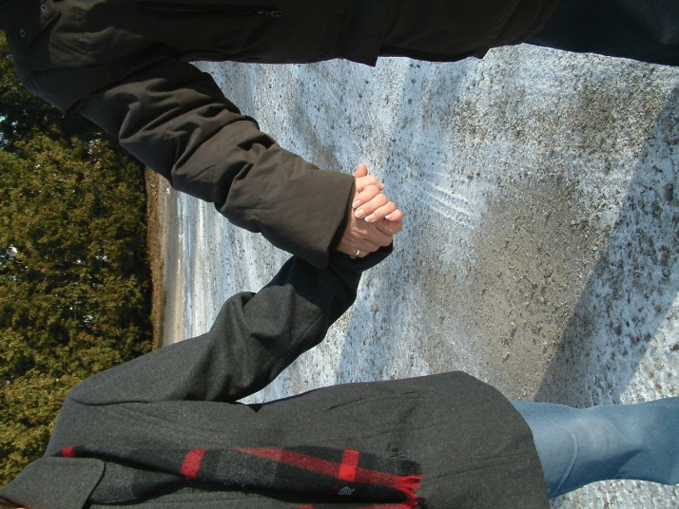
¹²Beloved, do not be surprised at the fiery ordeal that is taking place among you to test you, as though something strange were happening to you. ¹³But rejoice insofar as you are sharing Christ’s sufferings, so that you may also be glad and shout for joy when his glory is revealed. ¹⁴If you are reviled for the name of Christ, you are blessed, because the spirit of glory, which is the Spirit of God, is resting on you.
⁶Humble yourselves therefore under the mighty hand of God, so that he may exalt you in due time. ⁷Cast all your anxiety on him, because he cares for you. ⁸Discipline yourselves, keep alert. Like a roaring lion your adversary the devil prowls around, looking for someone to devour. ⁹Resist him, steadfast in your faith, for you know that your brothers and sisters in all the world are undergoing the same kinds of suffering. ¹⁰And after you have suffered for a little while, the God of all grace, who has called you to his eternal glory in Christ, will himself restore, support, strengthen, and establish you. ¹¹To him be the power forever and ever. Amen.
Contemplation and Conversation: In today’s world, what are we suffering? What are we learning?
From Brian Mack:
At the start of Bible study on Monday night, I was frustrated. My newly found infatuation with having internet at the farm was being seriously tested. Using Zoom, I kept getting the message, “Your internet connection is unstable.” After about ten frustrating minutes of attempting to re-connect, I gave up. Well…sort of. I had been looking forward to our discussion all day. I wanted to make some sense of these words of scripture and had been counting on the group to help me. So…I did the next best thing. I read the passage over many times, prayed about the author’s intent, and jotted down some key words or phrases that stood out for me. Over the course of the next few days, these words kept coming back to me. They all seemed to center around the idea that as a Christian I should expect to suffer for my faith, that I should expect to be tested by the devil, and that in the end I will be rewarded with eternal glory. Sounds great…there have been lots of sermons preached using this plot line. The problem for me is that living in 2020 Canada, I don’t feel that I have suffered for my faith. I don’t even think I have really suffered because of the Covid-19 crisis. What I do know is that I am a beloved child of God and this passage from 1st Peter offers that reassurance to me. God cares for me today. This care is shown through people who phone to just say “Hello”. This care is shown by a neighbor who had some spare cedar seedlings and wanted to share them. This care is shown when cookies are dropped off in my mailbox. This care is shown in the form of an e-mail from a colleague that I went to teacher’s college with. She and her husband have decided to connect more than just once a year via the Christmas epistle. This care is shown when through technology I can see the smiling faces of the people of Rockwood-Stone or our wider community. This care is LOVE. Thanks be to God.

Whether you are at home trying to help slow the spread of the virus,
working to help care for those who are impacted most by COVID-19
or working to keep some normalcy in this time,
may you know God’s deep and abiding love in your life.
Know you are a valued part of our Rockwood and Stone United Church families.

From Worship - We often think of things that slow us down or cause us to rely on the help of others as a problem that we want to be free of but living with a disability impacts how a person sees world and the disability is a part of their being. That raises the interesting question of “will there by disabilities in heaven?” which is explored in the video at https://disabilityandfaith.org/will-there-be-disabilities-in-heaven. – Lisa Leffler
A gift of belonging to a church is that the practice of gathering together for worship … to pray, sing, listen to scripture and share how God touches our lives – helps us grow in deeper relationship to God and each other. With COVID-19 keeping us at home and physically distant from our Stone or Rockwood families, we are missing each other. We are offering this practice of sharing beyond Sunday morning to deepen our connection. Each week you will be offered a picture, a scripture and a question for contemplation, as well as a short reflection for you to contemplate, have conversation with people in your life and/or join an online conversation on our Rockwood Stone Facebook page.

