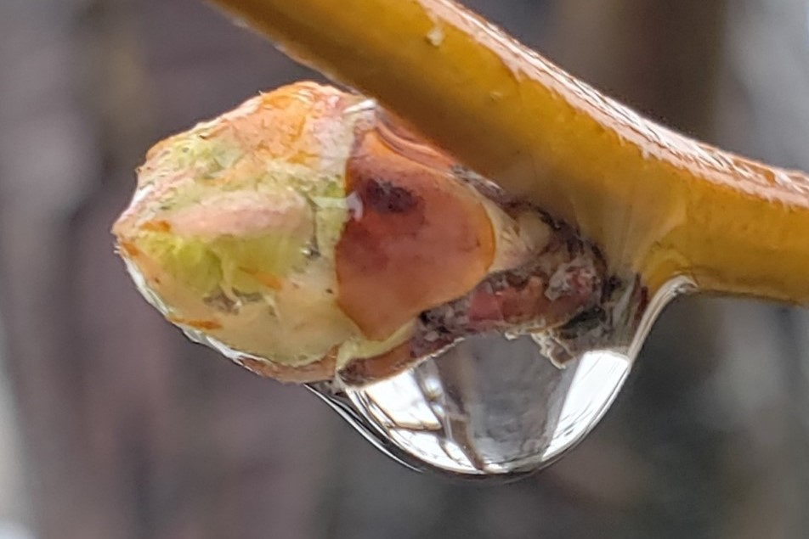
Contemplation and Conversation: Trinity Sunday, June 7, 2020
Scripture: 2 Corinthians 13:11-13 NRSV
https://www.biblegateway.com/passage/?search=2+Corinthians+13%3A11-13&version=NRSV
¹¹Finally, brothers and sisters, farewell. Put things in order, listen to my appeal, agree with one another, live in peace; and the God of love and peace will be with you. ¹²Greet one another with a holy kiss. All the saints greet you.
¹³The grace of the Lord Jesus Christ, the love of God, and the communion of the Holy Spirit be with all of you.
Contemplation and Conversation: Where are you being called to work towards positive change? What resources have helped you to broaden your perspective (please share them in the comments)?
From Lisa Leffler:
“Put things in order” seems like an important call to action at this time. It may seem like the world has been descending into chaos over the past couple weeks and needs a little re-ordering, but the reality is we have been living in disorder for generations. We have been living in a system that allows a few people to benefit from the suffering of many and tries to distract us from injustice by creating divides based on race, gender, income, etc.
Over the past couple of weeks people have been standing up in the streets through Black Lives Matter Marches calling for the government to put things in order. I was unable to join the march in Guelph on Saturday in person due to COVID restrictions which drew attention to some of the privilege I experience as white person living in Canada. Racism is not something I have to think about in my daily life, but it is something that I should be thinking about because it effects my friends, neighbours and people all around the world. Thankfully, the event held in Guelph was shared on Facebook live so I was able to attend virtually hear stories outside of my lived experience.
As the Black Lives Matter movement moves forward (hopefully – I pray our leaders hear the voices in the streets and create positive change) and we celebrate Pride Month and National Indigenous Awareness Month this month I need to continue listening to people’s stories so I can hear where God is calling me to help facilitate positive change in the world.

Whether you are at home trying to help slow the spread of the virus,
working to help care for those who are impacted most by COVID-19
or working to keep some normalcy in this time,
may you know God’s deep and abiding love in your life.
Know you are a valued part of our Rockwood and Stone United Church families.

Church Leaders Acknowledge the Racism in Their Midst
In response to the demonstrations across the United States and Canada in the wake of the May 25 death of George Floyd in Minneapolis, the leaders of the Evangelical Lutheran Church in Canada, the Anglican Church of Canada, and The United Church of Canada have issued a joint letter.
They write, “It is important for church members in our largely white churches to look at how we continue to perpetuate anti-Black racism, either inadvertently or intentionally. George Floyd’s words, ‘I can’t breathe,’ continue to ring in our ears; they act as a prophetic voice of the pain and re-traumatisation that is coming from peoples of African descent again and again.”
In March, these same church leaders sent a letter asking churches to engage with the International Decade for People of African Descent. This new letter offers tangible ways for individuals and congregations to begin conversations and really listen to the stories that emerge.
Moderator Richard Bott adds: “I am asking people in the United Church to delve into this topic individually and at church boards. If we don’t look at this issue and realize we are part of the problem, we can’t be part of the solution. This is the work of White members of the church, and the time has come to commit ourselves to this work, for everyone’s sake.”https://www.united-church.ca/news/church-leaders-acknowledge-racism-their-midst?mc_cid=006474a2c5&mc_eid=3913501fc3#downloads

A gift of belonging to a church is that the practice of gathering together for worship … to pray, sing, listen to scripture and share how God touches our lives – helps us grow in deeper relationship to God and each other. With COVID-19 keeping us at home and physically distant from our Stone or Rockwood families, we are missing each other. We are offering this practice of sharing beyond Sunday morning to deepen our connection. Each week you will be offered a picture, a scripture and a question for contemplation, as well as a short reflection for you to contemplate, have conversation with people in your life and/or join an online conversation on our Rockwood Stone Facebook page.

