Contemplation and Conversation: 3rd Sunday after Pentecost, June 21, 2020
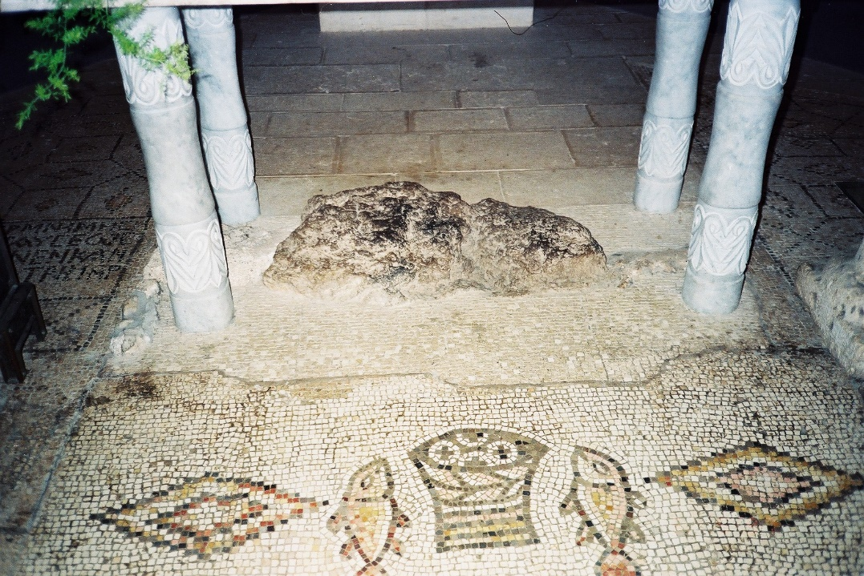
Scripture: Psalm 86:1-7 NRSV https://www.biblegateway.com/passage/?search=Psalm+86&version=NRSV
Contemplation and Conversation: What do you need from God today?
From Rev. Heather Leffler:
What a gift to know the One who is Holy Mystery and Wholly Love through Jesus. When crowds were hungry after listening to him teach all day, Jesus fed them with five loaves and two fishes, and everyone had enough. When the woman who bled for twelve years reached out in faith and touched the hem of his robe, she was healed. When another woman was about to be stoned for adultery, Jesus asked that the man who had not sinned throw the first stone and she was saved. Whatever we need the Psalmist’s words encourages us to take our petitions to God. Overworked or too much time on our hands, cry out to the Lord. Lonely or longing for some space to ourselves, call on God. Anxiously awaiting a time when we can gather together or afraid that the virus hasn’t spent itself and it’s not safe, cry in supplication to the One who offers us healing and hope. Whatever is on your heart, God is good and forgiving. May you know the steadfast love of the Lord today and always. May it be so.
Whether you are at home trying to help slow the spread of the virus,
working to help care for those who are impacted most by COVID-19
or working to keep some normalcy in this time,
may you know God’s deep and abiding love in your life.
Know you are a valued part of our Rockwood and Stone United Church families.

30th Anniversary of the United Church Apology to First Nations Peoples that was shared in Worship today - https://www.youtube.com/watch?v=t5ewlqtTVXo&t=20s
On this Indigenous Day of Prayer, please pray for our First Nations siblings.
A gift of belonging to a church is that the practice of gathering together for worship … to pray, sing, listen to scripture and share how God touches our lives – helps us grow in deeper relationship to God and each other. With COVID-19 keeping us at home and physically distant from our Stone or Rockwood families, we are missing each other. We are offering this practice of sharing beyond Sunday morning to deepen our connection. Each week you will be offered a picture, a scripture and a question for contemplation, as well as a short reflection for you to contemplate, have conversation with people in your life and/or join an online conversation on our Rockwood Stone Facebook page.

