Contemplation and Conversation
Creation Time 2 Sunday, September 20, 2020
Scripture: Matthew 20:1-16 NRSV https://www.biblegateway.com/passage/?search=Matthew%2020:1-16&version=NRSV
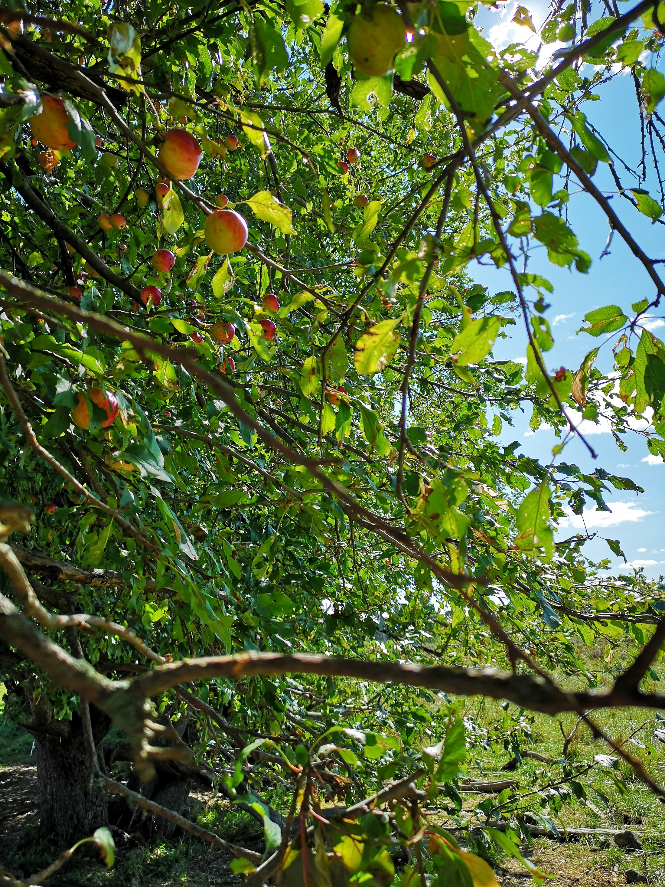
Contemplation and Conversation: What time would you have been hired for work?
From Rev. Heather Leffler:
I always saw myself as the person who was ready to work early in the morning. If I ever thought about why other people came late, I assumed they slept in. I remember thinking it really wasn’t fair that people who had worked hard all day would be paid the same as those who only worked for an hour. It was great that people at the end of the day received a day’s wages but the people who started earlier should have been given more. How could this be right?
Then one day I put myself in the shoes of the person who was up early preparing a meagre meal before sending children off to school with no lunch. Then staying home to care for an aging parent, fretting about where money would come from to buy dinner. Finally when a child came home to be with the parent, I could go to the town square praying there was still work at 5 pm. So grateful to have any work even if only an hour I would be filled with joy to be given a whole day’s pay.
Isn’t that God’s dream that each of us would have enough.
Now when I read this parable, I don’t worry about what is right. Rather I am filled with gratitude that we worship a God who isn’t worried about being fair or equal but instead longs for us to look at others with compassion and love and be grateful when everyone has what they need. May it be so.
Whether you are at home trying to help slow the spread of the virus,
working to help care for those who are impacted most by COVID-19
or working to keep some normalcy in this time,
may you know God’s deep and abiding love in your life.
Know you are a valued part of our Rockwood and Stone United Church families.


United Church of Canada
Posted on Facebook by Moderator Richard Bott

A gift of belonging to a church is that the practice of gathering together for worship … to pray, sing, listen to scripture and share how God touches our lives – helps us grow in deeper relationship to God and each other. With COVID-19 keeping us at home and physically distant from our Stone or Rockwood families, we are missing each other. We are offering this practice of sharing beyond Sunday morning to deepen our connection. Each week you will be offered a picture, a scripture and a question for contemplation, as well as a short reflection for you to contemplate, have conversation with people in your life and/or join an online conversation on our Rockwood Stone Facebook page.

