Contemplation and Conversation: 6th Sunday of Easter, May 17, 2020
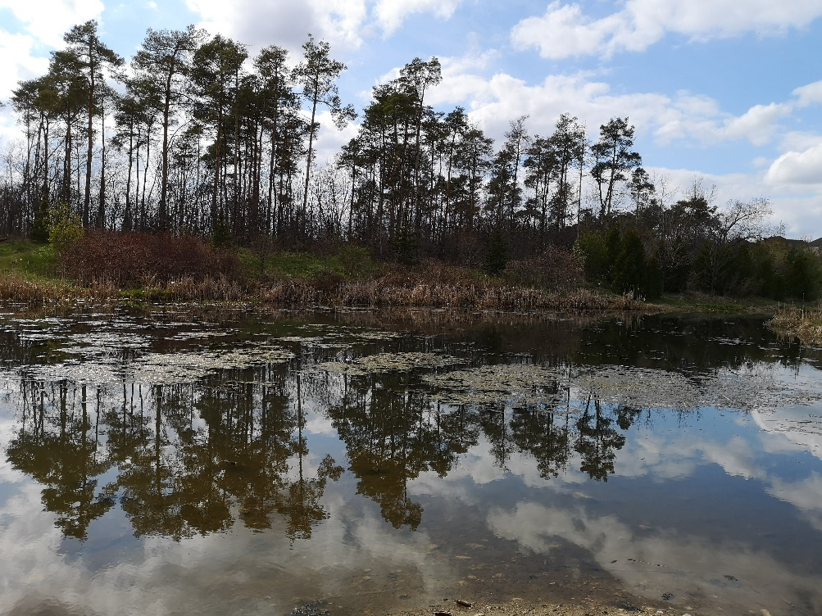
Scripture: John 14:15-21 NRSV https://www.biblegateway.com/passage/?search=John+14%3A15-21&version=NRSV
Contemplation and Conversation: Where have you experienced the Spirit in your life?
From Rev. Heather Leffler:
“And I will ask the Father, and he will give you another Advocate, to be with you forever.” Jesus’ promise to his disciples is his promise to us. Wherever we find ourselves, God is with us. The Spirit of God is in us and around us. The Greek word Paraclete that is translated Advocate is so much more. Jesus sent the Spirit to advocate, counsel, comfort, help, mediate and even broker for us. Again, and again I find myself in awe of the ways the Spirit works in my life. Our relationship with Anishnabeg Outreach (AO) is one of those places where I experienced the Spirit at work in the world. After searching with a First Nation’s Community to partner with for more than a year, I took part in a farm blessing. Approaching the First Nation’s elder who also shared in the event, I asked who we might connect with. He sent me to speak with Stephen Jackson. Soon after we entered into a partnership. Most recently with the help of the Rockwood Community, our churches of Rockwood and Stone have collected over 123 bikes, trikes and other ride on toys, as well as helmets and over 250 masks for AO. We continue to gather Canadian Tire Money to help them buy more helmets. Through AO we are able to offer support and grow in our understanding of the challenges our First Nations brothers and sisters’ experience. I have included Stephen’s newsletter if you would like to know more about their work. May we continue to be guided by the Spirit to love others as Jesus loves us.

Whether you are at home trying to help slow the spread of the virus,
working to help care for those who are impacted most by COVID-19
or working to keep some normalcy in this time,
may you know God’s deep and abiding love in your life.
Know you are a valued part of our Rockwood and Stone United Church families.

Sympathy – Please keep John Kearns and Bev Johnston in your thoughts and prayers as they mourn the death of John’s brother Jim. https://lfpress.remembering.ca/obituary/jim-kearns-1079187484

Zoom Worship – Thanks to everyone who persevered and was able to join worship and all those who tried to join us. Zoom is changing to be more secure so you will need to update before May 31. Zoom will guide you. There will be a new link in the bulletin for next Sunday.
A gift of belonging to a church is that the practice of gathering together for worship … to pray, sing, listen to scripture and share how God touches our lives – helps us grow in deeper relationship to God and each other. With COVID-19 keeping us at home and physically distant from our Stone or Rockwood families, we are missing each other. We are offering this practice of sharing beyond Sunday morning to deepen our connection. Each week you will be offered a picture, a scripture and a question for contemplation, as well as a short reflection for you to contemplate, have conversation with people in your life and/or join an online conversation on our Rockwood Stone Facebook page.

