Contemplation and Conversation: 2nd Sunday after Pentecost, June 14, 2020
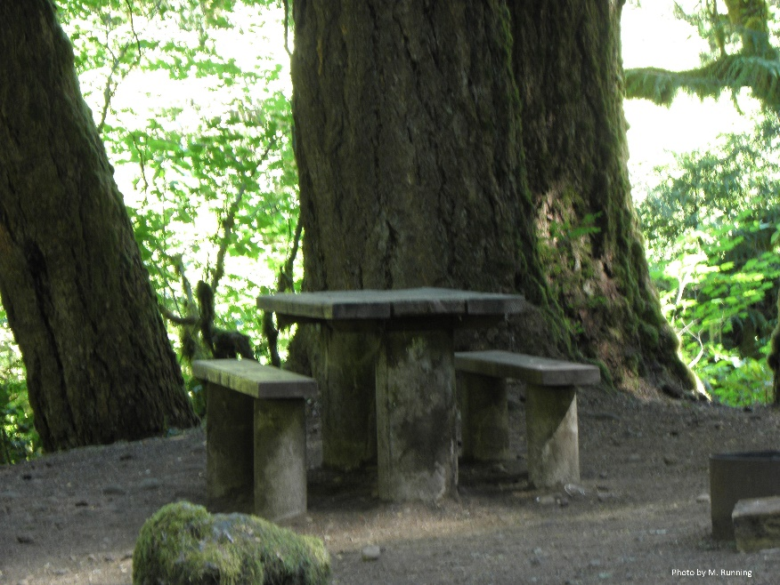
Scripture: Romans 5:1-5 NRSV https://www.biblegateway.com/passage/?search=Romans+5%3A1-5&version=NRSV
Contemplation and Conversation:
Where are you finding the hope that is ours through Jesus, even in the midst of suffering?
From Rev. Heather Leffler:
Even in the midst of this COVID-19 most of us are not suffering physically. We have homes, food, medical care, family and friends a phone call or video chat away. There is much to be thankful for. There is also suffering … anxiety about not working or too much work … concern about depleting savings … loneliness and longing for physical touch … fear and concern for loved ones who are front line health care providers, first responders and essential workers … fear and anxiety about protests and riots around the world … concern for our Black, Indigenous, Métis and South Asian neighbours who are suffering more because of systemic racism that is so much a part of us that we struggle to see it … There is suffering in our lives and so much suffering in our world. The Apostle Paul would understand our suffering. He wrote these words on a missionary trip to Corinth, longing to visit the Church in Rome. When he did finally visit Rome, it would be as a prisoner awaiting his death. Despite persecutions and the threat of death, Paul could find hope in suffering because of his deep and abiding trust that God’s love has been poured into our hearts through the Holy Spirit. Paul saw that as we endure suffering, we find strength and hope. May you know the presence of God’s comforting Spirit in the midst of your struggles and suffering and may you find hope.
Whether you are at home trying to help slow the spread of the virus,
working to help care for those who are impacted most by COVID-19
or working to keep some normalcy in this time,
may you know God’s deep and abiding love in your life.
Know you are a valued part of our Rockwood and Stone United Church families.

June 14, 2020 - 7:00 pm ET to 8:00 pm ET
This event is Online. Join Us on YouTube. https://www.youtube.com/user/unitedchurchofcanada
Black Lives Matter to The United Church of Canada.
We have participated in demonstrations. Letters have been written and statements have been made. Now it is time to worship together as people of faith.
The Black Clergy Network of The United Church of Canada invites the whole church to join virtually for a time of worship, prayer, and reflection to face the issues of anti-Black racism across our country and in our church. In worship we will lament, we will hope, and we will be reminded of the need to act against racism.
Please plan to join live and let others know you’ll be joining by sharing this event on social media. Use the hashtag #UCCan and tag the United Church on Facebook and Twitter.
This service of prayer and reflection will be led by members of the Black Clergy Network and will be livestreamed on The United Church of Canada's YouTube Channel. You will be able to observe the service as well as chat and comment through YouTube.
Plan to worship together live on June 14. Note that the 7 pm start time is for Eastern Time; please adjust for your local contexts.
Find Out More
Dear White People—in this blog post, Rev. Dr. Paul Douglas Walfall calls on White people in the church to put their love into action to counteract racism.
Church Leaders Acknowledge the Racism in Their Midst—the Moderator writes that the struggle against anti-Black racism is the work of White members of the church, and the time has come to commit themselves to this work.
Call for Churches to Do More to Address Anti-Black Racism—leaders of the Evangelical Lutheran Church in Canada, the Anglican Church of Canada, and The United Church of Canada have issued a joint letter calling on churches to do more to address anti-Black racism.
Learn more about the United Church's commitment to racial justice.

A gift of belonging to a church is that the practice of gathering together for worship … to pray, sing, listen to scripture and share how God touches our lives – helps us grow in deeper relationship to God and each other. With COVID-19 keeping us at home and physically distant from our Stone or Rockwood families, we are missing each other. We are offering this practice of sharing beyond Sunday morning to deepen our connection. Each week you will be offered a picture, a scripture and a question for contemplation, as well as a short reflection for you to contemplate, have conversation with people in your life and/or join an online conversation on our Rockwood Stone Facebook page.

