Contemplation and Conversation: 8th Sunday after Pentecost, July 26, 2020
Scripture:
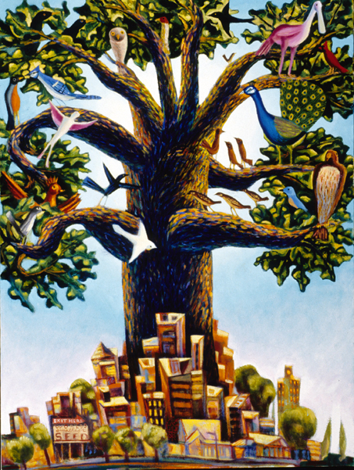
Matthew 13:31-33, 44-52 NRSV https://www.biblegateway.com/passage/?search=Matthew+13%3A31-33%2CMatthew+13%3A44-52&version=NRSV

Contemplation and Conversation:
The COVID response and our enforced curtailment of many activities give us time to think what is of value to us? What does our “heaven” look like? Would you be willing to sell all, trade all, for that heaven that nurtures others? Where are we without all our busyness? Where does our peace come from? How can we cultivate peace in our hearts so that comfort and joy sustain us and our communities?

From Rosslyn Bentley:
In this time of COVID reframing let us pray that the promise of heaven is the opportunity to reflect on what is important to us and our world. We have learned lessons about our own priorities and can perhaps consider what it is we can build on to make a precious world. Focus on family, our church family, good food, sleep, exercise, taking care of the earth and paying attention. Being mindful and nurturing our roots, the beauty of the earth – these are hard things to accomplish in our busy world but finding what nurtures you is precious indeed. I love working in my garden, the therapy of grubbing weeds, pruning, planting, nurturing new ideas and tending colour and insects to populate that heaven on earth is a true pleasure and sobering education – anyone else keeping slugs, earwigs and gypsy moths at bay? Participating in the garden tour was a chance to share my small kingdom of heaven with my church family and friends. I hope it felt a comfortable nurturing place for everyone.

Whether you are at home trying to help slow the spread of the virus,
working to help care for those who are impacted most by COVID-19
or working to keep some normalcy in this time,
may you know God’s deep and abiding love in your life.
Know you are a valued part of our Rockwood and Stone United Church families.

A gift of belonging to a church is that the practice of gathering together for worship … to pray, sing, listen to scripture and share how God touches our lives – helps us grow in deeper relationship to God and each other. With COVID-19 keeping us at home and physically distant from our Stone or Rockwood families, we are missing each other. We are offering this practice of sharing beyond Sunday morning to deepen our connection. Each week you will be offered a picture, a scripture and a question for contemplation, as well as a short reflection for you to contemplate, have conversation with people in your life and/or join an online conversation on our Rockwood Stone Facebook page.

