Contemplation and Conversation: 12th Sunday after Pentecost, August 23, 2020

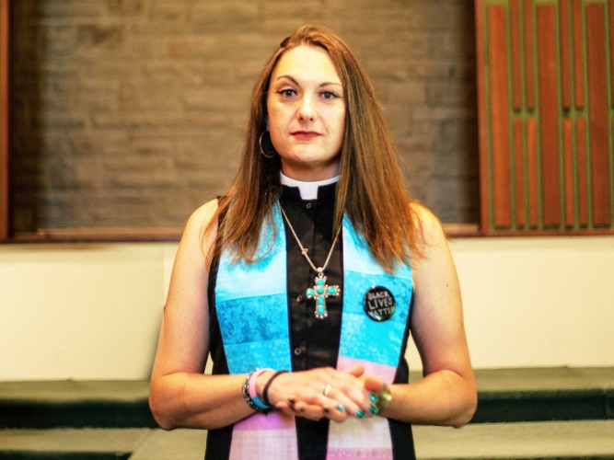

Scripture: Matthew 16:13-20 GNT https://www.biblegateway.com/passage/?search=Matthew+16%3A13-20&version=GNT
Contemplation and Conversation: How have you spoken your truth or God’s Truth in your life?
From Brent Stiles:
In this passage, Jesus put his disciples to the test by asking them a very important question. “Who do you say I am?” Jesus asks them. Simon Peter answers, “You are the Messiah, the Son of God.” Jesus goes on to say that this truth was given directly by God. Jesus was able to speak His truth and ultimately God’s truth to His disciples. When have you had to speak your truth or God’s truth to someone else in your life? Our Affirming Discernment Group at Rockwood/Stone Pastoral Charge will begin meeting again in September in the hopes of making our churches affirming in the future. Our group has been reading and studying the Word of God as well as reading books, listening to videos and joining webinars on becoming allies for all including our LGBTQ+ community. One of the videos that had caught our attention is a sermon that was given by Junia Joplin, a former Baptist pastor in Mississauga that came out as transgender to her congregation in June. She subsequently lost her job after the sermon. I highly encourage you to listen to the sermon. It is about 20 minutes long but well worth listening to. In the video, Junia speaks her truth and ultimately what she knows to be God’s truth. “I want to proclaim to my transgender siblings that I believe in a God who knows your name, even if that name hasn’t been chosen yet,” she said during the livestream. “I believe in a God who calls you a beloved daughter even if your parents insist you’ll always be their son.” After watching this video, I have realized even more how important the work of our Affirming Discernment Group is. We need a church that accepts, embraces and allows full participation for all within and outside our walls. Jesus wants us to speak our truth. Blessings to you! Brent
Link to Junia Joplin’s sermon: https://www.youtube.com/watch?v=S_VFXQXh2Xo&feature=emb_title

Whether you are at home trying to help slow the spread of the virus,
working to help care for those who are impacted most by COVID-19
or working to keep some normalcy in this time,
may you know God’s deep and abiding love in your life.
Know you are a valued part of our Rockwood and Stone United Church families.

A gift of belonging to a church is that the practice of gathering together for worship … to pray, sing, listen to scripture and share how God touches our lives – helps us grow in deeper relationship to God and each other. With COVID-19 keeping us at home and physically distant from our Stone or Rockwood families, we are missing each other. We are offering this practice of sharing beyond Sunday morning to deepen our connection. Each week you will be offered a picture, a scripture and a question for contemplation, as well as a short reflection for you to contemplate, have conversation with people in your life and/or join an online conversation on our Rockwood Stone Facebook page.

