Contemplation and Conversation: 5th Sunday of Easter 2020
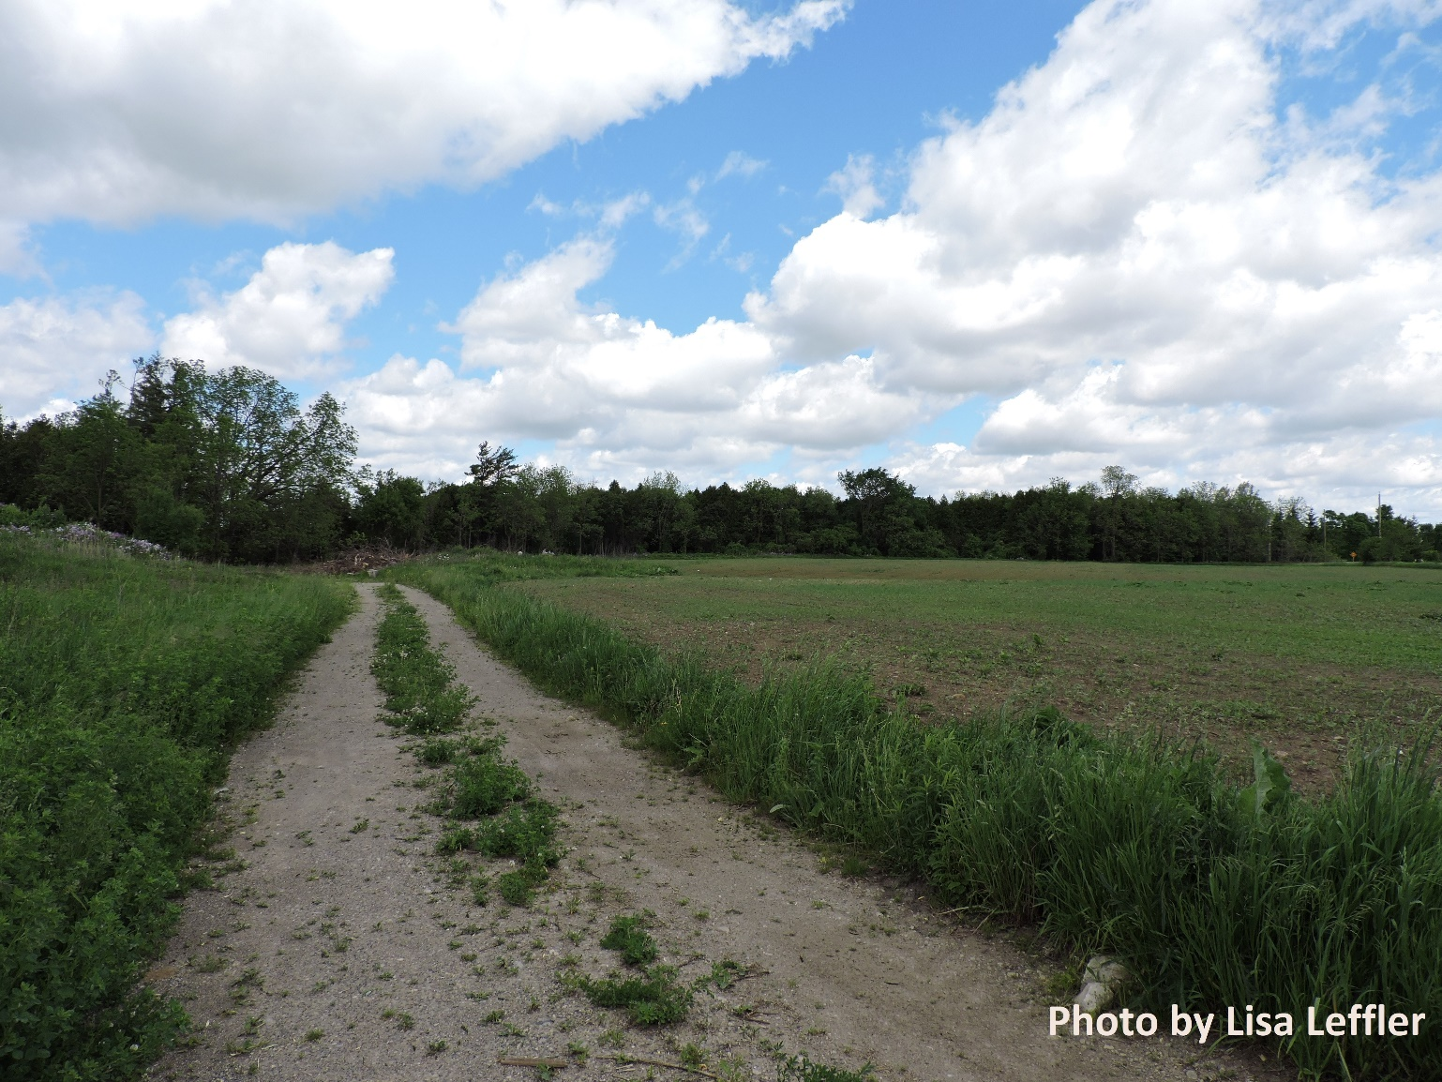
Scripture: John 14:1-14 NRSV https://www.biblegateway.com/passage/?search=John+14%3A1-14+&version=NRSV
Contemplation and Conversation: Who do you see God at work in in your life? How do you share God’s light with others?
From Lisa Leffler:
Growing up in the church I always looked forward to the end of the year when we would get Sunday School swag. We would wear with pride our bracelets that said WWJD (What would Jesus do?) – which were in theory a daily reminder to follow the path of Jesus but in practice were often little more than a fashion accessory.
When I read the gospels and think of all of the amazing things Jesus has done, I sometimes find it overwhelming – an impossible standard to live up to. How could I ever measure up Jesus who healed the sick, fed the hungry, even brought people back from the dead!
But in the scripture this morning I am reminded that Jesus did all those things not to create an impossibly high moral standard but so that we would recognize how God in our works lives.
Following the way of Jesus invites us to look for God in everyone we meet and to share the light of God’s loving spirit with others.

Whether you are at home trying to help slow the spread of the virus,
working to help care for those who are impacted most by COVID-19
or working to keep some normalcy in this time,
may you know God’s deep and abiding love in your life.
Know you are a valued part of our Rockwood and Stone United Church families.

Moderator's Online Worship - https://www.united-church.ca/blogs/round-table
During the COVID-19 pandemic, Moderator Richard Bott offers an online service for those looking to gather with others, pray, and worship together.
A gift of belonging to a church is that the practice of gathering together for worship … to pray, sing, listen to scripture and share how God touches our lives – helps us grow in deeper relationship to God and each other. With COVID-19 keeping us at home and physically distant from our Stone or Rockwood families, we are missing each other. We are offering this practice of sharing beyond Sunday morning to deepen our connection. Each week you will be offered a picture, a scripture and a question for contemplation, as well as a short reflection for you to contemplate, have conversation with people in your life and/or join an online conversation on our Rockwood Stone Facebook page.

