Contemplation and Conversation: 13th Sunday after Pentecost, August 30, 2020
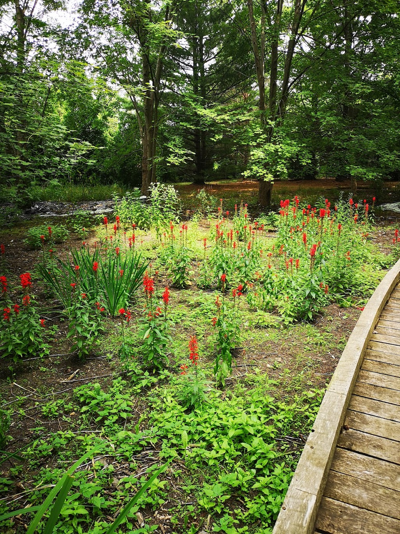
Scripture: Romans 12:9-21 https://www.biblegateway.com/passage/?search=Romans+12%3A9-21&version=NRSV
Spiritual Practices: Read one phrase from Paul’s words each morning and recite it throughout your day or read the full passage each evening and reflect on where you were able to live out these words.
Contemplation and Conversation: Which words offer you life and hope today?
From Rev. Heather Leffler:
Beloved, never avenge yourselves, but leave room for the wrath of God; for it is written, “Vengeance is mine, I will repay, says the Lord.” These are some of the most challenging words Paul offers us but they help me imagine the world as God intended it – a world where all people live together in peace and love. When I am angry at someone and respond with words of spite or they are angry at me and respond in kind, we both hurt. Our focus narrows and all we can see are offences, instead of seeing each other as people who are more than our failings. Our words or actions can lead to a complete breakdown of the relationship and often draw others in. When we lift our hurts, frustrations, fears and anger to God, we are freed to let go of them and see possibilities for healing and reconciliation. I trust in God’s infinite love “the vengeance of our Lord” is to surround us both in healing love so our relationship can be recreated.
Whether you are at home trying to help slow the spread of the virus,
working to help care for those who are impacted most by COVID-19
or working to keep some normalcy in this time,
may you know God’s deep and abiding love in your life.
Know you are a valued part of our Rockwood and Stone United Church families.

United Church of Canada
Emmanuel College faculty and staff respond to recent events in the US, Canada and around the world, including the deaths of George Floyd and Regis Korchinski-Paquet, and the viral video of Canadian Amy Cooper in Central Park. Go to https://www.emmanuel.utoronto.ca/home/emmanuel-faculty-and-staff-respond-to-racism/ to read and watch their statements. Associate Professor of Theology, Tom Reynolds’ “Prayer for a New Normal” which was shared in worship can also be found at https://www.youtube.com/watch?v=9KIoN2kUfqg along with Worship Professor Bill Kervin’s “Reconciliation Suite” https://www.youtube.com/watch?v=1oR5n05w-TQ&t=112s.
A gift of belonging to a church is that the practice of gathering together for worship … to pray, sing, listen to scripture and share how God touches our lives – helps us grow in deeper relationship to God and each other. With COVID-19 keeping us at home and physically distant from our Stone or Rockwood families, we are missing each other. We are offering this practice of sharing beyond Sunday morning to deepen our connection. Each week you will be offered a picture, a scripture and a question for contemplation, as well as a short reflection for you to contemplate, have conversation with people in your life and/or join an online conversation on our Rockwood Stone Facebook page.

