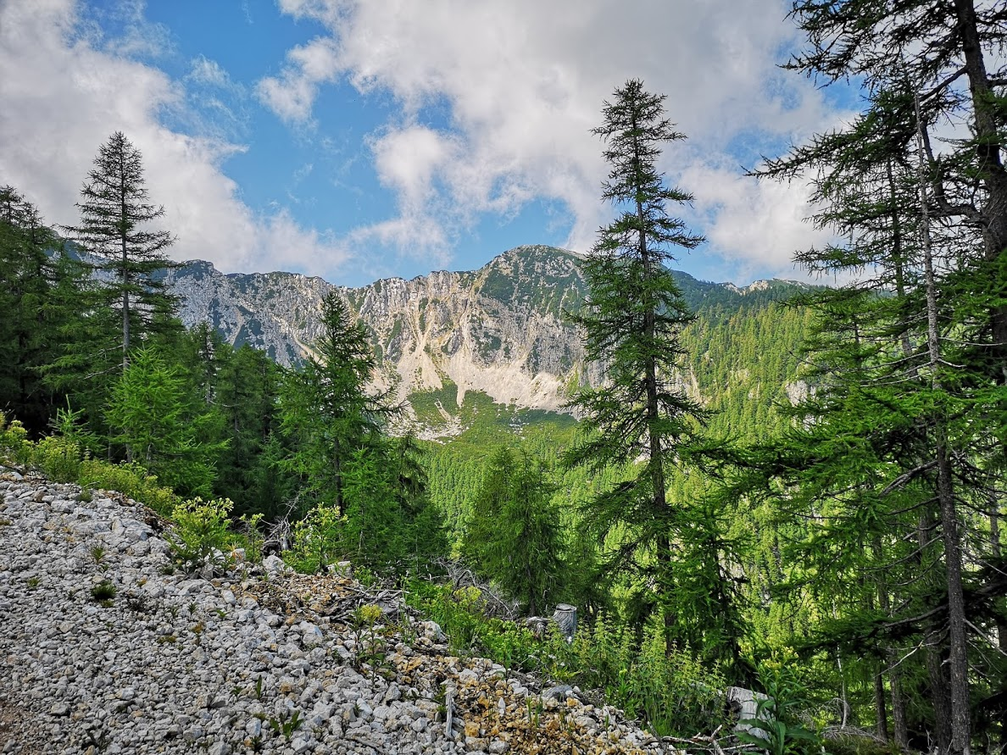
Contemplation and Conversation: 11th Sunday after Pentecost, August 16, 2020
Scripture: Psalm 133 NRSV https://www.biblegateway.com/passage/?search=Psalm+133&version=NRSV
¹How very good and pleasant it is
when kindred live together in unity!
²It is like the precious oil on the head,
running down upon the beard,
on the beard of Aaron,
running down over the collar of his robes.
³It is like the dew of Hermon,
which falls on the mountains of Zion.
For there the Lord ordained his blessing,
life forevermore.
Contemplation and Conversation:
What blessing did you receive today from your family or our church family?
From Rev. Heather Leffler:
God has not only gifted us with our birth families but also our church families. Living together is not always easy. During this time when we are urged to spend more time at home and only able to connect with those outside our social circles by phone or at a distance from behind masks; sometimes it is easier to see what is wrong with those closest to us than how they bless us. I hear the Psalmist inviting us to step back from our day to day struggles and see the gift of having family or friends to love and support us. When we can let go of the things that annoy us and give thanks for words and actions that bring us joy and well-being, we can bask in the love that offers comfort like warm oil and refreshment like the morning dew. May you see God’s blessing in those closest to you and be blessing to them.

Whether you are at home trying to help slow the spread of the virus,
working to help care for those who are impacted most by COVID-19
or working to keep some normalcy in this time,
may you know God’s deep and abiding love in your life.
Know you are a valued part of our Rockwood and Stone United Church families.

Canadian Foodgrains Bank – Lebanon Relief Fund
Just a reminder that donations for the Lebanon Relief Fund must be received before August 24 to be matched by the Canadian government. Please either send your donations by e-transfer to stoneuc.treasurer@gmail.com or mail to Bill Allen 4949 Wellington Rd. #29, Guelph, ON N1H 6H8. Thank you! This is a special appeal over and above Stone’s Foodgrains Project.

An Opportunity for Spirit Building with Anishnabeg Outreach
Friday, August 21 at 11 am at Anishnabeg Outreach Family Centre 236 Woodhaven Road, Kitchener
Please email Heather at hleffler@rogers.com if you can join us.
Hi Heather,
We would like to invite you and any colleagues you wish to invite to help build part of our Two Row Wampum. Here is a starting point of the Two Row Wampum -- https://www.onondaganation.org/culture/wampum/two-row-wampum-belt-guswenta/ From our perspective, it is about working together, building connection and partnerships or alliances and sometimes just working side-by-side. Friendship and respect are paramount. Wampum are stories, contracts, obligations and ways of being for First Nations.
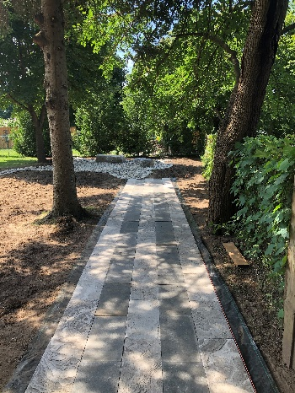
As we continue to build our exterior space and invoke more land-based perspectives and teaching, I invite you to also invite up to 20 participants in total from your organization to each lay a paving tile in our Wampum. This project is part of our Earth Blanket Awakening: a way to heal the land and people of the region. This is a seminal event that will lay the foundation for the future. Please make sure participants are free of Covid symptoms and have masks or masks will be provided. Attached is the beginning and framework of the pathway which will lead from our new teaching lodge to our pollinator garden under an archway of pine broughs. It will be quite inspiring and a true piece of art when it is finished. Laying the 30 pavers should only take a few minutes and I can offer a tour of our outside grounds and associated knowledge that I have.
I am anticipating it will only take an hour including tour/teachings/questions but I want to block time to ensure different groups don’t overlap.
In friendship,
Stephen Jackson, M.A.Sc.
CEO, Anishnabeg Outreach Employment and Training Inc.
226-972-1900

On Mon, Aug 10, 2020 at 10:19 AM, Barb Carscadden
<barb.c@ew-cs.com> wrote:
Hi Heather,
I hope you and your family are doing well.
I am sending this email to thank you for everything you have done for us since we moved into 107 Harris Street in 2015. This was a fantastic spot for us to expand our food bank, offer privacy in our office area and to have our New To You store become more visible in the community. We have enjoyed the 5 years at this location.
Thanks so much to everyone who has t awaken on the many building projects over the years including the ramp construction, painting the interior, fixing up the garage exterior, the Rogers Volunteer Day, and all the many tasks that have come up as a result of daily usage of this space. Finally, thanks to Darryl, Kevin and Scott who were involved in the “raccoon crisis”! That was not a pleasant task, I’m sure!
We are looking forward to settling into our new home on Dennis Street and believe it is the right move for us at this time. Our food bank, offices and store will be located all on one level which is so very important when offering services to our community.
We also look forward to continuing our partnership with the United Church and truly value all that you have done for the food bank and our clients. Marcia, Kay and the entire congregation have been a significant help, through the donation of food and frozen foods, grocery gift cards, free tickets to the Country Breakfasts, and more. All these contributions have helped those individuals who turn to us for assistance.
I am hoping you can pass on this email to your members.
Stay well.
Sincerely,
Barb.

Barb Carscadden, CVA
Manager, Volunteer Engagement & Transportation Services
Office 519-856-2113 Cell 226-979-5139

We would like to thank EVERYONE for their continued support during this very difficult time.
What an amazing community we have! HELP LOCALLY- GIVE LOCALLY

A gift of belonging to a church is that the practice of gathering together for worship … to pray, sing, listen to scripture and share how God touches our lives – helps us grow in deeper relationship to God and each other. With COVID-19 keeping us at home and physically distant from our Stone or Rockwood families, we are missing each other. We are offering this practice of sharing beyond Sunday morning to deepen our connection. Each week you will be offered a picture, a scripture and a question for contemplation, as well as a short reflection for you to contemplate, have conversation with people in your life and/or join an online conversation on our Rockwood Stone Facebook page.

