Contemplation and Conversation: 9th Sunday after Pentecost, August 2, 2020
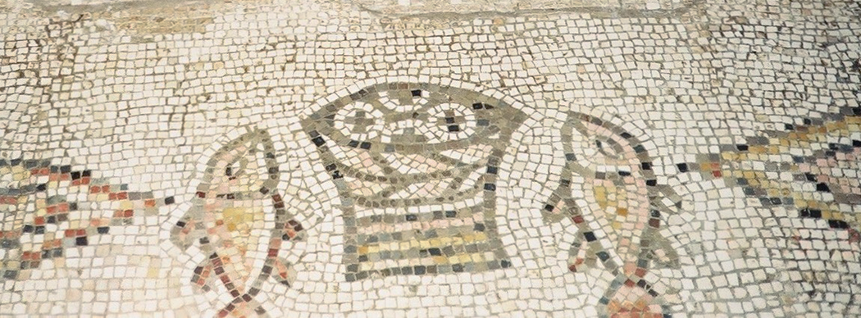
Scripture: Matthew 14:13-21 NRSV https://www.biblegateway.com/passage/?search=Matthew%2014:13-21&version=NRSV
Contemplation and Conversation: Where do you see signs of God’s abundance?
From Rev. Heather Leffler:
Tired after a long walk to the deserted place where Jesus was and a day spent listening in the hot sun, some families must have been anxious about what they would have for their evening meals. Feeling responsible for the crowd, the disciples couldn’t imagine there could be enough for everyone to eat. Jesus raise the five loaves and two fishes to God and prayed. Then he placed the food in baskets for the disciples to share with the crowd of 5,000. When everyone had enough and the 12 baskets came back, there were leftovers. In this time of COVID-19 I continue to see signs of God’s abundance. When Rockwood Outreach learned that Anishnabeg Outreach needed masks and bikes, your response was amazing. When Stone decided to hold a takeout supper to support their church in place of the roast beef dinner, all 60 meals sold out and people volunteered to make and deliver meals. Six families generously volunteered to share their beautiful gardens and properties for our garden tour on short notice, raising funds for outreach projects at Rockwood and the Canadian Foodgrains Bank project at Stone and allowing us much appreciated in person visits at safe distances. I give thanks to God for your generous support of our congregations and care for each other in this time.

Whether you are at home trying to help slow the spread of the virus,
working to help care for those who are impacted most by COVID-19
or working to keep some normalcy in this time,
may you know God’s deep and abiding love in your life.
Know you are a valued part of our Rockwood and Stone United Church families.

Our thoughts and prayers are with Bev Johnston and her family as they mourn the death of John Kearns; Jack and Edie Ward as they mourn the death of Jack’s brother-in-law, Bill Mulchinock; and Jeannie Southwell-Croft as she mourns the death of her sister-in-law.

United Church of Canada
Last modified on July 29, 2020
The Moderator has written a letter to the prime minister supporting Motion M-36 Emancipation Day by the Hon. Majid Jowhari. The motion proposes designating August 1 of every year as Emancipation Day to mark the abolishment of slavery in Canada. To read the Moderator’s letter go to https://www.united-church.ca/news/support-motion-m-36-making-aug-1-emancipation-day.
The United Church of Canada also calls on our communities of faith to commemorate August 1 as Emancipation Day as we work to educate our faith communities on anti-Black racism. Designating August 1 of each year as Emancipation Day is an important action in deepening Canada’s commitment toward eliminating anti-Black racism in our society.
As a church, we support working with members of Parliament to build on the spirit of the United Nations International Decade for People of African Descent by disseminating government initiatives towards this objective across all our congregations.

A gift of belonging to a church is that the practice of gathering together for worship … to pray, sing, listen to scripture and share how God touches our lives – helps us grow in deeper relationship to God and each other. With COVID-19 keeping us at home and physically distant from our Stone or Rockwood families, we are missing each other. We are offering this practice of sharing beyond Sunday morning to deepen our connection. Each week you will be offered a picture, a scripture and a question for contemplation, as well as a short reflection for you to contemplate, have conversation with people in your life and/or join an online conversation on our Rockwood Stone Facebook page.

