Contemplation and Conversation: 6th Sunday after Epiphany 2020
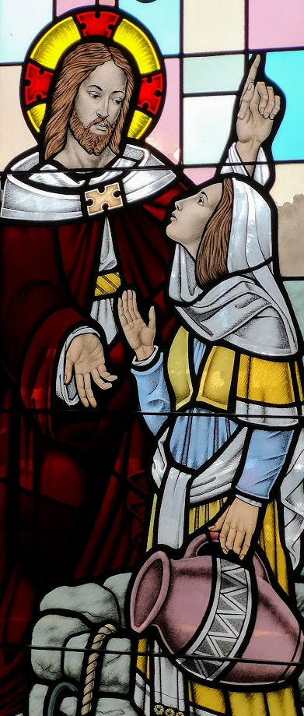
Scripture: Matthew 5:33-37 https://www.biblegateway.com/passage/?search=matthew+5%3A33-37&version=NRSV
Contemplation and Conversation: Where in your life is Jesus inviting you to offer words of healing and hope?
From Rev. Heather Leffler:
Growing up, where someone else would use a “four-letter word” my mother said, “Sugar.” My aunt would talk about those people from the other side of the tracks who used “that language”. As I watched and listened, I learned that the profane language we use is indeed influenced by where we grow up. However, it isn’t a reflection of how loving or hurtful, how sincere or insincere we are. In university, I would learn that different cultures swear by the things they value most. It gave pause that where I grew up, swearing was more about bodily functions than language of the Holy as in other cultures. Hearing the words of Jesus’ takes away any opportunity to look down on someone because of their choice of language. Jesus invites us each to be sincere and loving in all that we say and do. There is no need to swear by anything. Instead he urges us to be authentic in all conversations, letting our yes be yes and our no be no. Jesus’ words were always about bringing healing and hope to others.
Jesus with the Woman at the Well
at Ballinafad United Church
You are a beloved child of God. May the words you share
help you grow in relationship to God and others.
Know you are a valued part of our Rockwood and Stone United Church families.
A gift of belonging to a church is that the practice of gathering together for worship … to pray, sing, listen to scripture and share how God touches our lives – helps us grow in deeper relationship to God and each other. When life keeps you from being physically present at Stone or Rockwood, you are missed. We are offering a practice of sharing beyond Sunday morning to deepen our connection. Each week you will be offered a picture, a scripture and a question for contemplation, as well as a short reflection for you to contemplate, have conversation with people in your life and/or join an online conversation on our Rockwood Stone Facebook page.

