Contemplation and Conversation: 7th Sunday after Pentecost, July 19, 2020
Scripture: Psalm 139:1-13, 23-24 NRSV https://www.biblegateway.com/passage/?search=Psalm+139%3A1-14%2CPsalm+139%3A23-24&version=NRSV
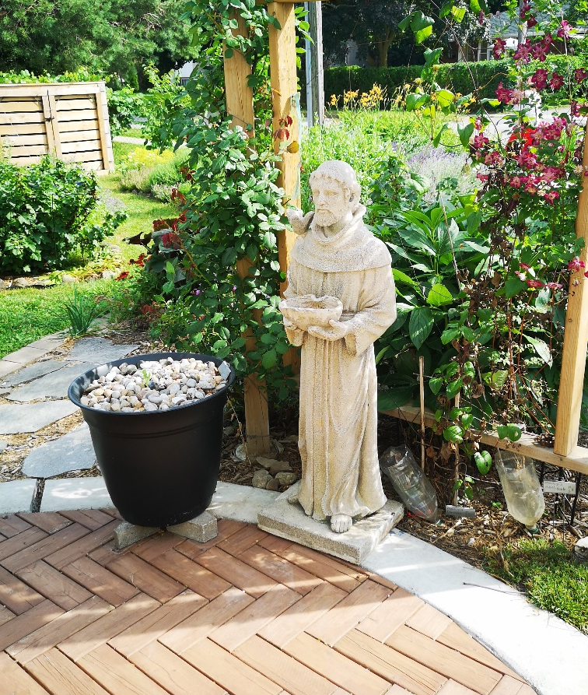
¹ O Lord, you have searched me and known me.
² You know when I sit down and when I rise up;
you discern my thoughts from far away.
³ You search out my path and my lying down,
and are acquainted with all my ways.
⁴ Even before a word is on my tongue,
O Lord, you know it completely.
⁵ You hem me in, behind and before,
and lay your hand upon me.
⁶ Such knowledge is too wonderful for me;
it is so high that I cannot attain it.
⁷ Where can I go from your spirit?
Or where can I flee from your presence?
⁸ If I ascend to heaven, you are there;
if I make my bed in Sheol, you are there.
⁹ If I take the wings of the morning
and settle at the farthest limits of the sea,
¹⁰ even there your hand shall lead me,
and your right hand shall hold me fast.
¹¹ If I say, “Surely the darkness shall cover me,
and the light around me become night,”
¹² even the darkness is not dark to you;
the night is as bright as the day,
for darkness is as light to you.
¹³ For it was you who formed my inward parts;
you knit me together in my mother’s womb.
Thanks to Heather Blair for sharing her garden.
Photo Taken by H. Leffler
²³ Search me, O God, and know my heart;
test me and know my thoughts.
²⁴ See if there is any wicked way in me,
and lead me in the way everlasting.
Contemplation and Conversation:
What thoughts would you share with God today? Are there secrets you are reluctant to share?
From Rev. Heather Leffler:
I work hard at remembering people’s names and their stories because for me being known matters. When someone takes the time to get to know me and remembers my name, I feel cared for. I am especially grateful to my family and friends who know my short comings and love me despite them. When we give one another this gift, we are mirroring the Holy One who knows us completely and loves us anyway. God loves us so much that we are free to face our darkest thoughts and biggest missteps and move away from them, confident that the One who lovingly “knit us together in our mother’s wombs” will “travel to the farthest limits of the sea” to bring us home. We are never outside the love of God.
Whether you are at home trying to help slow the spread of the virus,
working to help care for those who are impacted most by COVID-19
or working to keep some normalcy in this time,
may you know God’s deep and abiding love in your life.
Know you are a valued part of our Rockwood and Stone United Church families.
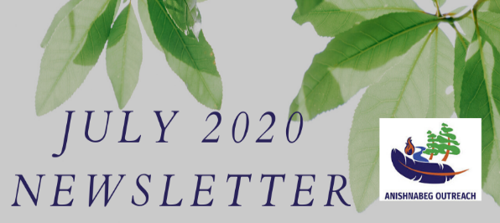
AO Vision: Build processes and tools that will position current and future First Peoples as prosperous leaders and strategic partners in Canada’s Future.
AO Mission: To help First People by creating a sustainable and comprehensive suite of centralized wrap around services for urban Indigenous people and to establish AO as an innovative hub/heart of best practices for economic development,training and employment on reserves.
I would like to acknowledge that the land on which we live and work today is the land traditionally used by the Haudenosaunee, Anishnaabe and Neutral people. I also acknowledge the enduring presence and deep traditional knowledge, laws and philosophies of the Indigenous people with whom we share this land today.
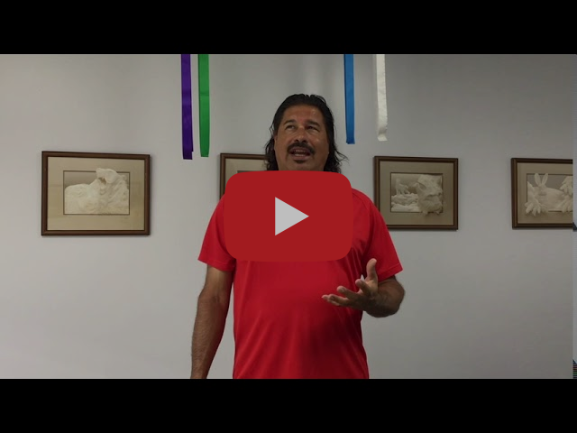

UPDATE: DONATIONS AND SPIRIT BUNDLES

Since our last newsletter update, we have made a number of enhancements to our program. It continues to evolve and improve as we establish more relationships and partnerships. With summer, we were gifted an abundance of Canada Summer Jobs students to help with all aspects of our programs. Some are helping to enhance our employment agency, some are building land-based programs for our Indigenous-led EarlyON and the remainder are working on our Spirit Bundles and medicine and food gardens. They have been such a blessing as many hands make light work.

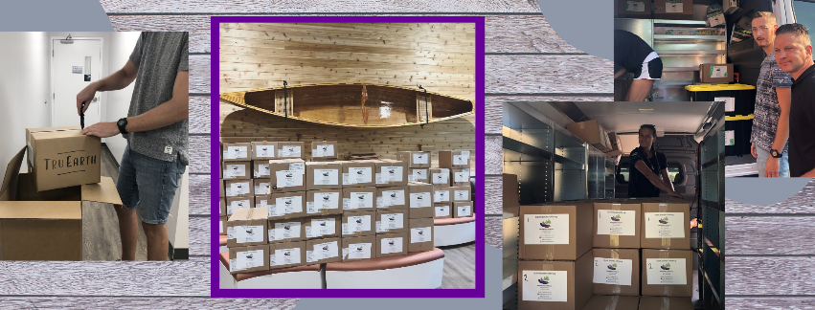

Spirit Bundles:
We have found the need for our Spirit Bundles to be greater than ever. We are constantly thinking of new ways we can continue to meet the specific needs of our community and enhance our program. Transportation is often a barrier for families and with our deliveries, we can ensure that the families are getting some basics. With our Spirit Bundle program, we have moved from emergency rations to food bundles that include frozen meat, vegetables, and fruit. The redirection to food bundles required us to purchase a commercial-sized freezer to help store these items before they go out for delivery. So far we have delivered over 15,000 pounds of food worth more than $40,000. Courtesy of all of the donations received, we have already provided more than $150,000 worth of support to families in need. Additionally, thanks to Tru Earth and its donation of 12,000 loads worth of laundry soap, we have switched from jugs of laundry soap to strips. Not only are the laundry strips lighter and easier to distribute but they are also eco friendly. Likewise, thanks to Life of Voice and their donation of furniture, kitchen items, chairs, desks, couches, beds, bedding, and other things, we have also been able to offer a variety of household items to our Spirit Bundle recipients.
Masks:
Since the onset of COVID-19, we have been working with local mask makers to ensure we have enough masks to meet the demand. The order on mandatory mask-wearing in both Kitchener and Guelph will probably increase demand higher than ever. We will be distributing a couple of thousand masks within the next few weeks and we have 500 more on the way. We regularly offer masks to the other local Indigenous agencies for their staff, families, and clients and are always augmenting the initial Spirit Bundle families.
WCDSB donation:
Last month, it came to our attention that the Waterloo Catholic District School Board had a large amount of unclaimed lost and found items. We collected, laundered, and sorted these items and we will be distributing these items as well.

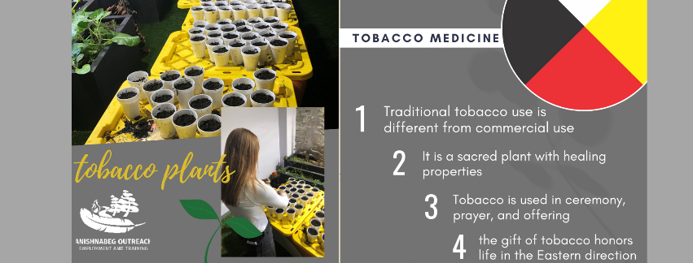

GARDEN PROJECTS AND PARTNERSHIPS:

The magnificent Spirit Maple on our property provided over 100 seedlings that we were able to germinate and gift to our community members all over Guelph, Cambridge, Kitchener, and Waterloo. The planting of these baby trees is a physical symbol and reminder of the roots our organization is taking all over the region. It reminds us of the value of community and represents its strength. Remember, we are all connected to the land on which we reside. These trees also offer people an opportunity to give back by growing and nurturing their tree for years to come as we promote sustainability and carbon neutrality when we can. We planted a traditional strain of tobacco plants known as 1000-year-old tobacco. Wild tobacco, sacred tobacco, or Nicotina rustica is an ancient plant that has been widely grown by Canada’s First Peoples throughout North America for many centuries. The 1000-year-old tobacco is named such because it originated from a few viable seeds found at an archeological site. Owen Bridge from Annapolis Seeds indicates that the seeds were found in a pottery vessel sealed with a pitch near the great lakes. Since their discovery, seed savers have preserved and propagated more seeds. We received seeds from a First Nations woman in the region who received them from the Waterloo Region Museum. We are now able to propagate and grow them. Now they have come full circle by returning to local Indigenous people for medicine. Once these seedlings are ready, people will be able to start their traditional medicine gardens at home. You can see updates on these projects across our social media platforms.
Thanks to our friends at the Waterloo Region Museum, we were able to kick start the building process with their kind donation of sage and sweetgrass plants that we transplanted from their gardens. Sage and sweetgrass are both traditional medicines represented on the medicine wheel along with cedar and tobacco. We are lucky enough to have cedar trees on property and we are now working on building a tobacco garden. These medicines have multiple uses such as smudging, offerings, and tea. We will now be able to have a ready supply of medicines available for community members who request them or as part of the Spirit Bundles.

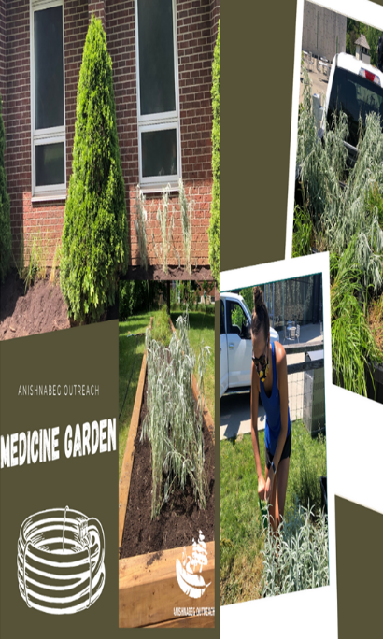
Our team has been hard at work building brand new gardens. In the garden space, there are strawberries, blueberries, and raspberries. These gardens will offer us more than 200 quarts of berries per season that we can distribute each year to our community. With the harvest, we plan to make a variety of different items such as jams and other delicious treats. Berries are also central to a variety of Indigenous teachings and traditions. Food is medicine and medicine can be found in food.
Did you know that the strawberry:
- It is known to be the heart berry due to its shape
- It reminds people of reconciliation and teaches people how to maintain heartfelt relationships in our families and communities. It teaches forgiveness and peace. Finding peace doesn't always come from the head/mind but comes from the heart.
- It is known to be a woman's medicine and teaches young women about creation, community and love
- It is an important food and medicine for some Indigenous cultures in North America
- It can treat digestive disorders, skin problems,
and strengthens the uterus during and after pregnancy
- It provides vitamin C

References:
http://www.wabano.com/wp-content/uploads/2012/08/Strawberry-Teachings.pdf
http://www.fourdirectionsteachings.com/transcripts/ojibwe.html

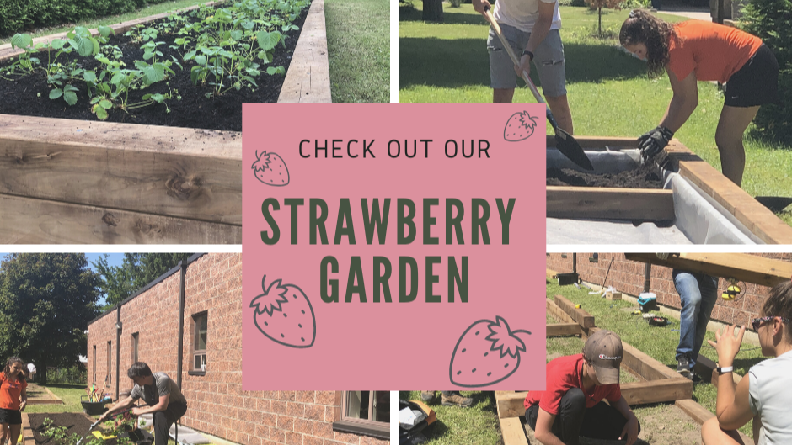

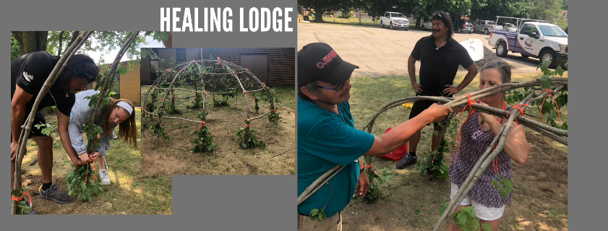

WHERE WE ARE HEADING:
While we have certainly been busy, there are still many things we want and need to accomplish. We are currently seeking donations and funding for new projects that we plan to get underway shortly. We need to expand the support for mental health due to Covid-19, social isolation, and systemic racism. We are looking at mental health support as a critical need. Mental health from an Indigenous perspective is sometimes unique and requires a cultural lens of understanding. Knowing the needs of culturally specific mental health is important and something that we are striving to deliver.
Lastly, we are looking for resources to build our very own pollinator garden on our property. This project is essential to tying together the greater community project we are working towards. As we seek to have a variety of different plants and produce on our property we need to recruit the hard labour of a variety of pollinators. We must work towards our greater goal of healing with the principles of sustainability at the forefront of each decision we make. This is why the establishment of food, medicine, and pollinating gardens are being built in a way that will ensure prosperous growth for years to come. In combination with projects such as our healing lodge, we feel that we are beginning to address individual healing and group healing at multiple levels. Our calling is to provide education, information, and healing – wrap-around services that are culturally pertinent and provide contemporary context. Some of this we do through the land.
There is a 500 plus year history of systemic discrimination against First Nations, Metis, and Inuit, which was mostly initiated and perpetuated by governments. Status cards, reservations, treaties, land claims, racism are a few of the significant topics. Needless to say, there is extreme distrust for government, government agencies, and health care organizations. Indigenous people will not reach out for support from non-Indigenous organizations. This is why partnering with an Indigenous-led organization is necessary to support Indigenous people.

STAY UP TO DATE ON SOCIAL MEDIA

Our mailing address is: 236 Woodhaven Rd, Kitchener, N N2C 1V5

Copyright © 2020, Anishnabeg Outreach, All rights reserved.

