Contemplation and Conversation: Easter Sunday, April 12, 2020
Scripture: Matthew 28:1-10 NRSV https://www.biblegateway.com/passage/?search=Matthew+28%3A1-10&version=NRSV
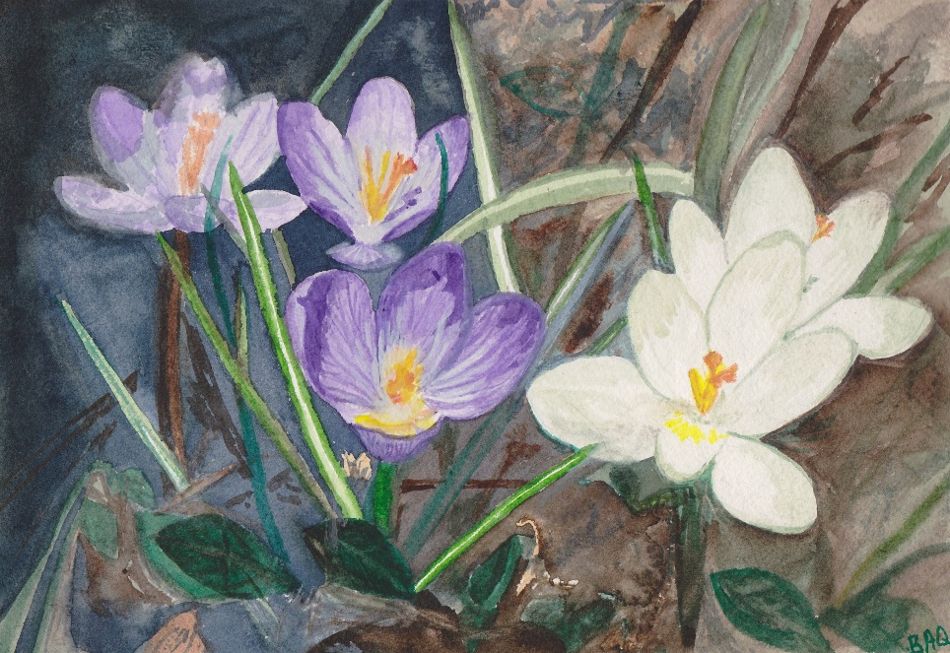
Contemplation and Conversation: Where do you see signs of hope today?
Painting by B. Quickfall

From Rev. Heather Leffler:
At a distance from our church and our family this Easter, it is easier than ever to imagine the mingling of fear and hope Jesus’ followers experienced that morning. In the midst of the COVID 19 pandemic there is much to fear … fear of loss of work and income … fear of losing business and businesses …fear of exhaustion … fear of mental health challenges … fear of harming relationships because of not seeing or seeing too much of each other … fear of becoming sick … fear of death … In the midst of their grief, fear and dawning hope, Jesus met the women and said, “Do not be afraid.” The resurrection assures us that whatever we face God is with us. We can let go of our fears. Whatever darkness we find ourselves in, our faith lets us look for and find signs of hope. As we sang and prayed together by Zoom this morning as Stone and Rockwood congregations, there was much joy. Today as we connect with family and friends by phone and computer, maybe even a hockey stick apart on driveways, we can give thanks. We give thanks to God for food and shelter, all those who are caring for others by keeping apart, our government leaders for seeking people in need and offering support, front line health workers, emergency responders, grocery store and all essential workers and everything people are doing to make a difference.
An Easter Gift on You Tube … https://youtu.be/yf3R4crINUM ... Enjoy the music of Rosslyn Bentley accompanied by Chris Barlow.

Whether you are at home trying to help slow the spread of the virus,
working to help care for those who are impacted most by COVID-19
or working to keep some normalcy in this time,
may you know God’s deep and abiding love in your life.
Know you are a valued part of our Rockwood and Stone United Church families.

Moderator's Live Online Worship – Easter Sunday, April 12, 2020 at 3 pm.
During the COVID-19 pandemic, Moderator Richard Bott offers an online service for those looking to gather with others, pray, and worship together. This afternoon you can join online at https://www.united-church.ca/events/moderators-easter-sunday-livestream-worship

A gift of belonging to a church is that the practice of gathering together for worship … to pray, sing, listen to scripture and share how God touches our lives – helps us grow in deeper relationship to God and each other. With COVID-19 keeping us at home and physically distant from our Stone or Rockwood families, we are missing each other. We are offering this practice of sharing beyond Sunday morning to deepen our connection. Each week you will be offered a picture, a scripture and a question for contemplation, as well as a short reflection for you to contemplate, have conversation with people in your life and/or join an online conversation on our Rockwood Stone Facebook page.

