Contemplation and Conversation: 5th Sunday of 2020
Scripture: John 11:1-6 NRSV https://www.biblegateway.com/passage/?search=John+11%3A1-6&version=NRSV
Consider taking time to read the whole story of Jesus raising Lazarus from John 11:1-45 https://www.biblegateway.com/passage/?search=John+11%3A1-45&version=NRSV
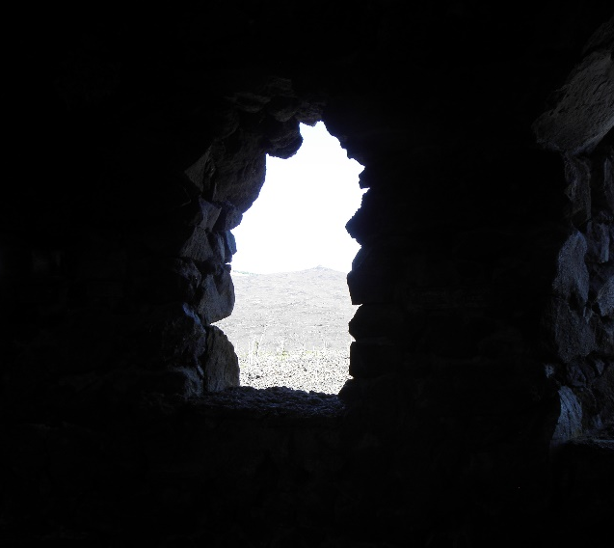
Contemplation and Conversation: Where have you seen signs of new life in the midst of the pandemic that point to God’s glory?
From Rev. Heather Leffler:
When Jesus does arrive in Bethany, his friend Lazarus has been dead for four days. Jesus weeps at Lazarus’ tomb for Mary and Martha’s pain, for Jesus’ own family and his disciples who will know that same grief with his coming death, and for all of humanity. His tears are tears of grief, sadness and anger that people cannot put God and each other first. Most of all they are tears of healing love. Through his tears, he restores Lazarus to life and his sisters. Through his tears, he prepares himself for his own death which will be the way to resurrection and life for all of us. I was struck today by the words “this illness does not lead to death” especially this morning as we mourn Earl’s death. There is no doubt that heart disease, cancer, other illnesses and COVID-19 lead to physical death and heart break for loved ones left behind. Jesus’ life, death, resurrection and ascension into heaven promise us that death is not the end. Embracing fully Jesus’ promise of new life with him frees us to see through our tears of fear, isolation, anger and grief to see the signs of new life around us in the midst of this pandemic and even death – stories of neighbours holding up their new phone number through a window to offer help to an elder … the News showing children creating videos of thanks to everyone who is working to care for one another in this time … our church family phoning, emailing, offering places to walk, picking up needed groceries, making and delivering hand sanitizer and praying for each other … I do not believe that God caused the pandemic, but I do believe that knowing God helps us reach out and care for others even as we maintain social distance and isolation. In loving others we feel God’s love for us and discover again God’s glory.
Photo by M. Running
Whether you are at home trying to help slow the spread of the virus,
working to help care for those who are impacted most by COVID-19
or working to keep some normalcy in this time,
may you know God’s deep and abiding love in your life.
Know you are a valued part of our Rockwood and Stone United Church families.

With Sympathy – Please keep Marion Osborne and Earl and Marion’s families in your thoughts and prayers, as they remember Earl who died last night. Two of Marion’s daughters are with her at home, as their family practices social isolation as much as possible.

From Lisa Leffler Are you feeling the strain of too much time inside or looking for something to add to your social distancing routine? I would like to share my spiritual practice from 2019 with you with some suggestions of how you might use my pictures to engage in some spiritual practices. You can reach my photo project from the Common Threads article http://ccsonline.ca/2020/03/a-little-outdoor-time/#page-content
In a time of distance
The unexpected always happens in the way
The unexpected has always occurred:
While we are doing something else,
While we are thinking of altogether
Different things – matters that events
Then show to be every bit as unimportant
As our human concerns so often are;
And then, with the unexpected upon us,
We look at one another with a sort of surprise;
How could things possibly turn out this way
When we are so competent, so pleased
With the elaborate systems we’ve created –
Networks and satellites, intelligent machines,
Pills for every eventuality – except this one?
And so we turn again to face one another
And discover those things
We had almost forgotten,
But that, mercifully, are still there:
Love and friendship, not just for those
To whom we are closest, but also for those
Whom we do not know and of whom
Perhaps we have in the past been frightened;
The words brother and sister, powerful still,
Are brought out, dusted down,
Found to be still capable of expressing
What we feel for others, that precise concern;
Joined together in adversity
We discover things we had put aside:
Old board games with obscure rules,
Books we had been meaning to read,
Letters we had intended to write,
Things we had thought we might say
But for which we never found the time;
And from these discoveries of self, of time,
There comes a new realisation
That we have been in too much of hurry,
That we have misused our fragile world,
That we have forgotten the claims of others
Who have been left behind;
We find that out in our seclusion,
In our silence; we commit ourselves afresh,
We look for a few bars of song
That we used to sing together,
A long time ago; we give what we can,
We wait, knowing that when this is over
A lot of us – not all perhaps – but most,
Will be slightly different people,
And our world, though diminished,
Will be much bigger, its beauty revealed afresh.

Marcia Haworth shared the poem “A Poem for Troubled Times” by Alexander McCall Smith which spoke to her. https://www.alexandermccallsmith.com/news/poem

Moderator's Online Worship - March 29, 2020 –During the COVID-19 pandemic, Moderator Richard Bott invites you to gather with others, pray, and worship together at https://www.united-church.ca/blogs/round-table/moderators-online-worship-march-29-2020
A gift of belonging to a church is that the practice of gathering together for worship … to pray, sing, listen to scripture and share how God touches our lives – helps us grow in deeper relationship to God and each other. When life keeps you from being physically present at Stone or Rockwood, you are missed. We are offering this practice of sharing beyond Sunday morning to deepen our connection. Each week you will be offered a picture, a scripture and a question for contemplation, as well as a short reflection for you to contemplate, have conversation with people in your life and/or join an online conversation on our Rockwood Stone Facebook page.

