Contemplation and Conversation: 4th Sunday of Lent 2020
Scripture: John 9:1-5 NRSV https://www.biblegateway.com/passage/?search=John+9%3A1-5&version=NRSV
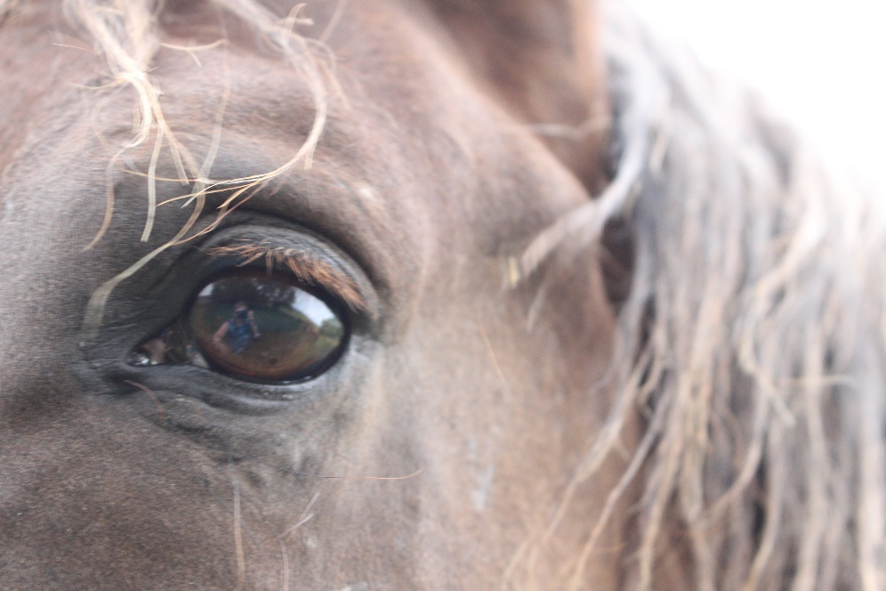
(Consider taking time to read the whole story of Jesus healing the man who was born blind thttps://www.biblegateway.com/passage/?search=John+9&version=NRSV)
Photo by M. Running
Contemplation and Conversation: Where are God’s works being revealed in your life? in the world?
From Rev. Heather Leffler:
In this story that should have been about restoration to community, gratitude for healing, and giving glory to God; people could not, would not recognize God’s actions. The disciples were looking for someone to blame for the man being blind. When he was healed, the man’s neighbours could not believe he was the same person. The Pharisees would not believe his healing was from God because it happened on the Sabbath. Afraid of being forced out of their faith community, even his parents would not acknowledge the miracle. Only the man himself was willing to openly acknowledge that Jesus was from God. In this time of social distance and isolation, illness and even death, there will be people that blame and shame, people who ignore the needs of others and refuse to see that the whole world is in this together. May we be like the man Jesus healed. May we see and give thanks for the places God’s love is being lived out in the world and respond in prayer, gratitude and loving action. May we bring comfort and hope by connecting with others through the amazing technology we have and by sharing our time and resources. May we hold in prayer all those who put themselves at risk as they continue to work to care for others. May we pray for a change of heart for those who will not put the needs of all ahead of their own. Most of all may we pray for the most vulnerable among us.
Whether you are at home helping slow the spread of the virus,
working to help care for those who are impacted most by COVID-19
or working to keep some normalcy in this time,
may you know God’s deep and abiding love in your life.
Know you are a valued part of our Rockwood and Stone United Church families.

From Barb Parker:

Pandemic
What if you thought of it
as the Jews consider the Sabbath—
the most sacred of times?
Cease from travel.
Cease from buying and selling.
Give up, just for now,
on trying to make the world
different than it is.
Sing. Pray. Touch only those
to whom you commit your life.
Center down.
And when your body has become still,
reach out with your heart.
Know that we are connected
in ways that are terrifying and beautiful.
(You could hardly deny it now.)
Know that our lives
are in one anothers hands.
(Surely, that has come clear.)
Do not reach out your hands.
Reach out your heart.
Reach out your words.
Reach out all the tendrils
of compassion that move, invisibly,
where we cannot touch.
Promise this world your love–
for better or for worse,
in sickness and in health,
so long as we all shall live.
–Lynn Ungar 3/11/20 (www.lynnungar.com/poems/pandemic)

Moderator's Online Worship - March 22, 2020
During the COVID-19 pandemic, Moderator Richard Bott offers an online service for those looking to gather with others, pray, and worship together. https://www.united-church.ca/blogs/round-table/moderators-online-worship-march-22-2020

A gift of belonging to a church is that the practice of gathering together for worship … to pray, sing, listen to scripture and share how God touches our lives – helps us grow in deeper relationship to God and each other. When life keeps you from being physically present at Stone or Rockwood, you are missed. We are offering this practice of sharing beyond Sunday morning to deepen our connection. Each week you will be offered a picture, a scripture and a question for contemplation, as well as a short reflection for you to contemplate, have conversation with people in your life and/or join an online conversation on our Rockwood Stone Facebook page.

