Contemplation and Conversation: 2nd Sunday of Lent 2020
Scripture: John 3:13-17 https://www.biblegateway.com/passage/?search=John+3%3A13-17&version=NRSV
(If you have time, you might read Nicodemus’ story, John 3:1-17.)
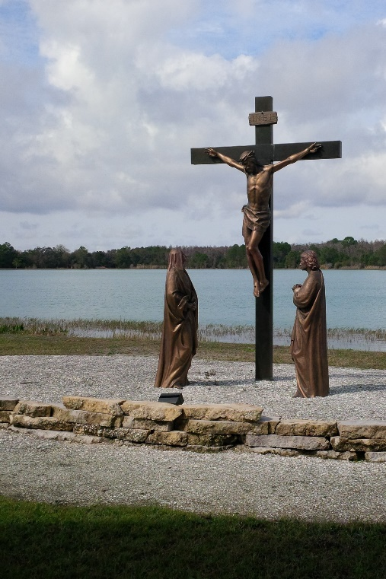
Contemplation and Conversation: What does Jesus’ death mean for your life?
From Rev. Heather Leffler:
John’s gospel seems clear. Jesus said that he had to be lifted up on the cross so that those who believe in him could have eternal life. Over time Jesus’ death has meant different things to the church.
Jesus died for our sins.
Jesus died to pay a debt to the Devil. – 1st millennium
Jesus died to pay a debt to God. -- Anselm of Canterbury in the 11th century
I would offer two perspectives I have found most helpful for you to contemplate.
Jesus did not come to change the mind of God about humanity. It did not need changing. Jesus came to change the mind of humanity about God! God is not someone to be afraid of but is the Ground of Being and on our side. – John Duns Scotus (1266-1308)
The gospel of the cross is not about rescuing us from our finitude; it's about a compassionate God's solidarity with us in our (yes, perhaps impossible) creaturehood and the slow grace of divine suffering-love which, without pretending finality, ef­fects its social and personal transformations from within.
– John Douglas Hall (1928-) United Church Theologian
Bethany Center, Lutz, Florida
Photo by H. Leffler
May you know the deep and abiding love of the One
who would die so we can know the fullness of life God longs for us.

A gift of belonging to a church is that the practice of gathering together for worship … to pray, sing, listen to scripture and share how God touches our lives – helps us grow in deeper relationship to God and each other. When life keeps you from being physically present at Stone or Rockwood, you are missed. We are offering this practice of sharing beyond Sunday morning to deepen our connection. Each week you will be offered a picture, a scripture and a question for contemplation, as well as a short reflection for you to contemplate, have conversation with people in your life and/or join an online conversation on our Rockwood Stone Facebook page.

