Contemplation and Conversation: 24th Sunday after Pentecost, November 15, 2020
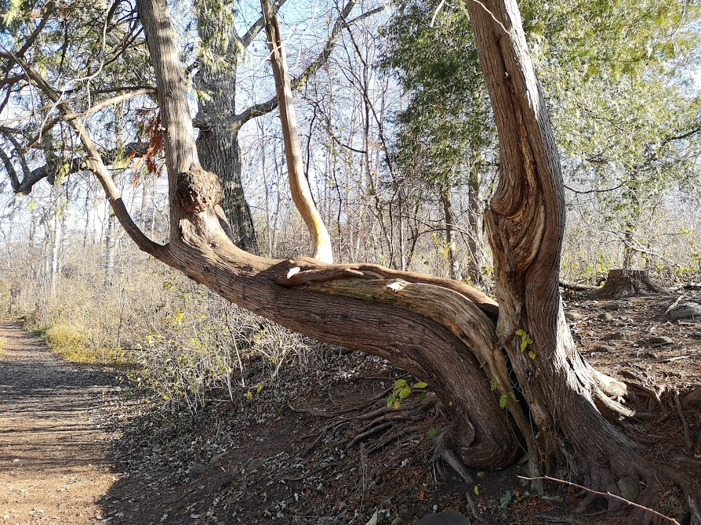
Scripture: Matthew 25:14-30 NRSV https://www.biblegateway.com/passage/?search=Matthew%2025:14-30&version=NRSVhttps://www.biblegateway.com/passage/?search=Matthew%2025:14- 30&version=NRSV
Contemplation and Conversation: Do you have a talent or skill do you have hesitated to use? What holds you back from sharing?
From Rev. Heather Leffler:
This continues to be a challenging passage for me. It is hard for me to reconcile the master giving the one who had the most more and throwing the one who was afraid into the outer darkness with the loving God I know through Jesus. It becomes especially challenging when this parable is used to justify Christians having wealth and not sharing their wealth because they deem others undeserving.
The passage changes for me when we see God as the master giving us our gifts, skills, experience and expertise. The parable then becomes an invitation to use what we have to make a difference in the world. Do you cook or bake? Can you build or make things? Can you draw or paint? Can you sing or play an instrument? Can you listen when someone is in need? Can you make people laugh or share words of hope? When we share our talents to make a difference in our homes, classes or workplaces, in our churches and communities, we are living out our faith. The more we use our talents the better we become, the more we can use them to care for the earth and each other. William Barclay writes, “If we have a talent and exercise it, we are progressively more able to do it. … It is the lesson of life that the only way to keep a gift is to use it in the service of God and in the service of others.

Whether you are at home trying to help slow the spread of the virus,
working to help care for those who are impacted most by COVID-19
or working to keep some normalcy in this time,
may you know God’s deep and abiding love in your life.
Know you are a valued part of our Rockwood and Stone United Church families.

Further Conversation … Would you like to talk more about today’s reflection? Email Heather at hleffler@rogers.com. Following worship next Sunday, she will invite others to join you in a Zoom break out room to share in further conversation.

From our Rockwood Stone Affirming Discernment Circle
Brian Burke is a name familiar to hockey fans in our congregations. He has recently published his memoirs entitled Burke's Law. His son, Brendan, came out as gay in November of 2009 and was tragically killed in an automobile accident in February of 2010. To view an interview done by TVO with Brian Burke about changing attitudes toward gay athletes when he was still General Manager of the Toronto Maple Leafs go to https://www.youtube.com/watch?v=rqIeFbTrfjc&feature=emb_logo . The social activism campaign entitled “You Can Play” referenced in the interview was launched on March 4, 2012 by three co-founders: Patrick Burke (son of Brian and brother of Brendan), Brian Kitts, and Glenn Witman. “You Can Play” is an official partner of the National Hockey League. It is a campaign dedicated to the eradication of homophobia in sports, centered on the slogan, "If You Can Play, You Can Play” https://www.youcanplayproject.org/ .

Question: How can sports organizations help to promote inclusivity? What is being done in our area?

If you would like to explore this topic further, please email hleffler@rogers.com so we can set up a time for a discussion group.

United Church of Canada – from Moderator Richard Bott on July 16, 2020
A challenged dropped in my inbox today – come up with a version of "The Lord's Prayer" to a hymn tune you enjoy.
Here's what came out of my pen - the tune is Hyfrydol (VU 333 - Love Divine, All Loves Excelling).
[Edit: You are welcome to use and share this, as with anything I write and post here, under a Creative Commons Attribution-Non-Commercial license.]
God, Creator, in the heavens,
holy is your glorious name!
May your kingdom be among us;
your will lived, on earth, the same.
Give to each the food that's needed;
sins forgiven, as we forgive.
Lead us not into temptation,
from all evil your people save.
Yours the kingdom, yours the power,
yours the glory, now and always.
May we sing this song forever,
in our nights and in our days!
Prayer and praise our lips are speaking,
hearts together in one accord;
offering, now, our lives, our living;
you, Creator God, adored!
A gift of belonging to a church is that the practice of gathering together for worship … to pray, sing, listen to scripture and share how God touches our lives – helps us grow in deeper relationship to God and each other. With COVID-19 keeping us at home and physically distant from our Stone or Rockwood families, we are missing each other. We are offering this practice of sharing beyond Sunday morning to deepen our connection. Each week you will be offered a picture, a scripture and a question for contemplation, as well as a short reflection for you to contemplate, have conversation with people in your life and/or join an online conversation on our Rockwood Stone Facebook page.

