Contemplation and Conversation: 3rd Sunday after Epiphany, January 24, 2021
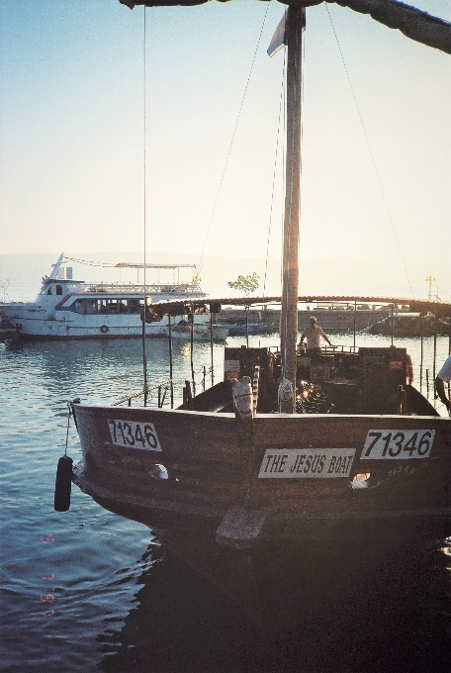
Scripture: Mark 1:14-20 https://www.biblegateway.com/passage/?search=Mark%201%3A14-20&version=NRSV
Contemplation and Conversation: How is Jesus inviting you to fish for people?
From Rev. Heather Leffler:
When I first read this passage, I find myself singing and imagining the actions of “I Will Make You Fishers of Men”. I am flooded with warm memories of Sunday School teachers and friends from days gone by. It is delightful to hear the story of Simon who Jesus would call Peter, Andrew, James and John leaving their boats and faithfully followed Jesus. It was even more exciting in Bible studies to learn that as followers of John the Baptist, they were looking for a new way that Jesus offered them.
The part of the story that has always troubled me is what does it mean to “fish for people”? The surface answer has always been we need to tell people about Jesus – evangelize. This means share the good news about Jesus but has come to have a negative image. A reflection I read this week, expressed the concern that at times the church has actually “fished” people in to give money for causes when they couldn’t afford it.
The same reflection I read invited us to rethink the story again. What if in fishing for people, Jesus was asking the disciples to reach out and make a difference in people’s lives? Sometimes that would be sharing their experiences with Jesus. Other times they might go back to fishing to make sure someone had enough to eat. Fishing for people might mean finding ways to care for others through our words, prayers and actions. May it be so.

Whether you are at home trying to help slow the spread of the virus,
working to help care for those who are impacted most by COVID-19
or working to keep some normalcy in this time,
may you know God’s deep and abiding love in your life.
Know you are a valued part of our Rockwood and Stone United Church families.

Virtual Robbie Burns – Thanks to Chris Arbuckle for sharing this link https://youtu.be/lTPmU5wb1qI to the Guelph Pipe Band’s “A Virtual Burns Night” … tonight, January 24 at 7 pm.

Further Conversation … Would you like to talk more about today’s reflection? Email Heather at hleffler@rogers.com. Following worship next Sunday, she will invite others to join you in a Zoom break out room to share in further conversation.

From our Rockwood Stone Affirming Discernment Circle

It has taken me a little longer than some to find the right career path. For almost 15 years, I have split my time between post-secondary education and random jobs that mostly pay minimum wage and often jobs that hire people for just under full-time to avoid paying benefits. I have been blessed to have a family who is willing and able to support me on this journey, so I have never had to worry about having a place to stay or enough to eat but there have been many times in my life when I have had little to no money for anything other than bills.
I vividly remember a few years ago friends wanting to get together and go to a movie. They are all doing well in their chosen careers so the cost of going to a movie was not a concern for them but for me I spent the two weeks stressing about how I was going to scrape up enough money to attend. In the end my sister who was also attending had a coupon that she let me use so I could go.
It was a huge relief for me that I could attend without the social shame of sharing that I couldn’t afford it. That was until someone suggested after the movie that we should all go out for coffee. I wanted to spend time with my friends but there was no way I could pay for a coffee. I remember sitting in the parking lot crying trying to figure what excuse I could give for not purchasing anything.
That is a feeling I never want someone to experience in church. Ten dollars for a book for book club that isn’t available at the library, or a dollar a week at choir may not seem like a significant expense but it could be a barrier to someone who is struggling to pay their bills.
We are taught by our society that being poor is something to be ashamed of so even when a church feels like a safe space it can be challenging to ask for support. As we are exploring ways to make sure our church is inclusive to everyone, I would invite you to reflect on ways we can ensure that groups and activities at our church are financially accessible. Lisa Leffler

United Church of Canada – Moderator Richard Bott wrote on January 16
It's time to redouble our efforts.
I know we're tired. I know we're getting forgetful (ok, I'll speak for myself), and not quite as careful I was before.
But the numbers, and the models, and the people who *know*, are warning us that we need to be even more careful in our COVID-19 protocols. The new varients of the SARS-COV-2 virus are much more easily transmitted.
*Much* more easily transmitted.
This is coming at a time when many of our hospital systems are near their capacity to deal with not only patients dealing with COVID-19, but any seriously ill person.
I know I'm tired of it all... the restrictions and the curfews and the wondering when the vaccine is going to be available for everybody... but this is the time we need to take a deep breath, and recommit ourselves to doing everything we can to take care of our neighbours and ourselves.
When the health authorities are telling us to tighten our bubbles, to stay home except for truly urgent or emergency matters, to make sure we're wearing our masks and washing our hands more regularly - then we need to *do* it.
Not look for ways to get around it.
Love calls us to do.
And to do more.
Let's.
A gift of belonging to a church is that the practice of gathering together for worship … to pray, sing, listen to scripture and share how God touches our lives – helps us grow in deeper relationship to God and each other. With COVID-19 keeping us at home and physically distant from our Stone or Rockwood families, we are missing each other. We are offering this practice of sharing beyond Sunday morning to deepen our connection. Each week you will be offered a picture, a scripture and a question for contemplation, as well as a short reflection for you to contemplate, have conversation with people in your life and/or join an online conversation on our Rockwood Stone Facebook page.

