Contemplation and Conversation:
4th Sunday after Epiphany, January 31, 2021
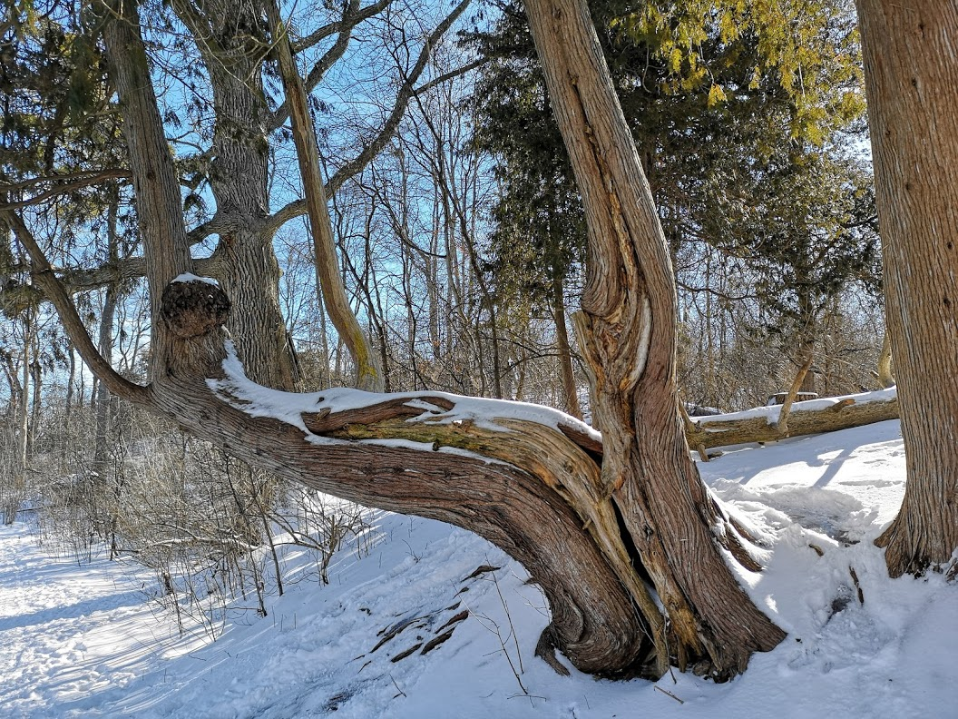
Scripture: Mark 1:21-28 https://www.biblegateway.com/passage/‌?search=Mark%201%3A21-28&version=NRSV
Contemplation and Conversation: What beliefs or ideas do you need to be freed from in order to be more loving?
From Rev. Heather Leffler:
In his commentary on 1 Corinthians 8, my favourite Biblical commentator William Barclay explained beliefs about devils, demons and evils spirits in the time of Jesus. He writes that people believed there were devils and demons in the air that would attach themselves to food in order to possess people. Many people had their meat dedicated in temples to different gods to create a barrier in the meat to prevent this from happening.
While we might not believe there are demons and devils floating in the air waiting to possess us like the man with the evil spirit whom Jesus healed, there is no doubt that there is evil in the world that is spread by spoken and printed word, and especially online posts.
I was very sad to read this morning that a group of protesters in Los Angeles shut down one of the largest vaccination sites in the U.S. in response to misinformation being spread about vaccines. Much harm is done by people spreading misinformation in the name of one cause or another. While having strong convictions is important, imposing our beliefs on others especially in ways that causes harm can never be a loving response.
Might Jesus have been freeing this man from ideas and beliefs that were separating him from others and hurting his neighbours? Whatever spirit had possessed him, we know that Jesus actions restored him to community. May we have the courage to call people who share misinformation that is hurting others.

Whether you are at home trying to help slow the spread of the virus,
working to help care for those who are impacted most by COVID-19
or working to keep some normalcy in this time,
may you know God’s deep and abiding love in your life.
Know you are a valued part of our Rockwood and Stone United Church families.

Further Conversation … Would you like to talk more about today’s reflection? Email Heather at hleffler@rogers.com. Following worship next Sunday, she will invite others to join you in a Zoom break out room to share in further conversation.

From our Rockwood Stone Affirming Discernment Circle
We pray today for the six men who were killed in the Quebec City mosque attack. We pray to for friends and family of those hurt and injured, people who live in fear of attacks because of their faith, and all those all those impacted by the attack.
https://theconversation.com/remembering-the-quebec-city-mosque-attack-islamophobia-and-canadas-national-amnesia-152799?utm_medium=email&utm_campaign=Latest%20from%20The%‌20Conversation%20Canada%20for%20J

United Church of Canada—From Moderator Richard Bott
The road is long,
but each movement takes me onward;
the path is steep,
but I can lean into the earth, and rise;
the way is gloomy,
but my skin feels the sun as it breaks through
the clouds;
hidden or clear,
switchback or straight,
this is the journey we're on...
but one thing I *know*
is that others have travelled,
are travelling,
will travel,
this way...
from messages left,
and glimpses,
and shouts of encouragement,
I *know* I am not alone,
even in my greatest aloneness;
and so I will journey,
and leave my own words,
my own waves,
my own shouts,
to support others along.
Bless now, God, this journey,
from day to day,
and ever on,
for me,
for those who go before,
for those who are yet to come.
Amen.
A gift of belonging to a church is that the practice of gathering together for worship … to pray, sing, listen to scripture and share how God touches our lives – helps us grow in deeper relationship to God and each other. With COVID-19 keeping us at home and physically distant from our Stone or Rockwood families, we are missing each other. We are offering this practice of sharing beyond Sunday morning to deepen our connection. Each week you will be offered a picture, a scripture and a question for contemplation, as well as a short reflection for you to contemplate, have conversation with people in your life and/or join an online conversation on our Rockwood Stone Facebook page.

