Contemplation and Conversation: 3rd Sunday of Easter, April 18, 2021
Scripture: Psalm 4 NRSV https://www.biblegateway.com/passage/?search=Psalm%204&version=NRSV
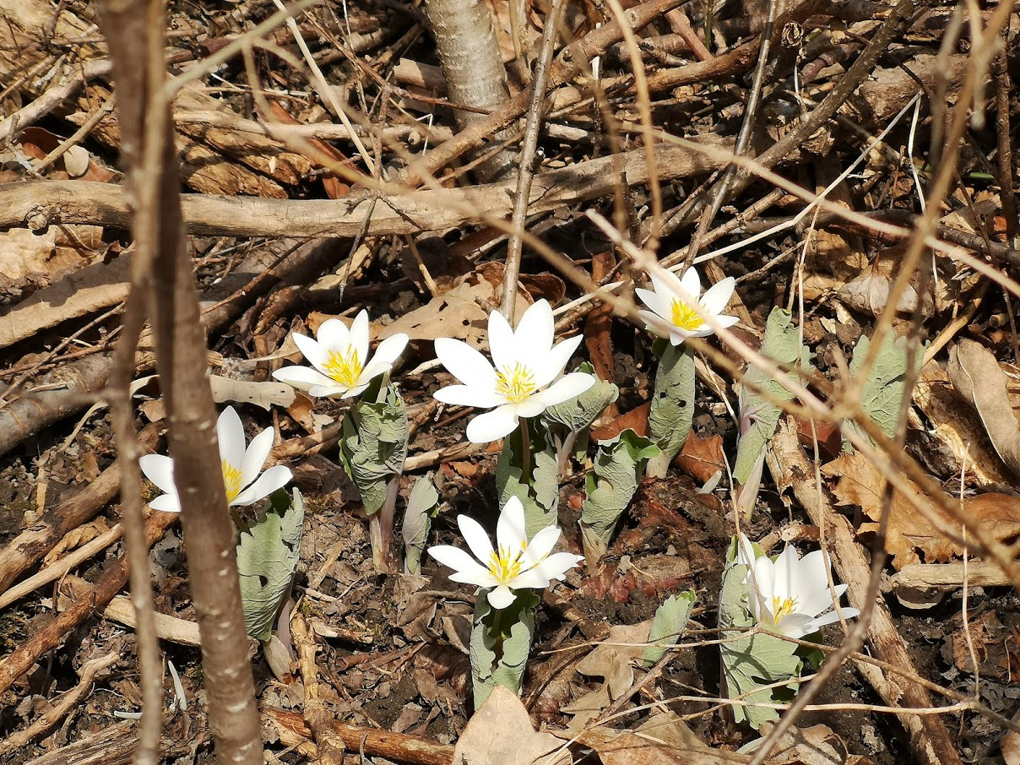
Selah is a Hebrew word of uncertain meaning. It might be an instruction to take a musical break … to pause and reflect on what was said. It can be an invitation to us to pause … breath … and open ourselves to God’s presence with us.
Contemplation and Conversation: How are you today?
From Rev. Heather Leffler:
The Psalms were the Hebrew people’s prayers and hymns to God. At times they offered heartfelt thanks and praise to the Holy One. At other times, they expressed genuine fear, anger and pain to God. The writers and readers of these words shared them trusting God was with them, listening to their prayers and answering in love.
As we are preregistering or receiving vaccines, we expected that things would be getting better. Instead, we find ourselves in the midst of a shutdown with stronger regulations than we experienced with earlier lockdowns. Many of us are weary and longing for an end to this “new” normal. Scripture reminds us again and again that God knows what we are experiencing and walks with us through these challenging times. God welcomes our words of lament and frustration, fear and anger, listens in love and offers us comfort and hope.
In our worship this morning, we shared how we are doing. Being with our friends from Rockwood and Stone and John Arbuckle’s friends from Sudbury, we were reminded that being Children of God means being part of a loving, caring community that holds us in our struggles and joys. The joy of celebrating John’s 100th birthday with old friends and new assures us that we are held in love and prayer.
We don’t know what the Psalmist was experiencing but we know he trusted that God was with him. His confidence invites us to confidently share whatever we are experiencing with God, assured that we are not alone. God is with us in life, in death and life beyond death. Thanks and praise be to God.

Whether you are at home trying to help slow the spread of the virus,
working to help care for those who are impacted most by COVID-19
or working to keep some normalcy in this time,
may you know God’s deep and abiding love in your life.
Know you are a valued part of our Rockwood and Stone United Church families.

Further Conversation … Would you like to talk more about today’s reflection? Email Heather at hleffler@rogers.com. Following worship next Sunday, she will invite others to join you in a Zoom break out room to share in further conversation.


From Guelph-Wellington Women in Crisis
Dear Friends,
Thanks to you, many women and children in our community will have the support they need and safe place to go. The pandemic has shown us many of our community’s most vulnerable are suffering and our services are needed more than ever. Your generosity means the world to us and allows us to continue providing wrap around support to women escaping violence.
Thank you again for your ongoing support of Guelph Wellington Women in Crisis.
Sincerely,
Justine

From the Affirming Discernment Circle
Gay Liberal MP calls on O’Toole to disavow Tory MP’s remark suggesting he’s ‘unclean’
JOAN BRYDEN
OTTAWA
THE CANADIAN PRESS
PUBLISHED 2 DAYS AGO
UPDATED 2 DAYS AGO
A gay Liberal MP is calling on Conservative Leader Erin O’Toole to disavow a remark by one of his caucus members that appeared to suggest he and other LGBTQ people are “unclean.”
Toronto MP Rob Oliphant was indignant Friday after Conservative MP Tamara Jansen responded to a highly personal speech he’d given on a bill to ban the discredited practice of conversion therapy.
Oliphant, a United Church minister, argued that objections to the bill are rooted in the belief that “God made a mistake” when he created people like him and that they should change who they are. He quoted from the Bible to urge MPs to “do justice and to love kindness.”
Jansen responded with a Bible quote of her own: “Woe to you, teachers of law and Pharisees, you hypocrites. You are like whitewashed tombs, which look beautiful on the outside but on the inside are full of the bones of the dead and everything unclean.”
Oliphant retorted that people like him are not “unclean.”
“It is deeply offensive to play Bible baseball like that … It is offensive even to use that word in the context of this debate.”
In an interview later, Oliphant called on O’Toole to disavow Jansen’s comments.
Jansen later said she used the quote “in reference to hypocrisy.”
“I plan to reach out to Mr. Oliphant and apologize for the misunderstanding,” she said in a statement.
The furor erupted during final debate on Bill C-6, which would criminalize the practice of forcing children or adults to undergo therapy aimed at altering their sexual orientation or gender identity.
Liberal, Bloc Quebecois, New Democrat and Green MPs all support the bill.
But some Conservatives have expressed fears that the wording of the bill would outlaw conversations between parents and their children or prohibit young people struggling with their sexual identity from seeking religious or other counsel. O’Toole himself has suggested it needs to be amended and has given his caucus a free vote on the bill.
Oliphant, who kicked off final debate on the bill for the government, said those fears are “tired and worn out” excuses for objecting to the ban on conversion therapy.
“The political rhetoric is they’re trying to not sound like they are still living in the Stone Age, saying they are not against (banning) conversion therapy but just this bill,” he told the Commons.
“It is time to talk truth in this place. If someone is against this bill, they are against me and against people like me. They are saying ultimately that we are less than they are, that somehow God made a mistake when God created us and that we should change who we are or at least consider changing who we are.”
Jansen countered with the story of “Charlotte,” a young woman she’s heard from whose parents had helped her find a counsellor when she decided she no longer wanted “to continue with her lesbian activity” and who now fears the bill would outlaw that kind of support.
Edmonton Conservative MP Michael Cooper prefaced his speech by stressing that conversion therapy is “absurd, it is wrong and it is harmful” and should be banned.
But he went on to argue that the bill’s failure to precisely define conversion therapy means the ban could apply to voluntary counselling and “good faith” conversations between persons struggling with their sexual identity with medical professionals, parents and other family members, religious leaders and others.

United Church of Canada – From Moderator Richard Bott

(My brain gets rather pushy when I suddenly wake up out of a deep sleep. I'm not sure this makes any sense. I guess I'll find out in the morning! I think the words can be sung to "Blessed Assurance"! I hope you are sleeping well.)
The night it has fallen, the dark wraps around,
a quilt of safekeeping in which I am found,
listening to breezes passing on by,
my words of thanksgiving, they float to the sky.
This is my story, my heart beating on,
moving in tune with the Divine song;
this is my story, trav'ling along,
each passing moment, knowing that I belong.
The dawn it is coming, something new on the way,
living Christ's calling, each moment, each day;
actions of loving - God, neighbour as self -
are a forever treasure, yes, my greatest wealth.
This is my story, my heart beating on,
moving in tune with the Divine song;
this is my story, trav'ling along,
each passing moment, knowing that I belong.
Sometimes life is heavy, I feel so alone,
mistakes and mis-steps, my confidence blown;
I grumble my prayers with tears on my face,
and, again, I am shocked by forgiveness and grace!
This is my story, my heart beating on,
moving in tune with the Divine song;
this is my story, trav'ling along,
each passing moment, knowing that I belong.
A disciple of Jesus, a child of God,
an everyday wanderer, in many ways flawed,
and yet I am beloved, called, and set free,
so, Holy Spirit, with you I must be!
This is my story, my heart beating on,
moving in tune with the Divine song;
this is my story, trav'ling along,
each passing moment, knowing that I belong.

A gift of belonging to a church is that the practice of gathering together for worship … to pray, sing, listen to scripture and share how God touches our lives – helps us grow in deeper relationship to God and each other. With COVID-19 keeping us at home and physically distant from our Stone or Rockwood families, we are missing each other. We are offering this practice of sharing beyond Sunday morning to deepen our connection. Each week you will be offered a picture, a scripture and a question for contemplation, as well as a short reflection for you to contemplate, have conversation with people in your life and/or join an online conversation on our Rockwood Stone Facebook page.

