Contemplation and Conversation: 4th Sunday of Easter, April 25, 2021
Scripture: Psalm 23 https://www.biblegateway.com/passage/?search=Psalm%2023&version=NRSV
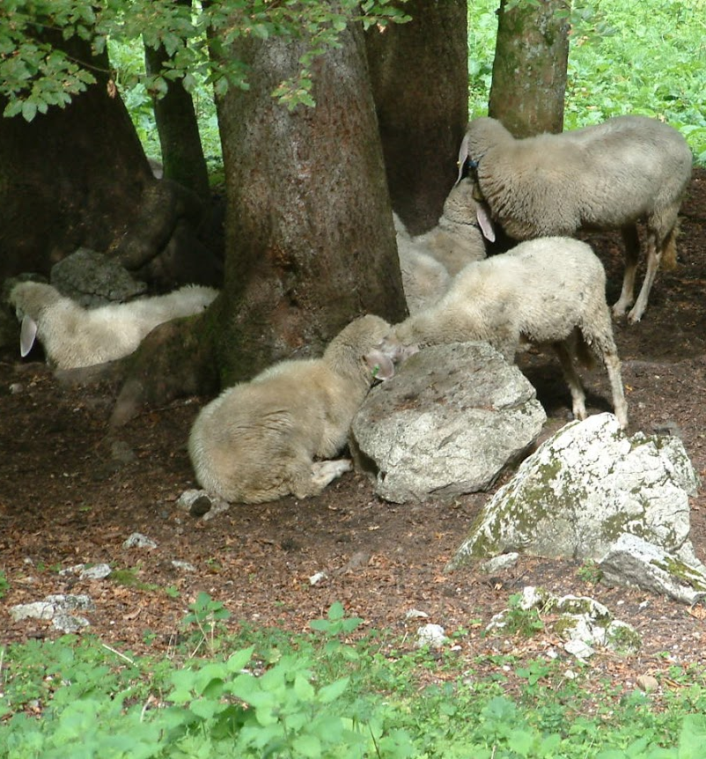
Contemplation and Conversation: How is Jesus offering you comfort and hope today?
From Rev. Heather Leffler:
The familiar words of the 23rd Psalm wash over me and fill me with gratitude and hope.
Even in the midst of the pandemic, I shall not want.
Jesus, my good shepherd, cares for all my needs.
Lockdown is in our safe, comfortable home.
City workers treat and test my water
so that I can enjoy it straight from the tap,
and use it for whatever I need.
Being part of Rockwood and Stone United,
gathering on Zoom, connecting by phone and email
nurtures my soul.
Through our United Church of Canada,
the Spirit nudges us to reach out and share God’s love
to make a difference in the world.
Thank you for being with me in these challenging times.
Knowing you are there to guide and protect me
gives me comfort and hope.
Through essential workers, you provide me with food.
Through scientists, health care workers and volunteers, I received my vaccine.
This lets me face the virus and other things that make I fear.
Spring sunshine and warm rain bathe me in your love.
I trust your steadfast love and forgiveness are mine
in life, in death and life beyond death.
May it be so. Amen.
What does your 23rd Psalm sound like today? Share it with us on Facebook.

Whether you are at home trying to help slow the spread of the virus,
working to help care for those who are impacted most by COVID-19
or working to keep some normalcy in this time,
may you know God’s deep and abiding love in your life.
Know you are a valued part of our Rockwood and Stone United Church families.

Further Conversation … Would you like to talk more about today’s reflection? Email Heather at hleffler@rogers.com. Following worship next Sunday, she will invite others to join you in a Zoom break out room to share in further conversation.

Our Church Family
Harry Doyle (Ione’s partner) from Rockwood will be celebrating his 85th Birthday on May 9th. If you would like to send greetings, please forward them to Ione so that she can share them with Harry at his retirement home. Harry Doyle, c/o Ione Cox 167 Lou’s Blvd. Rockwood, ON N0B 2K0 or kit3@mybluecat.xyz

United Church of Canada – from Moderator Richard Bott on 23rd of April at 23:14
Tonight, I got to pray the words I have been praying daily for others, for myself.
I received my first dose of a vaccine against Covid-19 today. I urge everyone, if you are medically able, to be vaccinated as soon as a vaccine is available to you.
For those who say, "God protects me...," vaccines are one of the ways God does that.
And I'll keep praying this prayer, as people around the world continue to be vaccinated. Feel free to join me.
My God...
bless the hands that hold the needle,
as I give thanks for their care,
bless all those who have brought this vaccine into being,
and those who have gotten it
from there to here;
bless this body that begins the work,
and bless the antibodies it produces,
may they have long and lasting memory,
to protect from COVID's harm.
Thank you for the science and the medicine,
thank you for the researchers, all;
thank you for the gifts that have been given,
may we make certain this gift is available
to *all* the world - the great and the small.
In the name of the Creator,
in the presence of the Healing Christ,
with the grace of the Holy Spirit, I pray.
May it be so.

A gift of belonging to a church is that the practice of gathering together for worship … to pray, sing, listen to scripture and share how God touches our lives – helps us grow in deeper relationship to God and each other. With COVID-19 keeping us at home and physically distant from our Stone or Rockwood families, we are missing each other. We are offering this practice of sharing beyond Sunday morning to deepen our connection. Each week you will be offered a picture, a scripture and a question for contemplation, as well as a short reflection for you to contemplate, have conversation with people in your life and/or join an online conversation on our Rockwood Stone Facebook page.

