Contemplation and Conversation: Palm Sunday 2020
Scripture: Matthew 21:1-11 NRSV https://www.biblegateway.com/passage/?search=matthew+21%3A1-11&version=NRSV
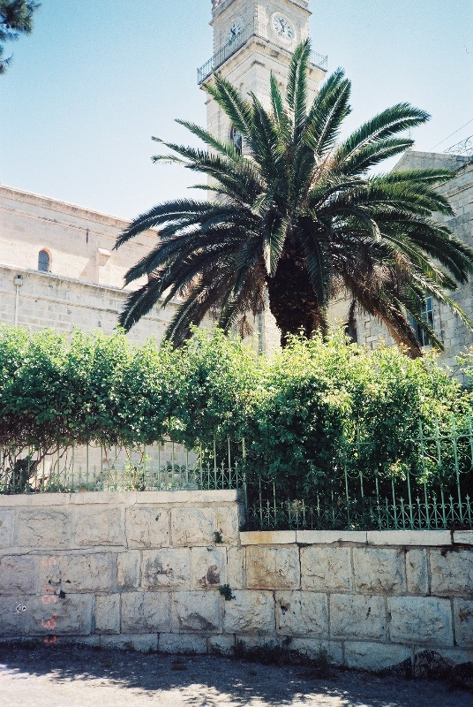
Contemplation and Conversation: What would you ask Jesus for today?
From Rev. Heather Leffler:
Often on Palm Sunday, the sun is shining with the promise of spring and we are waving branches and joyfully sing “Hosanna”. We imagine a parade with Jesus at the head, riding triumphantly into Jerusalem. “Hosanna” has come to be a word of praise and thanks to the Holy One. Pausing to look up the Biblical meaning of “Hosanna” this year, I was struck by its original meaning “Please, save us.” Today it seems good to ask God to save us especially the first responders, care givers and essential workers … heal the sick … receive with open arms those who are dying … comfort their families and friends … guide the politicians and their advisors … and show us how to be Christ to each other in this challenging time. “Hosanna to the Son of David! Save us Jesus!”
Whether you are at home trying to help slow the spread of the virus,
working to help care for those who are impacted most by COVID-19
or working to keep some normalcy in this time,
may you know God’s deep and abiding love in your life.
Know you are a valued part
of our Rockwood and Stone United Church families.
Israel Photo by H. Leffler

Moderator's Online Worship – April 5, 2020
During the COVID-19 pandemic, Moderator Richard Bott offers an online service for those looking to gather with others, pray, and worship together. https://www.united-church.ca/blogs/round-table/moderators-online-worship-april-5-2020

A gift of belonging to a church is that the practice of gathering together for worship … to pray, sing, listen to scripture and share how God touches our lives – helps us grow in deeper relationship to God and each other. With COVID-19 keeping us at home and physically distant from our Stone or Rockwood families, we are missing each other. We are offering this practice of sharing beyond Sunday morning to deepen our connection. Each week you will be offered a picture, a scripture and a question for contemplation, as well as a short reflection for you to contemplate, have conversation with people in your life and/or join an online conversation on our Rockwood Stone Facebook page.

