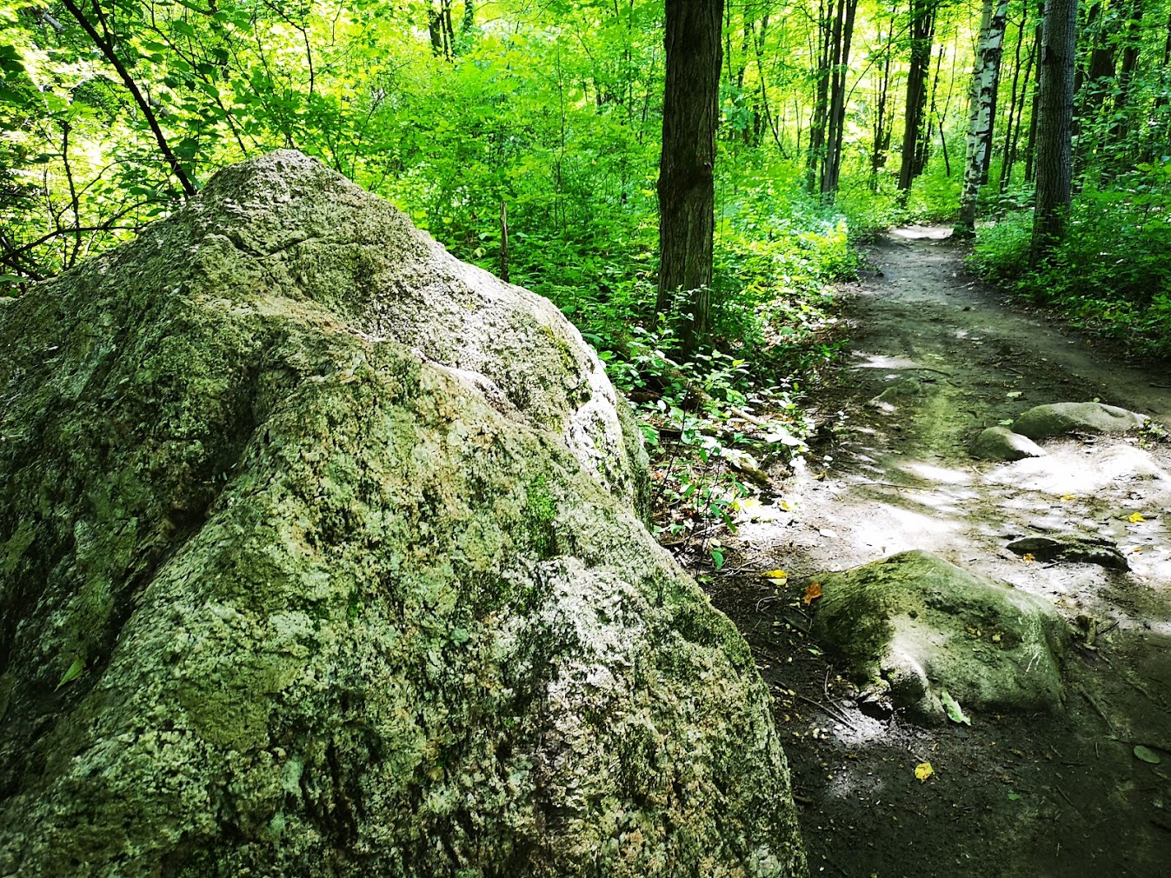
Contemplation and Conversation: World Communion Sunday, October 4, 2020

Scripture: Matthew 21:33-46 https://www.biblegateway.com/passage/?search=Matthew%2021&version=NRSV
Contemplation and Conversation: What stumbling blocks have you let go of, in order to rediscover Jesus is the cornerstone of your life and faith?
From Rev. Heather Leffler:
This is not an easy parable to hear even for those of us who are not Pharisees. The Pharisees heard clearly what Jesus was saying. Throughout history the Jewish people had ignored, rejected and killed prophets God had sent to Israel, believing they knew everything they needed to know. But the Holy One wanted more for God’s people. God imagined a kingdom where everyone would have a place and have enough. Recognizing the words from Psalm 118, the Pharisees knew Jesus was referring to himself as the cornerstone. They couldn’t imagine that he was a prophet from God let alone the long-awaited Messiah – God’s son. What they were sure they knew – that they had the one right path to God – became a stumbling block to them accepting God’s son.
Reflecting back on the history of our church this morning in worship, I was struck by how many times things we are sure of make us stumble and then we rediscover Jesus our cornerstone and begin to build something new. When I was a child, I could not take communion because the church believed that children would not understand this precious gift from God. Then in 1989 a United Church study document called “A Place for You” invited us to imagine Jesus coming to dinner and refusing to let our children come to the table to eat with Jesus. Letting go of our belief that children must fully understand the sacrament and be confirmed before they could join us at the Lord’s Table, we now enjoy the gift of sharing communion with our children and delight when they serve us. Together we grow in understanding this precious gift. May we continue to find the places in our lives and our faith where God is inviting us to let go of what we have believed or the way we have “always” done things to be more loving and inclusive.
Today’s Worship If you would like to view today’s worship, go to https://us02web.zoom.us/rec/play/im-xV87rumUkq877M8xwUJvd2KGbB5BvAMBCh1w9D-dcxYqEYKo8rljtleLtyouLuW91hTFwW4ceQA4L.ZImHqdgKJKv57KCZ?startTime=1601820048000 .

Whether you are at home trying to help slow the spread of the virus,
working to help care for those who are impacted most by COVID-19
or working to keep some normalcy in this time,
may you know God’s deep and abiding love in your life.
Know you are a valued part of our Rockwood and Stone United Church families.

Further Conversation … Would you like to talk more about today’s reflection? Email Heather at hleffler@rogers.com. Following worship next Sunday, she will invite others to join you in a Zoom break out room to share in further conversation.

United Church of Canada
Posted by Moderator Richard Bott on Facebook October 3, 2020
This is not a sprint.
This is not a marathon.
Both of those suggest
that there is a destination,
an endpoint,
a goal.
This is life.
Life that has been.
Life that will be.
Life that is - now.
There are signposts on our travel,
but each of them point
in a myriad of directions,
a multiplicity of possibilities.
There are waystations.
Places of rest and recouperation,
places to share a meal and conversation,
places for a breath, or a moment to stop.
But, pilgrim, this journey is one
where the paths move under your body,
and life, itself, moves you along.
Breathe deeply. Be inspired.
And know that,
on this journey,
you are never, ever, alone.
A gift of belonging to a church is that the practice of gathering together for worship … to pray, sing, listen to scripture and share how God touches our lives – helps us grow in deeper relationship to God and each other. With COVID-19 keeping us at home and physically distant from our Stone or Rockwood families, we are missing each other. We are offering this practice of sharing beyond Sunday morning to deepen our connection. Each week you will be offered a picture, a scripture and a question for contemplation, as well as a short reflection for you to contemplate, have conversation with people in your life and/or join an online conversation on our Rockwood Stone Facebook page.

