Contemplation and Conversation
Thanksgiving Sunday, October 11, 2020

Scripture: 2 Corinthians 9:6-15 https://www.biblegateway.com/passage/?search=2+Corinthians+9%3A6-15&version=NRSV
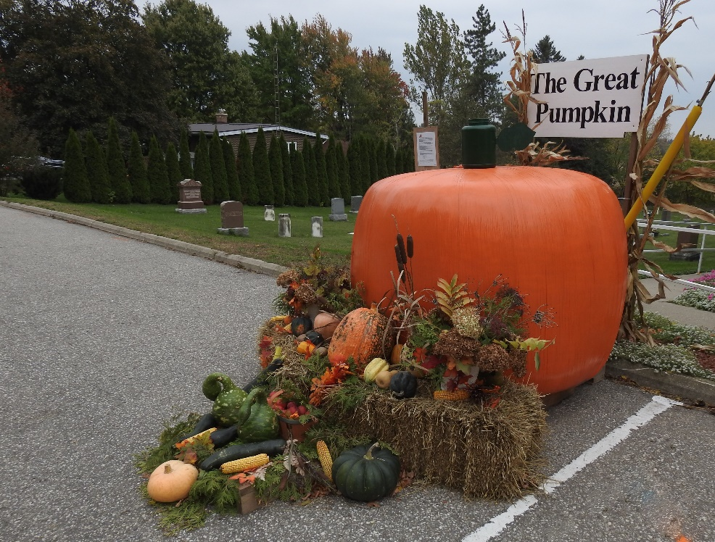
Contemplation and Conversation:
What are you thankful for this Thanksgiving Day?
When have you shared something and received a gift from God in return?
From Rev. Heather Leffler:
Over the years particularly attending stewardship events, I have heard people share amazing stories about the more they give the more they receive. One family was saving for a home but felt called to use some of their savings to help someone in need. Soon after they had the opportunity to purchase a lovely home, they could afford much sooner than they originally expected. Always these stories were shared with deep gratitude to God. Not having my own story to tell, I didn’t know how to share their incredible stewardship. Today as I thought about God supplying all our needs, I realized I have had this experience with sharing my time. When I was a young mom and student studying in Toronto two days a week, I offered to be a companion for my friend’s Week of Guided Prayer. We agreed I would only have two retreatants because of all my commitments that week. Then on the Sunday afternoon a person arrived that hadn’t been expected. I told my friend I was supposed to companion the new participant. He wasn’t sure but agreed. On Tuesday morning I went to the church to meet my retreatants. One drove me to the bus so I could go to school and the next day another picked me up so I could meet with them at their church before I headed home. I was able to participate fully in the week and at the same time go to school and look after my family. Again, and again in my life when I take on something I didn’t plan, the other things in my life fall into place and I give thanks for the Spirit’s guidance in my life. May you know the gift of generosity in your life.

Whether you are at home trying to help slow the spread of the virus,
working to help care for those who are impacted most by COVID-19
or working to keep some normalcy in this time,
may you know God’s deep and abiding love in your life.
Know you are a valued part of our Rockwood and Stone United Church families.

United Church of Canada
October 9, 2020
Fall is in the air these days. In this part of southern Ontario the leaves are changing but not yet at their peak. The weather seems to shift several times a day, the winds are gusty, and the apples, squash, and pumpkins are all ready to eat. In other parts of the country the season is more advanced... I know from my friends in Nunavut that the berry picking is pretty much done because the snow has arrived.
There is a predictability about the change of seasons that is especially welcome this year, when so much of what we are experiencing is not predictable.
We didn’t expect to be experiencing life in a pandemic. We didn’t expect to be celebrating Thanksgiving without getting together with groups of friends and family. We kept thinking that this will all be over soon… and now that “soon” has long past we realize that we don’t know when it will be “over” or actually what things will be like when that time comes.
And yet… we give thanks.
Thanks for the winds and erratic weather and for the yellow, orange, and red leaves that tell us a new season has arrived, as it always does at this time of year.
Thanks for our communities of faith that gather for worship and connection through the amazing electronic tools we have… and for the ministers who lead them.
Thanks for those who work to provide the essential services that the rest of us depend on.
Thanks for the opportunities that the months of social isolation have given for many of us to share more time with those in our own households, and perhaps to pause and think about the things that give life value.
Thanks for the small things that people do for one another in this time, to offer something special or to reach out to someone who is alone.
Thanks for the opportunity we have through Mission & Service to share with those whose needs are greater than our own.
Thanks for the leaders in government and the public health officials who have been working so hard to bring in measures to protect the safety of Canadians and see us through this uncertain time.
Thanks for the funny moments that make us laugh in the midst of it all.
Thanks for good books and streamed movies and yes, even for video games.
Thanks for long walks (especially with dogs).
Thanks for a special meal some time this weekend, even if it is shared around a smaller table.
We give thanks!
O give thanks to the LORD, who is good, and whose steadfast love endures forever.
May God bless you and yours and may you find joy at this Thanksgiving time.
Blessings,
Nora
Nora Sanders is General Secretary of The United Church of Canada.
A gift of belonging to a church is that the practice of gathering together for worship … to pray, sing, listen to scripture and share how God touches our lives – helps us grow in deeper relationship to God and each other. With COVID-19 keeping us at home and physically distant from our Stone or Rockwood families, we are missing each other. We are offering this practice of sharing beyond Sunday morning to deepen our connection. Each week you will be offered a picture, a scripture and a question for contemplation, as well as a short reflection for you to contemplate, have conversation with people in your life and/or join an online conversation on our Rockwood Stone Facebook page.

