Contemplation and Conversation:
20th after Pentecost Sunday, October 18, 2020
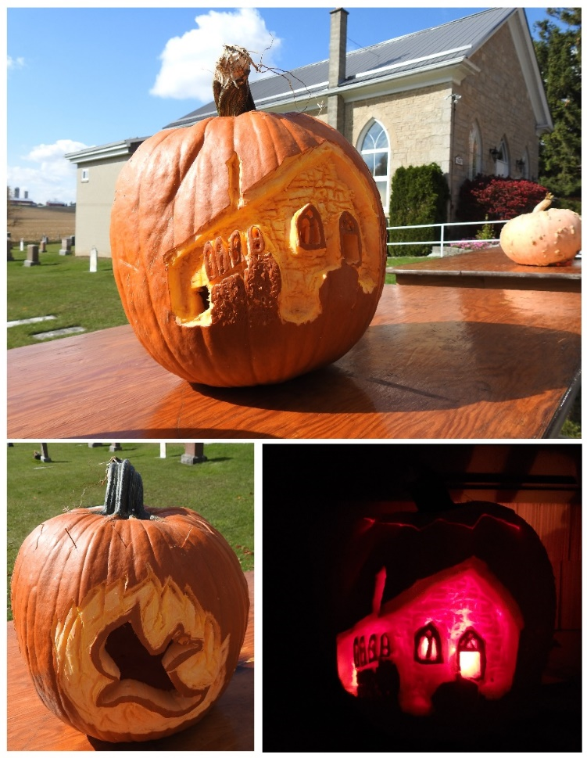
Scripture: Exodus 33:12-23 https://www.biblegateway.com/passage/?search=exodus+33%3A12-23&version=NRSV
Contemplation and Conversation:
Where do you see God at work in your life?
How do you connect with God?
From Lisa Leffler:
Our scripture today asks a question that I think most people of faith have asked at some point, “How do we know that God is with us?” Moses and the Hebrew people were feeling lost and alone and needed the reassurance that God was with them, so God chose to show Godself to them as they passed by.
In a time when we are having to remain physically distanced many of us are feeling lost and alone so how does God reveal Godself in our lives? Like so many things in faith I think the answer to this question is simple yet complicated. God is revealed to us today in many different ways.
God is in the fun and community we experienced in the Foodgrains Pumpkin Growing Contest.
God is in the comfort and companionship in the sharing and listening at Spirit Saturdays.
God is in the care and work of our volunteers that maintain our church properties.
God is in the stillness and silence found in prayer.
God is in the complexity and interconnectedness of all of creation.
Each one of us will experience God in different places and at different times. One of the biggest gifts of a church community is the opportunity to share those experiences so that when someone is feeling distance from God (like we all will at some point) they can be inspired to look for new places to recognize God at work in their lives with the support of a loving a community.

Today’s Worship If you would like to view today’s worship, go to https://drive.google.com/file/d/1S5ZFgzYHIoVPNhy7sSFo3sadw7Mw0gQK/view?usp=sharing .
Sorry about the confusion with the start of worship. Blessings, Heather
To view the Stone’s Pumpkin Project video, go to https://www.rockwoodstoneunitedchurches.com/canadian-food-grains-bank.html.
Whether you are at home trying to help slow the spread of the virus,
working to help care for those who are impacted most by COVID-19
or working to keep some normalcy in this time,
may you know God’s deep and abiding love in your life.
Know you are a valued part of our Rockwood and Stone United Church families.

Further Conversation … Would you like to talk more about today’s reflection? Email Heather at hleffler@rogers.com. Following worship next Sunday, she will invite others to join you in a Zoom break out room to share in further conversation.

United Church of Canada
World Food Day Prayer by Michael Shewburg
Creator of all that is, all that has ever been, and all that will ever come, in the season we know in the North as autumn, we offer gratitude for the cycle of the seasons. In this season we begin to reap what we have sown, tended to, prayed over, and fretted on. In all of this, we know that you have been there, watching over your creation and all its creatures.
We lament over crops that were lost this year, to drought, and hail, and floods, to frost, to lack of workers, to pandemic. We lament over crops that were never planted, where farmers could not access their land or do not have the privilege to acquire land. Help us to stand in solidarity with farmers whose harvest never came to yield; help us to see land not as a resource to use, but as a gift to share.
As the leaves begin to turn brilliant reds, oranges, and yellows, we begin to pull from the ground the fruit of our labour. The potatoes, squash, brussels sprouts, cabbage, apples, pears and more begin to fill our baskets. We give thanks. The corn and beans are ready to be stored; they have dried on their stocks. We know that these foods will sustain us through the winter.
We give thanks for labourers who have come to harvest, workers from near and far, many who travel to this land to find work. Sustainer, open our eyes to their sacrifice and help us to honour their gift. We pray for a safe harvest for all labourers and farmers.
As the honeybee prepares for winter, we enjoy honey’s nectar sweetness. As the broiler chicken is fully grown, we give thanks for their life that will sustain us. As the hunter patiently awaits the deer, we honour its gift as nourishment.
Creator, we are called back to remember our interconnectedness during this harvest season. Forgive us the times that we have been disconnected from our relations in our desire to take more than we should. Call us back into the fabric of creation so that we might live in the abundance of life.
For all this, and more, we give thanks.
Amen.
―Michael Shewburg is Executive Director of Five Oaks and lives on an organic farm with his farming partner Ryan and son Marshall.
A gift of belonging to a church is that the practice of gathering together for worship … to pray, sing, listen to scripture and share how God touches our lives – helps us grow in deeper relationship to God and each other. With COVID-19 keeping us at home and physically distant from our Stone or Rockwood families, we are missing each other. We are offering this practice of sharing beyond Sunday morning to deepen our connection. Each week you will be offered a picture, a scripture and a question for contemplation, as well as a short reflection for you to contemplate, have conversation with people in your life and/or join an online conversation on our Rockwood Stone Facebook page.

