Contemplation and Conversation: All Saints Day, November 1, 2020

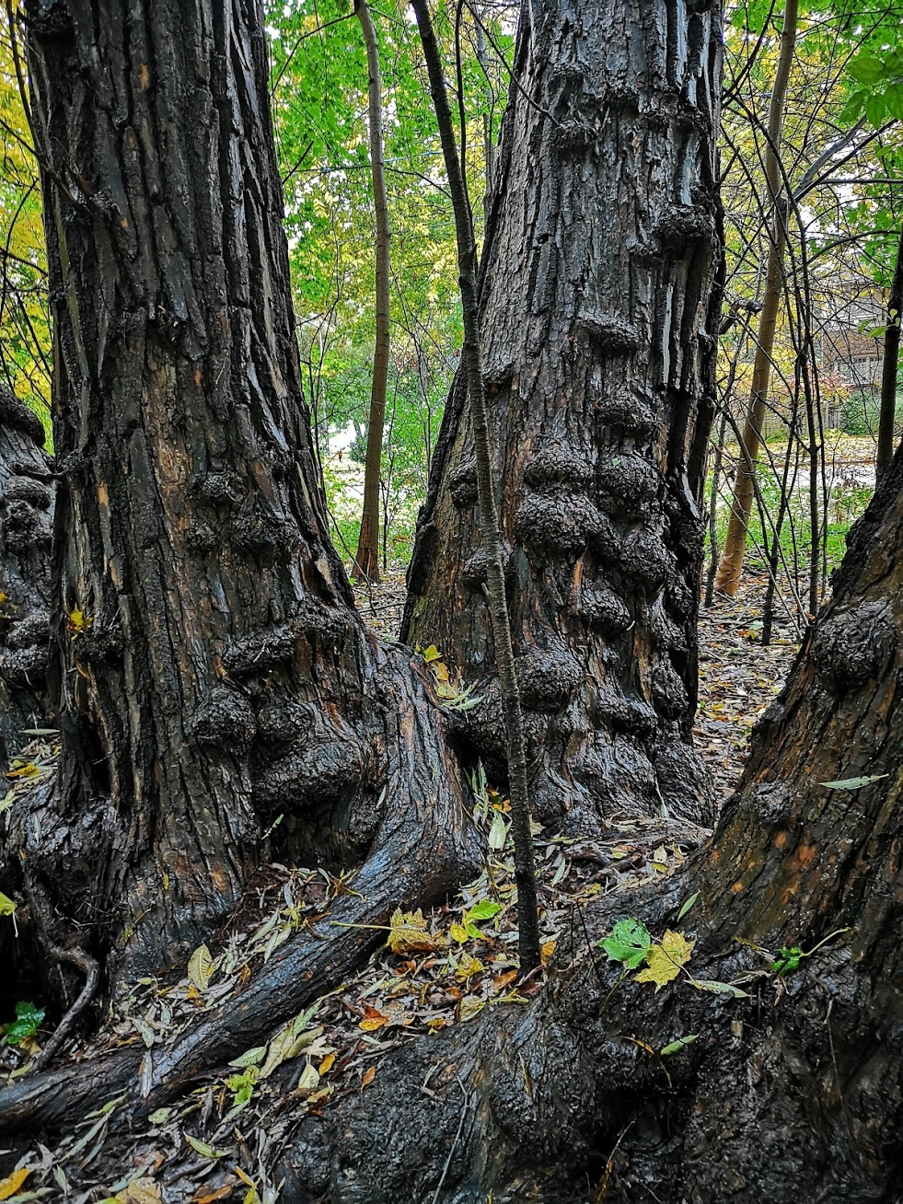
Scripture: Psalm 34 1-10, 22 (NRSV) https://www.biblegateway.com/passage/?search=Psalm+34%3A1-10%2CPsalm+34%3A22&version=NRSV
Contemplation and Conversation: Who are the people who have shaped your faith?
From Rev. Heather Leffler:
On this All Saints Day, I am so aware of the gift of knowing God in my life. Knowing that God answers our prayers when we are sick or afraid, lonely or grieving, in need or in trouble. Knowing that God sends people into our lives to tell us stories of faith and the stories of how God is at work in their lives, so we can recognize God’s Spirit at work in our own lives.
When Lisa and I were walking on Friday, we passed a woman who reminded us of a beloved member of our congregation. When we passed the woman a second time, she spoke, and her voice too reminded us of our friend. Thanks to this nudge from the Spirit, I called, and our friend and I had a wonderful visit.
As I ponder the people who nurtured my faith as a child and those who continue to invite me into a deeper relationship with God through new spiritual practices, I am aware of the times I hesitated to invite someone to church. Are they busy on Sunday mornings? Would they be interested? Would I offend them? My excuse since I entered ministry has been that I don’t know how good the preacher is. What I do know is that being part of congregation has meant so much to me and our family. As I give thanks today for those who have nurtured my faith, I pray I can move passed my excuses to invite others to come to know God’s love in their lives and the gift of becoming part of our congregations of Rockwood and Stone that are making a difference in the world.

Today’s Worship If you would like to view today’s worship, go to https://us02web.zoom.us/rec/play/3D_BW7axaJ1NQXCh3jKGmcamAT6b9lLqzBVHb37ZyR2j4J6FNs6k7aieLUi7ToiqKm3X6g1_b-jQZv7M.bdyhQrSJwP5MScM8?autoplay=true&startTime=1604243567000 .
Whether you are at home trying to help slow the spread of the virus,
working to help care for those who are impacted most by COVID-19
or working to keep some normalcy in this time,
may you know God’s deep and abiding love in your life.
Know you are a valued part of our Rockwood and Stone United Church families.

Further Conversation … Would you like to talk more about today’s reflection? Email Heather at hleffler@rogers.com. Following worship next Sunday, she will invite others to join you in a Zoom breakout room to continue the conversation.

From our Rockwood Stone Affirming Discernment Circle
On Rocking the Boat
It amazes me, that from time to time; some Christians use the phrase, ‘don’t rock the boat’, when that is a distinctly un-Christ-like position to take. My Jesus was a radical revolutionary. My Jesus consorted with thieves, prostitutes and tax collectors. My Jesus held the hands of the unclean, both in body and soul. My Jesus not only rocked the boat, He invited Peter to step out of it in faith. (Matthew 14:29) Christ’s church is not charged with maintaining the status quo; it is challenged to completely and utterly overthrow the establishment and rebuild one based on the love of our God and each other. Understandably that is a scary position to be in, but we need not be afraid. In another boat, in the midst of a terrible storm, we learn that even the winds and the waves obey our Saviour. (Matthew 8:26) A rocking boat should be the least of our worries; whereas the love of our Creator and of each other should be of vital concern and interest to all those who bear His name.
We see a wonderful example of God’s love in the rainbow, which is a symbol of the covenant between Creator and all of creation. (Genesis 9:13) Whenever I see a rainbow, I feel that love which includes all the people of God whether they live in the village or on the margins. Perhaps there is no better way of advertising the ministry and mission of Christ’s church than emblazoning rainbows on our signs to show that we honour and affirm this covenant. The affirmation of a rainbow is meant for all the sons of Adam and daughters of Eve; do not be deceived into thinking that it denotes a small segment of creation. However, be vigilant in your radical inclusivity because if one of us is excluded, the covenant is weakened for all.
Often the Bible story that is the most challenging for ‘comfortable’ folk is when Jesus turns over the tables in the temple and chases out the moneylenders. Sadly, we have let the power of money rule in the house of God once again.
Laughingly we cite ‘the new Golden Rule’ he who has the gold makes the rules... ha ha. But that isn’t what Jesus taught. When the moneylenders had been chased out he said, “My house will be called a house of prayer for all people (Mark 11:17) – that is all the people who God loves and who are affirmed in that love with the sign of a rainbow.
Jesus did not value power, or position, or even affluence; some of his greatest battles were against the influential Pharisees. Jesus healed on the Sabbath and that annoyed the people in power. Jesus touched bleeding women, and that really ticked them off. Jesus also accused the Pharisees of loving money more than they loved their God. Jesus told them they couldn’t serve both God and Money (Luke 16:13) and neither can his church.
So ultimately the decision is not about whether one small church, in one small town, puts one small rainbow, on one small sign; it is about whether we as bearers of Christ’s name will step out of the boat in love, unity and faith and hold Jesus’ church up as a beacon of inclusivity for all to see. There may be storms, some may choose a different path, but never let it be said that we choose to act out of love of money, over the love of God, whatever the consequences.
In closing I would encourage you not to conflate the importance of one’s ministry with its length. Thus far the message which Jesus brought has lasted 670 times longer than His ministry.
I remain,
In His Service and assured of His Love
Kathleen Sorensen
From the Affirm United Website https://affirmunited.ause.ca/worship-resources/.
If you would like to talk more about this reflection or what it means to become an affirming church, contact a member of the Discernment Circle Brent Stiles, Barb Eley, Marion Bascom, Lisa Leffler, Liz Guthrie or Brian Mack.
United Church of Canada
As we gather to worship God today,
and commemorate and celebrate
all of God's saints,
and all of the world's souls,
we hold in prayer the people killed,
those injured, and
all who are grieving,
following the sword attack in Quebec City
on Halloween night.
God of all love,
where healing is needed,
be present in the hands and hearts
of the healers;
where grief overwhelms,
be present in the eyes and tears
of those who remember;
where safety is needed,
be present in the bodies and minds
of those who protect.
As disciples of Jesus,
we pray for your hurting world.
Amen.
From Moderator Richard Bott

A gift of belonging to a church is that the practice of gathering together for worship … to pray, sing, listen to scripture and share how God touches our lives – helps us grow in deeper relationship to God and each other. With COVID-19 keeping us at home and physically distant from our Stone or Rockwood families, we are missing each other. We are offering this practice of sharing beyond Sunday morning to deepen our connection. Each week you will be offered a picture, a scripture and a question for contemplation, as well as a short reflection for you to contemplate, have conversation with people in your life and/or join an online conversation on our Rockwood Stone Facebook page.

