Contemplation and Conversation:
Remembrance Sunday, November 8, 2020
Scripture: Joshua 24:1-3a, 14-25 https://www.biblegateway.com/passage/?search=Joshua+24%3A1- 3a%2C+14-25&version=NRSV
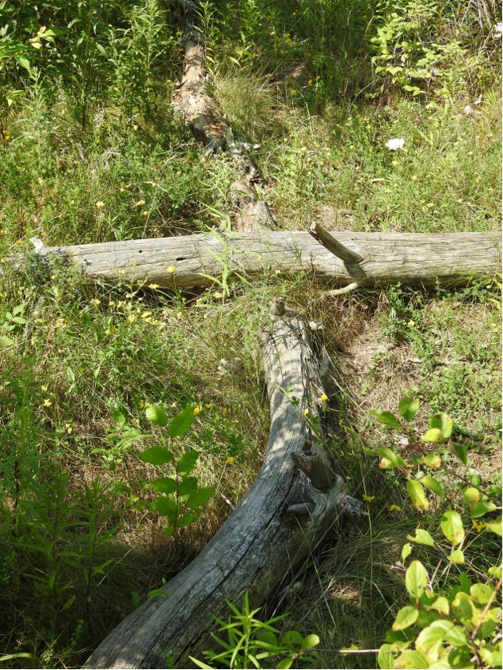
¹Then Joshua gathered all the tribes of Israel to Shechem, and summoned the elders, the heads, the judges, and the officers of Israel; and they presented themselves before God. ² And Joshua said to all the people, “Thus says the Lord, the God of Israel: Long ago your ancestors—Terah and his sons Abraham and Nahor—lived beyond the Euphrates and served other gods. ³ Then I took your father Abraham from beyond the River and led him through all the land of Canaan and made his offspring many. I gave him Isaac;
Photo by Lisa Leffler
¹⁴ “Now therefore revere the Lord, and serve him in sincerity and in faithfulness; put away the gods that your ancestors served beyond the River and in Egypt, and serve the Lord. ¹⁵ Now if you are unwilling to serve the Lord, choose this day whom you will serve, whether the gods your ancestors served in the region beyond the River or the gods of the Amorites in whose land you are living; but as for me and my household, we will serve the Lord.”
¹⁶ Then the people answered, “Far be it from us that we should forsake the Lord to serve other gods; ¹⁷ for it is the Lord our God who brought us and our ancestors up from the land of Egypt, out of the house of slavery, and who did those great signs in our sight. He protected us along all the way that we went, and among all the peoples through whom we passed; ¹⁸ and the Lord drove out before us all the peoples, the Amorites who lived in the land. Therefore we also will serve the Lord, for he is our God.”
¹⁹ But Joshua said to the people, “You cannot serve the Lord, for he is a holy God. He is a jealous God; he will not forgive your transgressions or your sins. ²⁰ If you forsake the Lord and serve foreign gods, then he will turn and do you harm, and consume you, after having done you good.” ²¹ And the people said to Joshua, “No, we will serve the Lord!” ²² Then Joshua said to the people, “You are witnesses against yourselves that you have chosen the Lord, to serve him.” And they said, “We are witnesses.” ²³ He said, “Then put away the foreign gods that are among you, and incline your hearts to the Lord, the God of Israel.” ²⁴ The people said to Joshua, “The Lord our God we will serve, and him we will obey.” ²⁵ So Joshua made a covenant with the people that day, and made statutes and ordinances for them at Shechem.
Contemplation and Conversation: How do you live out your faith in your community?
From Brian Mack:
An unexpected package arrived on my doorstep on Thursday. It contained the eulogies that were spoken at the recent funerals of my Aunt Lorna and my Uncle Harold along with two small keepsakes. In both the eulogies special mention was made of the importance of faith in their lives. Zion Lutheran Church in North Battleford was described as their second home—a place where they developed special relationships with various Pastors and their young families, a place where their voices could rise in song in the choir, a place where they helped prepare food for the marginalized, a place where they swapped stories at coffee time before the service, a place where they kept track of friends facing the ups and downs of everyday life, and a place where they felt supported during times of illness and mourning. Within the walls of the church, they served the Lord.
Perhaps more importantly, they took their faith into the wider community. On their many walks downtown or in the mall which they frequented, they took time to share a story or a joke with people they knew or with complete strangers. They always chose to see the best in people or in difficult situations. Without any thought of recompense, they helped where they could by using their culinary and mechanical talents to aid new families getting started on their street. They provided a nurturing atmosphere for their grandchildren and great grandchildren who looked forward to going to church and social outings with them. They brought joy into the lives of many young people outside their family circle, especially after retirement, by teaching youngsters how to ballroom dance, how to fish, how to set up a tent, how to clean up after themselves, how to water ski, and how to respect God’s creation. Within the community, they served the Lord.
The faith which was nurtured through their association for fifty-five years with Zion Lutheran enabled my Aunt and Uncle to put things in perspective and to make the world a better place one little giggle, one little story, or one “love ya” at a time. Thanks be to God.

Whether you are at home trying to help slow the spread of the virus,
working to help care for those who are impacted most by COVID-19
or working to keep some normalcy in this time,
may you know God’s deep and abiding love in your life.
Know you are a valued part of our Rockwood and Stone United Church families.

Further Conversation … Would you like to talk more about today’s reflection or the information from the Affirming Discernment Circle? Email Heather at hleffler@rogers.com. Following worship next Sunday, she will invite others to join you in a Zoom breakout room to continue the conversation.

United Church of Canada
We offer to you, O God, our prayers for those who seek justice and resist evil. We pray for those who need your presence and strength to stand firm; for those who are oppose the use of violence in any form in faithful response to the Prince of Peace. We pray for those are prepared to be firm to protect those in danger. We pray for those who walk with others who need strength. We pray for those who protest, those who organize letter campaigns, those who give sacrificially on behalf of others.
We pray for those who speak the unpopular truth; who protect the unpopular victims; who choose the unpopular path of peace.
We pray for those who do not let their desire for peace hinder the requirements of justice, and for those who do not let their zeal for justice override the call for peace.
From "On This Day of Remembrance," prayers for Remembrance Sunday by the Rev. Dr. Neil Parker, military chaplain at the 4th Canadian Division Training Centre in Meaford, ON https://www.united-church.ca/prayers/prayer-people-courage
From our Rockwood Stone Affirming Discernment Circle
When I was little my mom dressed my sisters and I in plain tracksuits and kept our hair cropped short. Anyone who knows me now will know that was really not my style. I have always preferred to wear dresses and clothes that our society considers more feminine. So, clothing was always a point of contention in our house. It was made so much worse by the fact that it was not uncommon for people to see our short hair and say, “What lovely little boys!” It hurt to be misgendered.
And yet when I first learned about non-binary genders and the use of pronouns other that “he/him” or “she/her” it was a little beyond my understanding. But through educational resources (videos, books, articles, etc.) and conversations with people who are non-binary, I began to realize that they are as confident that they don’t fit into one gender as I was that I was a girl every time I was misgendered.
So, the question for me shifted from “What does non-binary, two-spirited, transgendered, etc. even mean?” to “How can I shift my speech patterns to avoid causing hurt to others by misgendering them?”
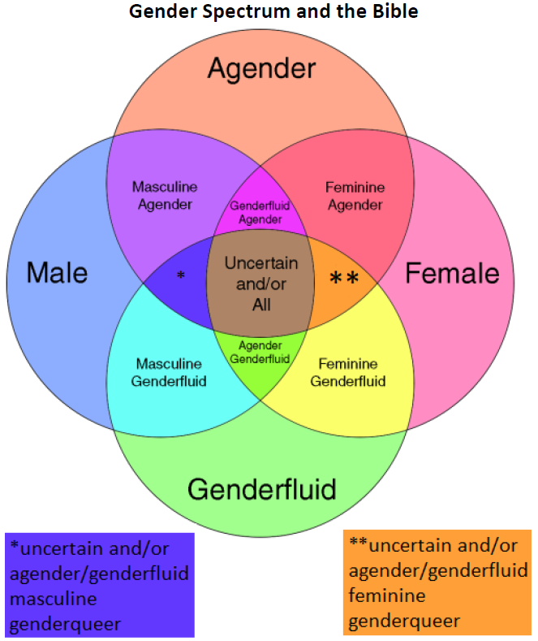
I think the most important thing to remember when it comes to gender is to ask not to assume. Most people will be happy to tell you their pronouns if you simply ask. In a video I watched recently a transgender woman suggested a great way to ask the question. She said when you are introducing yourself, offer your own pronouns as a way to open the conversation without putting pressure on the other person.
As our understanding of and language around gender continues to evolve, it can feel like a lot to learn. But a small bit of effort in learning can make a big difference in making someone feel accepted and included.
One resource that has helped to understand the gender spectrum a little more fully is the chart below. This chart may contain terms you have never heard of before and that’s okay. The Affirming Discernment process is a chance for us all to learn and grow.
If you would like to explore this topic further, please email hleffler@rogers.com so we can set up a time for a discussion group. – Lisa Leffler

A gift of belonging to a church is that the practice of gathering together for worship … to pray, sing, listen to scripture and share how God touches our lives – helps us grow in deeper relationship to God and each other. With COVID-19 keeping us at home and physically distant from our Stone or Rockwood families, we are missing each other. We are offering this practice of sharing beyond Sunday morning to deepen our connection. Each week you will be offered a picture, a scripture and a question for contemplation, as well as a short reflection for you to contemplate, have conversation with people in your life and/or join an online conversation on our Rockwood Stone Facebook page.

