Contemplation and Conversation: Christ the King Sunday, November 22, 2020
Scripture: Psalm 100 NRSV https://www.biblegateway.com/passage/?search=Psalm%20100&version=NRSV
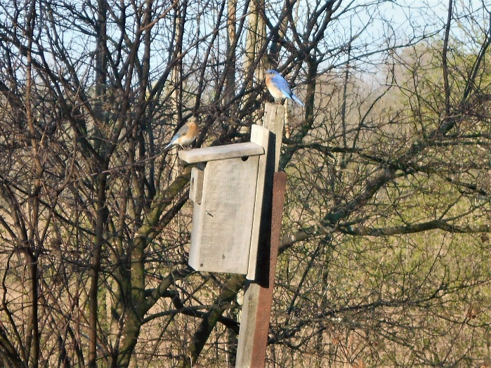
Contemplation and Conversation: What fills your heart with song?
From Karen Richardson:
In loving memory of my brother Stan who passed on November 21, 2019.
I chose Psalm 100 from the lectionary for this contemplation because lately I’ve become very aware of what music means in my life. After years of it “living” in the basement I brought my record player (from the 70s) up to the main floor and started going through my 45s and albums. It amazed me how I was able to sing along to songs some of which I had not heard in decades and yet there are times I can’t remember what I did yesterday. My brother died a year ago and the week before his passing, a friend of his from high school came to visit – one of their things was for one of them to sing ‘You take the high road’ and the other would respond with ‘and I’ll take the low road’. My brother who at that stage was not very verbal heard Chris singing ‘You take the high road’ and immediately responded ‘and I’ll take the low road’. We often hear how important music is to those with dementia. Music can touch our souls in a very meaningful way. Hearing Patty and Randy sing Hallelujah or singing Go Now in Peace are just two examples of how music is a spiritual experience for me and often bring tears to my eyes.
During these times the first verses “Sing to the Lord, all the world! Worship the Lord with joy; come before him with happy songs!” sound like a stretch. One of the things I miss most about worshipping in the church is singing hymns together. The music that has been offered through ZOOM has been a gift but somehow not quite the same as singing along with the congregation. As we head into winter, being able to count our blessings will help to get us through. Remembering that a lot of things have been able to continue, that we have made more and deeper relationships through our circle of care, being able to meet as a charge and not just individual congregations, enjoying the meals, and celebrating the ways the congregations have continued their outreach just to name a few. I think it is more important than ever to celebrate what gives us joy and as Mark Twain said, ‘to sing like no one is listening’.

Whether you are at home trying to help slow the spread of the virus,
working to help care for those who are impacted most by COVID-19
or working to keep some normalcy in this time,
may you know God’s deep and abiding love in your life.
Know you are a valued part of our Rockwood and Stone United Church families.

Further Conversation … Would you like to talk more about today’s reflection? Email Heather at hleffler@rogers.com. Following worship next Sunday, she will invite others to join you in a Zoom break out room to share in further conversation.

From our Rockwood Stone Affirming Discernment Circle
Jesse Thistle is the author of “From the Ashes”. He is a Metis man who struggled with addiction as a young adult. In the following videos he shares his wisdom and learning from the experience.
In the first video he highlights some key learnings from his time living on the street. In the second video he goes more in depth into his story and talks about the affects of generational trauma.
https://www.youtube.com/watch?v=Dw4rLBNwOL4&feature=emb_logo
https://www.youtube.com/watch?v=k1ndIigCTcE

United Church of Canada
Moderator Richard Bott November 21, 2020
The Executive of the United Church of Canada General Council today apologized for its role in separating mothers from their babies in maternity facilities under its leadership from the end of World War II to 1980.
The apology also stressed that these adoptive practices deprived men of their right to know their children, while the children themselves never had the opportunity to know their family of origin and very often the environment they were from.
With this apology the United Church commits to implementing a four-pronged plan aimed at confronting any belief that promotes shame, honoring the dignity of every human being, offering support to families and "promoting values of truth and openness as well as to foster healing and reconciliation for all those who have been affected by adoption. "

A gift of belonging to a church is that the practice of gathering together for worship … to pray, sing, listen to scripture and share how God touches our lives – helps us grow in deeper relationship to God and each other. With COVID-19 keeping us at home and physically distant from our Stone or Rockwood families, we are missing each other. We are offering this practice of sharing beyond Sunday morning to deepen our connection. Each week you will be offered a picture, a scripture and a question for contemplation, as well as a short reflection for you to contemplate, have conversation with people in your life and/or join an online conversation on our Rockwood Stone Facebook page.

