Contemplation and Conversation: 11th Sunday after Pentecost, August 8, 2021
Scripture: Ephesians 4:25-5:2 https://www.biblegateway.com/passage/?search=Ephesians%204%3A25-5%3A2&version=NRSV
Contemplation and Conversation: What do you do with angry words?
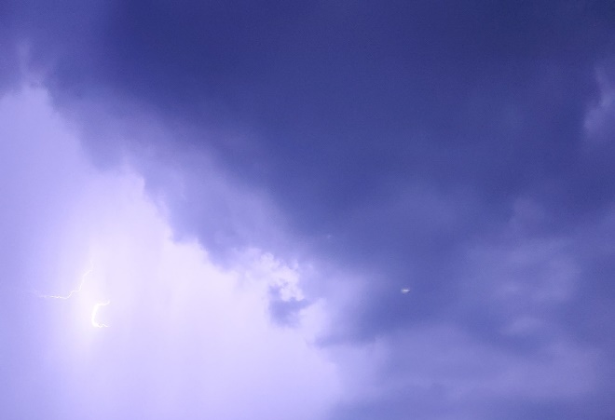
From Rev. Heather Leffler:
Paul is clear that our words matter. When we use angry or hurtful words, when we omit or stretch the truth, he wants us to know we hurt not only the person we are speaking to but ourselves, and sometimes our families and communities. Paul urges us to build each other up instead of tearing each other down.
What can we do when angry or hurtful words boil up inside us? Holding in our emotions can be just as devasting for our health and can also hurt relationships. Remembering Jesus’ asking God to forgive those who condemned him to death offers us a model for us but before we can move to that place, we may need another model.
The Psalmist and Job invite us to share words of anger, pain and lament with God, trusting God will hear us and help us heal. Being able to share what we are experiencing can help us move passed our pain. Finding someone who will listen without judgment – a counsellor or spiritual director, a trusted friend or family member – can help us begin to heal.
In this time, when emotions are raw, and relationships are stretched to the limit, may we trust that the Holy One will receive whatever words we need to share, and may we find people who can listen.
Whether you are at home trying to help slow the spread of the virus,
working to help care for those who are impacted most by COVID-19
or working to keep some normalcy in this time,
may you know God’s deep and abiding love in your life.
Know you are a valued part of our Rockwood and Stone United Church families.

Further Conversation … Would you like to talk more about today’s reflection? Email Heather at hleffler@rogers.com. Following worship next Sunday, she will invite others to join you in a Zoom break out room to share in further conversation.

Our Rockwood Stone Family
Did you miss this year’s Rockwood Stone Garden Tour? It’s not to late to enjoy a video tour on YouTube https://youtu.be/lHP3lRsael0.

United Church of Canada from Moderator Richard Bott on August 4 at 11:57
Sing praise to God,
si-ng out to the Three who are One;
join with the cry of the hawk,
with the moon and the sun;
as the rivers dance on,
and the oceans' waves crash on the shore;
let your love be the guide of your life,
all the world to adore.
Oh, sing out your wonder and hope
in what is to come!
Go where the Spirit's bright wings urge you on,
and your heart starts to thrum;
be the healers, the lovers,
transformers God calls you to be;
and in the healing, the loving, find all
you need to be free!
Sing praise to God,
to the One, the One who is three;
Creator, Christ, Spirit-Holy,
the Great Trinity!
To our Love, who is within,
around, betwixt and between;
to the Holy, the Sacred, the Great
Mystery Unseen!
Tune: Irish folk song, "Buachaill On Eirne" (or "Come by the hills") #mod43hymn

A gift of belonging to a church is that the practice of gathering together for worship … to pray, sing, listen to scripture and share how God touches our lives – helps us grow in deeper relationship to God and each other. With COVID-19 keeping us at home and physically distant from our Stone or Rockwood families, we are missing each other. We are offering this practice of sharing beyond Sunday morning to deepen our connection. Each week you will be offered a picture, a scripture and a question for contemplation, as well as a short reflection for you to contemplate, have conversation with people in your life and/or join an online conversation on our Rockwood Stone Facebook page.

