Contemplation and Conversation: 24th Sunday after Pentecost, November 7, 2021
Scripture: Psalm 127 https://www.biblegateway.com/passage/?search=Psalm%20127&version=NRSV
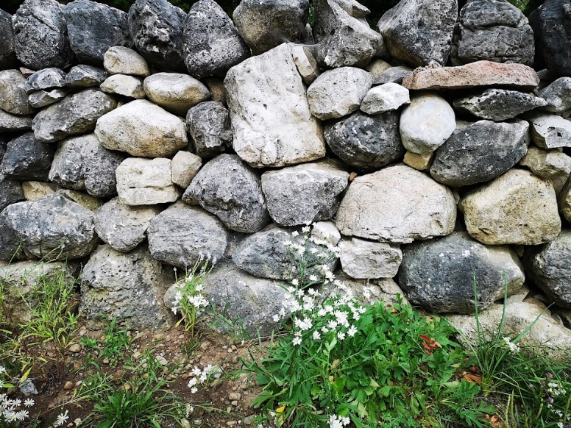
Contemplation and Conversation: What might you ask God build in your life?
From Rev. Heather Leffler:
Psalms speak to us in many different ways depending on where we are in our lives. I might have avoided this particular Psalm at another time, not wanting to focus on arrows, warriors and enemies at the gate. In this later half of my life, I hear the Psalmist’s words as a gentle reminder to invest my time, energy and resources in relationships.
Just as Zoom has taught us that the church is the people who gather to worship and work together not the building or electronic space that we gather in. The home God builds for us is our family, our church family and the precious groups of neighbours, friends and co-workers with whom we share loving, life-giving relationships. These sustain us through university dorms, first time homes, homes to raise our families, condos, apartments and rooms in retirement villages. The places we live in are only temporary. While we need to invest some resources in them, the Psalmist encourages us to save our best for what God is building. The relationships God offers us, like our relationship with the Holy One are with us in life, in death and life beyond death.
May we be guided by the Spirit to build those relationships where we will not only loving nurture one another but encourage us to look outward to care for God’s creatures and creation. Amen.
Whether you are at home trying to help slow the spread of the virus,
working to help care for those who are impacted most by COVID-19
or working to keep some normalcy in this time,
may you know God’s deep and abiding love in your life.
Know you are a valued part of our Rockwood and Stone United Church families.

United Church of Canada Published On: July 26, 2021
As the night gets deeper,
and the stars shine bright,
my heart celebrates,
as I remember all those
who have lived their lives,
all those who have moved and had being,
enmeshed by your love,
God of all creation.
I celebrate those who have held on
to what needed to be held on to!
I celebrate those who made change,
those who reformed,
those who helped us to shake off
what we had created
that got in the way of living your love,
God of all creation.
May your church be reformed again,
transmuted and transfigured,
shaken, stirred, and
rocked to its core.
Once more, help us, we pray,
to let go of everything
that keeps us
from living the Creator's love,
from following the way of Christ's disciples,
from flying where the Holy Spirit carries us...
from all that keeps us
from loving all your creation,
as you have loved us.
Re-form us, loving God!
Amen
A gift of belonging to a church is that the practice of gathering together for worship … to pray, sing, listen to scripture and share how God touches our lives – helps us grow in deeper relationship to God and each other. With COVID-19 keeping us at home and physically distant from our Stone or Rockwood families, we are missing each other. We are offering this practice of sharing beyond Sunday morning to deepen our connection. Each week you will be offered a picture, a scripture and a question for contemplation, as well as a short reflection for you to contemplate, have conversation with people in your life and/or join an online conversation on our Rockwood Stone Facebook page.

