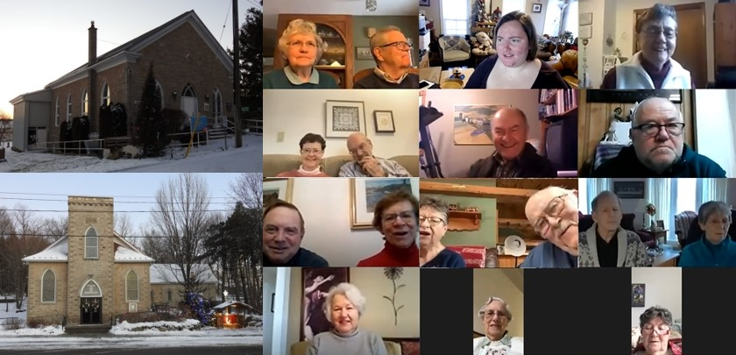
Contemplation and Conversation: Baptism of the Lord, January 9, 2022

Scripture: Psalm 29 https://www.biblegateway.com/passage/?search=Psalm+29++&version=NRSV
Contemplation and Conversation: What brings you to worship? Has this changed over the years?
From Brian Mack:
In his book entitled Giving to God, Mark Allan Powell lists a variety of reasons as to why people stop coming to church. Some people complain about the order of service. Others sight internal squabbling. Some argue that the church is too liberal while others argue that it is too conservative. Some would say that the services are boring or that the programs offered aren’t contemporary enough. In the end, Powell concludes that no matter what reasons people may give for not coming to church, they all boil down to the fact that people do not feel their needs are being met.
I suspect that in our covid-19 world, a number of other reasons could be offered. Church isn’t the same without singing. I can’t stand all the protocols. I miss being able to shake hands, hug, or share a cup of coffee or a sweet after the service so why bother worshipping. Worship just isn’t the same if I can’t be in the building. I miss the pomp and circumstance associated with different times of the church year.
Psalm 29 begins with the words “Ascribe to the Lord.” The Psalmist reminds us that the essence of worship is to glorify God who is revealed through nature and who blesses us with peace. When we engage in personal study and prayer, gather on Zoom for devotion, meet outdoors to acknowledge God, or sit masked and socially distanced in our sanctuaries, we choose to consciously sacrifice some of our time and to set aside our wants in order to honor our Creator. By worshipping regularly, we are given the opportunity to discover than in praising God our most fundamental need, the cultivation of a genuine relationship with the One we call both Holy Mystery and Wholly Love, is being met. All of our other needs seem trivial in comparison. We know why we are in church. We know why we participate in worship. Thanks be to God.
Whether you are at home trying to help slow the spread of the virus,
working to help care for those who are impacted most by COVID-19
or working to keep some normalcy in this time,
may you know God’s deep and abiding love in your life.
Know you are a valued part of our Rockwood and Stone United Church families.

Further Conversation … Would you like to talk more about today’s reflection? Email Heather at hleffler@rogers.com. Following worship next Sunday, she will invite others to join you in a Zoom break out room to share in further conversation.

Our Rockwood Stone Family
If you missed today’s worship service, email hleffler@rogers.com for the link.
Following worship there was a conversation about how we can (and do) support those in need in our community. There are many outreach projects in our communities that support people who are homeless and struggle with food insecurities – including some of our outreach partners:
East Wellington Community Services (https://www.eastwellingtoncommunityservices.com/)
The Canadian Foodgrains Bank (https://foodgrainsbank.ca/)
Anishnabeg Outreach (https://aocan.org/)
Rural Women’s Support Program (https://gwwomenincrisis.org/get-help/rwsp/)
Mission and Service (https://united-church.ca/community-and-faith/get-involved/generosity-through-mission-and-service/what-mission-and-service)
Thank you to all the support you have given to these groups over the past year. If you would like to donate to them anytime you can do so through our treasures by designating which outreach project you would like to support.

United Church of Canada Published On: January 8, 2022
From Moderator Richard Bott
Tomorrow is a Sunday where many Christian communities of faith will be reflecting on Jesus' baptism and, by extension, ours.
Did you know that one of the very few things that are *required* by the doctrine of The United Church of Canada in the worship life of communities of faith is that baptisms must be done in the traditional Triune formula of "God: Father, Son, and Holy Spirit"? There are a whole bunch of interesting reasons for it, but, in the end it's not something ministers or communities of faith have a choice about - it's a must.
That can make it difficult for folks like me, who believe that expansive language for God helps us to understand that God is greater than the boxes our human language perpetuates.
So, what can we do?
Well... as long as we're using the required words, there's nothing that keeps us from building on them!
I think, if I were a minister at a baptism, right now, the words I would hope to use would go something like this...
[Name], we baptize you
in the name of God the Father,
the Mother, the Parent of all Creation;
(a big handful / shell-full / cup full of water is poured on the head of the person being baptized)
yes, we baptize you
in the name of God the Son,
the Holy Child
who loves you all your days;
(another big handful / shell-full / cup full of water is poured on their head)
oh, we baptize you
in the name of God the Holy Spirit,
whose wings will carry you
to places you can only begin
to dream of!
(a third big handful / shell-full / cup full of water is poured on their head)
Blessed of the Creator, Christ, and Holy Spirit,
we bless you, too,
and place upon you
the sign of the cross,
[anointing with water or oil in the sign of the cross, or placing on them a physical cross that will be theirs to carry]
so the world will always know -
and you will never forget -
that you are a disciple of Jesus,
and a beloved child of God!
Friends,
let's welcome [Name]
with a song of celebration!

A gift of belonging to a church is that the practice of gathering together for worship … to pray, sing, listen to scripture and share how God touches our lives – helps us grow in deeper relationship to God and each other. With COVID-19 keeping us at home and physically distant from our Stone or Rockwood families, we are missing each other. We are offering this practice of sharing beyond Sunday morning to deepen our connection. Each week you will be offered a picture, a scripture and a question for contemplation, as well as a short reflection for you to contemplate, have conversation with people in your life and/or join an online conversation on our Rockwood Stone Facebook page.

