Contemplation and Conversation: 5th Sunday after Epiphany, February 6, 2022
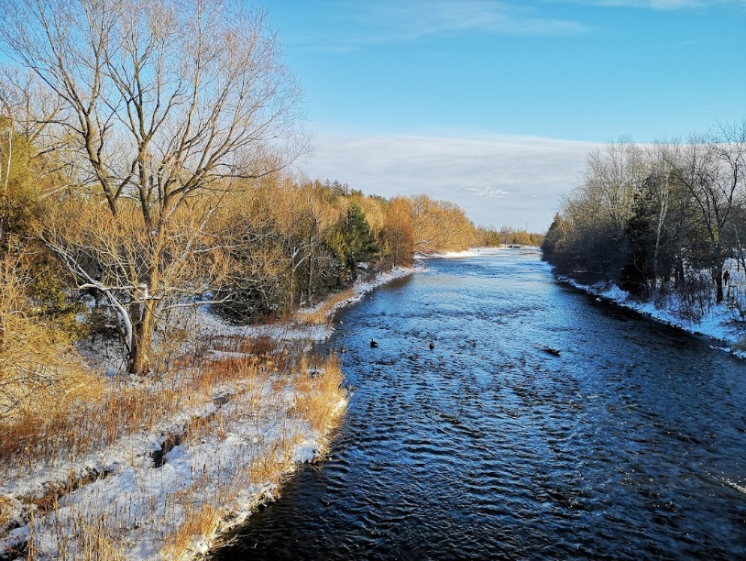
Scripture: Luke 5:1-11 NRSV https://www.biblegateway.com/passage/?search=Luke%205%3A1-11&version=NRSV
Contemplation and Conversation: How are you living out Jesus’ call to be his disciple?
From Rev. Heather Leffler:
It had been a long night and Simon and the others didn’t have enough fish for breakfast. They were tired and wanted to go home but the nets wouldn’t clean themselves. The crowd gathered around the teacher was at least an interesting distraction.
When Jesus asked to sit in the boat to teach, Simon started to listen more closely. He, his brother Andrew and their friends James and John were followers of John the Baptist. Nothing they had heard John say had touched Simon so deeply. When Jesus said they should take their boats out again, Simon Peter told him they had caught nothing all night, but he did what Jesus said. As the fish filled the boats, Peter’s heart overflowed, how could he deserve to be with this Holy One of God. And yet Jesus, wanted him. What could he do but follow?
My introduction to Jesus was not as dramatic as Peter’s. I grew up in the church. I always knew I belonged to the church and to God. My understanding of call has deepened over time. Wherever we are in our relationships, our education, our work or retirement and leisure activities, all we do is done to honour God. Whether we are caring for a child, baking a cake, wiring a house, milking a cow or making a phone call, if we use our gifts to the best of our abilities and offer what we do in love we are living out our call to be a disciple.
May all we do and think and say be faithful to Jesus. Amen.
Whether you are at home trying to help slow the spread of the virus,
working to help care for those who are impacted most by COVID-19
or working to keep some normalcy in this time,
may you know God’s deep and abiding love in your life.
Know you are a valued part of our Rockwood and Stone United Church families.

Further Conversation … Would you like to talk more about today’s reflection? Email Heather at hleffler@rogers.com. Following worship next Sunday, she will invite others to join you in a Zoom break out room to share in further conversation.
Our Rockwood Stone Family
If you missed today’s worship service, you can email rockwoodstoneuc@gmail.com for a link.
To read A Song of Faith (2006), go to https://united-church.ca/community-faith/welcome-united-church-canada/faith-statements/song-faith-2006 .
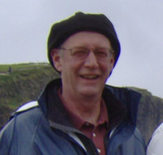
Our Sympathy
Ralph Douglas Lancaster
1948-2022
We are heartbroken to announce that Ralph died of cancer January 29, 2022. He died at home surrounded by the love of his family.
Dearly beloved husband of Cathy Gage, together for 50 wonderful years. Cherished and devoted father of Graham (Keri Commanda) and Emily (Martin Lemieux) adored Papa of Addie and Ethan. Loving brother of Stuart (Ingrid), Linda (Bill Hanshaw), Larry (Patty), and Bruce (Danny). Dear brother-in-law of Sharon (Art Clarmo), Lynda (John Allman), and Dani (Kent Lang). He leaves many nieces and nephews, grand nieces and nephews and cousins. Ralph touched many lives with his caring and compassionate way throughout his teaching career and his long involvement with playing sports, coaching, and refereeing. We will miss his quick wit, wonderful sense of humour and his laughter. We wish to thank family and friends for their steadfast support and love throughout Ralph’s illness.
Cremation has taken place. In honour of Ralph’s love of the outdoors and of adventure, donations to the Grand River Conservation Foundation “New Guelph Lake Nature Centre” www.grandriver.ca/en/grand-river-conservation-foundation.aspx
(519) 621-2761 would be appreciated. There will be a celebration of Ralph’s life at a later date when gatherings are safe.
Arrangements entrusted to GILCHRIST CHAPEL – McIntyre & Wilkie Funeral Home, One Delhi Street, Guelph, (519-824-0031). We invite you to leave your memories and donations online at: www.gilchristchapel.com and they will be forwarded to the family.

United Church of Canada From Moderator Richard Bott, December 2, 2022
God spoke to me this morning,
in the sound of falling snow.
"Sleep, child," They said,
and I felt Them rock me back to sleep,
my nightmares released from
the corrals of my mind.
God spoke to me this morning,
in the Horizon's bright pink,
against the grey of an overcast sky.
"Wake, child," They said,
"today's possibilities are waiting for you,"
and They gave my gratitude a push
as I put on my mask,
and headed out the door.
God spoke to me, today,
in the warmth of a paper cup of coffee,
and a toasted bagle with cream cheese.
"Wait! child," They said,
so I hunkered down with "Ol' Dan"
(as he likes to be called)
and we chatted about his night
and his thoughts about the coming day,
and we ate and drank and warmed up together,
(though mine was a hot chocolate.)
God is still speaking,
oh, yes, They are!
I just hope that I keep listening,
keep feeling, keep sensing;
keep knowing and wondering
and loving and being,
with all that I have,
and all that I am
in response to Their words,
as I go on my way.

Black History Month
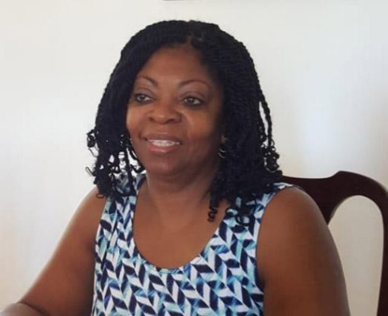
Credit: Courtesy of Yvonne Wright
Published On: January 31, 2022
“Get out of my face, go back to where you came from,” I was told by one of my grade seven classmates. I was puzzled and wondered what he meant by that. I responded by saying “I am not in your face,” and somehow immediately felt silly with my response.
I was thirteen when I came to Canada from Jamaica in 1968. I arrived in the summertime. My parents thought that it was a good idea because it would allow me some time to get used to my new surroundings, more specifically, the language.
I came from a small village on the west side of the island where, though I wrote and spoke English, I had an accent. My parents tried their best to prepare me for school, by explaining some of the things that I might find differently. We spoke about the pronunciation, eye contact when speaking to the teacher, not having to stand in class when responding to the teacher. And I recall my mom explaining that I will not be wearing uniforms.
So as September rolled around, I felt that I was ready, prepared and excited to start a new school in this new country. I cannot say that my first day was uneventful.
For the first two years of attending school, my sister and I were the only Black students in our classes. The only other Black student was my newfound friend from England. How very strange was that? Some of the students looked at me with strange looks on their faces. Comments were made that I talked funny, about my hair, and I was made fun of because I didn’t know how to play floor hockey.
Being with White people, though, was not new to me. While in Jamaica, White folks would pass through my village from time to time. My maternal grandmother is part Scottish and could easily have passed for White. So, interacting with White people was by no means strange for me. However, to be surrounded by so many White folks everywhere I went was very different. But hearing the comments being made toward me, the stares that were made at me, and the name calling were quite discomforting.
One afternoon, threats were made that traumatized my younger siblings. As we walked back home for lunch, a group of boys told my sisters that they would be hanged on their way back to school. Of course, my sisters were too young to understand what was said and barely mentioned it at home. My older sister, however, heard what was said and decided to walk my sisters back to school. To their surprise, these young boys, had a noose hanging from the tree where my sisters had to walk. This was frightening for all of us. My older sister, of course, chased these boys away. To this day, we wondered what the outcome might had been had our older sister not walked them back.
Eventually, my dad sat us done, and shared his stories about his own experiences of interacting with White people while he was on the farm working program in the United States. These are now familiar stories: they couldn’t eat with the White people; they weren’t allowed to go anywhere with them, to the White folks, the farmworkers were slaves. The stories were not pleasant. It made me wonder why my parents decided to immigrate to Canada. While my dad’s experience happened in the U. S. context, there were many similarities to life in Canada. My mom would chime in to say, “That is why I didn’t want to go to the U.S. or England for that matter.” These stories led me to believe that Canada was different, but in fact, it wasn’t. I went through school, working very hard to achieve good grades, trying not to upset anyone, trying to make friends with anyone who would want to associate themselves with me.
As the years went by, more and more blacks started entering the schools. We eventually formed a high school club called the West Indian Students Association. The club was to support each other and to create a space for learning about who we were as Black students and where we fit in. It was also to help the White students learn about who we were.
As I am reflecting on all these stories, it brings a smirk to my face knowing that we have been struggling with racism and discrimination for such a long time and the struggle continues.
This consciousness of being Black and different followed me right through my schooling years, and later in my place of work and even in my church. I must note, though, that I was pleased that my church was willing to participate in the activities and worship around Black History Month. Guest speakers brought the message and shared their experiences and expertise in the areas of Black history in Canada and racism. For sure, there were some thought-provoking sermons.
A few years ago, I attended the Black Clergy gathering in Edmonton. I was so disappointed by the stories that were being shared about experiences of racism. It felt like not much has changed over the years. Some of the questions that were being asked of me back in the Sixties are still being asked today.
- Where are you from?
- Where are you really from?
- How long does it take to do your hair?
- You have an accent!
Sometimes I wonder if I am being too sensitive. However, I don’t think so. The work to dismantle racism in all its facets is not easy. We need to be in each other faces. We need to be ready to respond and challenge people when they display racist attitudes and actions. I believe that the more our voices are heard, the more stories are told, the more information that is put forth, the more likely it is that we can all share and live into this Kin-dom of God.
—Yvonne Wright was born in Jamaica but was raised in Canada from a young teen. She has been a member of the United Church most of her life and is very passionate about her faith and church. She is currently a member of Sydenham-Heritage Community of Faith in Brantford, ON.
From https://united-church.ca/blogs/round-table/get-out-my-face

A gift of belonging to a church is that the practice of gathering together for worship … to pray, sing, listen to scripture and share how God touches our lives – helps us grow in deeper relationship to God and each other. With COVID-19 keeping us at home and physically distant from our Stone or Rockwood families, we are missing each other. We are offering this practice of sharing beyond Sunday morning to deepen our connection. Each week you will be offered a picture, a scripture and a question for contemplation, as well as a short reflection for you to contemplate, have conversation with people in your life and/or join an online conversation on our Rockwood Stone Facebook page.

