Contemplation and Conversation: 3rd Sunday of Lent, March 20, 2022
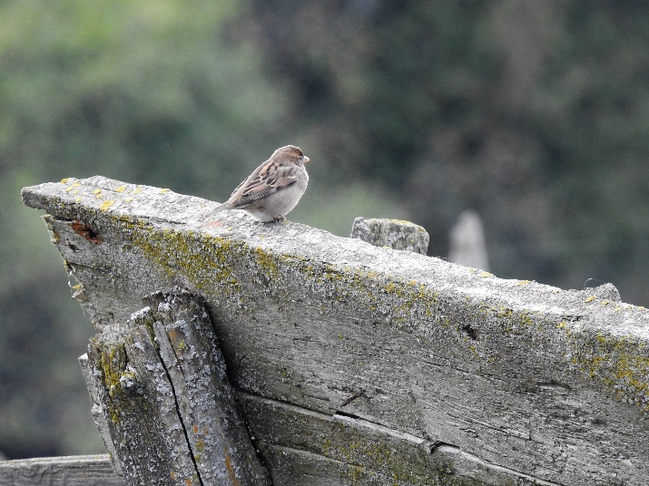
Scripture: John 10:1-9 CEV https://www.biblegateway.com/passage/?search=John%2010%‌3A9&version=CEV
From Rev. Heather Leffler:
William Barclay one of my favourite Biblical Commentators paints a picture of Jesus as the gate that has stayed with me. In the hills in Palestine, the shepherd was responsible for the sheep being fed, watered and kept safe, day and night, winter, spring, summer and fall. During the day their sling and staff were used to gently bring back a straying sheep or firmly ward off a wolf, lion or bear, thief or robber. At night away from home, the shepherd would shelter the flock in a three walled enclosure. The shepherd themself would lie across the fourth side as a human gate that kept the sheep from straying, and wild animals or humans from threating the sheep.
There have been many changes in my lifetime about what is seen as right and wrong. When I was growing up a family friend had been forced to leave her church and was rejected by her family because she was pregnant before she was married. Now we ask if a child is loved not whether they were conceived in or out of marriage. Divorce which once forced people to leave their church, may sometimes be the most loving way parents can care for each other and their children. Instead of seeing heterosexuality as the only acceptable path, we now recognize that God created and loves people who fall across the diversity of the rainbow spectrum of sexuality and gender.
What hasn’t changed is Jesus. He is the gate that offers me boundaries, comfort and protection. Jesus never waivered in inviting us to see all people as children of God to be loved and cared for. He forgives me when my judgments get in the way of loving others. The Spirit helps me make choices that keep me from hurting others or myself.
Contemplation and Conversation
Where is Jesus inviting me to let go of being judgmental
and accept someone as they are?
Prayer
Jesus, thank you for being the gate that helps me set boundaries for my life to keep me safe and well. Amen.
Whether you are at home trying to help slow the spread of the virus,
working to help care for those who are impacted most by COVID-19
or working to keep some normalcy in this time,
may you know God’s deep and abiding love in your life.
Know you are a valued part of our Rockwood and Stone United Church families.

Further Conversation … Would you like to talk more about today’s reflection? Email Heather at hleffler@rogers.com. Following worship next Sunday, she will invite others to join you in a Zoom break out room to share in further conversation.

Our Rockwood Stone Family
If you missed today’s worship service, email rockwoodstoneuc@gmail.com for a YouTube link.
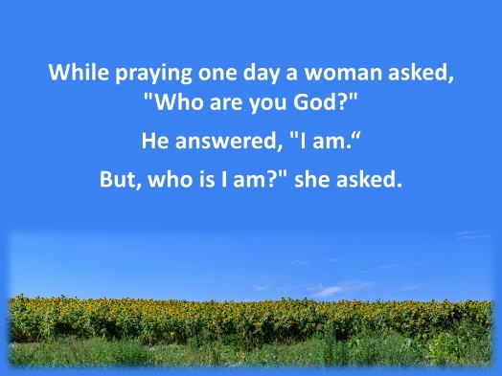
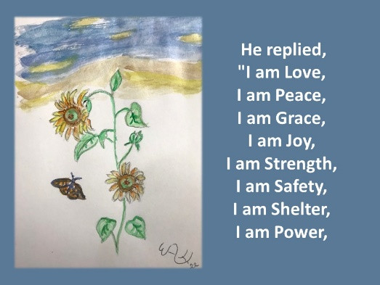
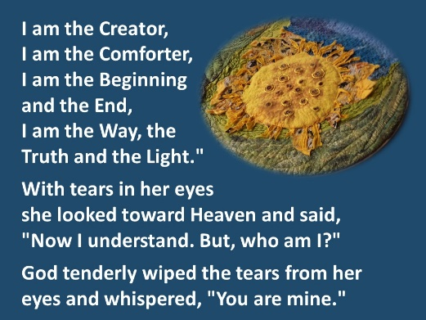
Thanks to Ollie for our Offering Praise today and to Gord Carothers and Elsa Hore for their pictures and Barb Parker’s picture of Heather Nagel’s sunflower.

United Church of Canada From Moderator Richard Bott, To Root Out Quiet Racism
—A prayer for March 21, the International Day to Eliminate Racial Discrimination
While we give thanks for
the diversity of people—
of cultures and ethnicities,
of histories and life-stories,
of skin colour and language and
hearts that love the world;
the best way to give thanks
is to disassemble the systems,
the stories, the mythos,
that privilege one colour over another—
is to root out (and un-root)
the insidious beliefs
of those of us with privilege
(sometimes hidden quietly within,
sometimes disguised,
sometimes trumpeted as manifesto)
that “me and mine” are better than
“you and yours.”
To root out quiet racism—
to root out White Fragility,
and White Supremacy—
so that it withers and dies.
It is time.
It is well past time.
On this International Day
to End
Racial Discrimination.
God of all creation,
bless us all with what we need,
to take on this work,
and live it.
Today.
Every day.
Always.
Until this International Day
is a thing of memory.
In Jesus’ name.
May it be.

A gift of belonging to a church is that the practice of gathering together for worship … to pray, sing, listen to scripture and share how God touches our lives – helps us grow in deeper relationship to God and each other. With COVID-19 keeping us at home and physically distant from our Stone or Rockwood families, we are missing each other. We are offering this practice of sharing beyond Sunday morning to deepen our connection. Each week you will be offered a picture, a scripture and a question for contemplation, as well as a short reflection for you to contemplate, have conversation with people in your life and/or join an online conversation on our Rockwood Stone Facebook page.

