Contemplation and Conversation: 4th Sunday of Lent, March 27, 2022
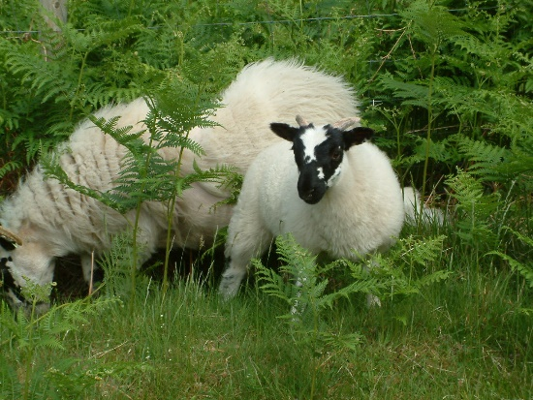
Scripture: John 10:10-18 CEV https://www.biblegateway.com/passage/?search=John+10%3A10-18&version=CEV
From Brian Mack
In the summer of 1962, my parents had a typical mixed farm – a small herd of Milking Shorthorns, a flock of Rhode Island Red hens, and some young Yorkshire sows. One thing was missing from the menagerie—a flock of sheep. As the idea that we should have some sheep grew in Dad’s mind, he began to read articles as to what sheep required to keep them comfortable in farm papers, like the Family Herald. He talked to various farmers who had experience with sheep so that he would know how to house and feed them. He was told who to contact to get a flock sheared and how to arrange for the fleeces of wool to be sold in Toronto. Lots of information was gathered as autumn turned to winter, but still no sheep.
A few days before Christmas, Clayton Patterson (Patty’s father) dropped in for a visit. He’d heard that Dad might be interested in purchasing some sheep and just happened to have a group of fifteen western cross bred ewes in his barn that would give birth about Easter time. Dad and I went to see them the next day, some money was exchanged, Clayton delivered them to our farm, and my family became instant shepherds. As an aside, Clayton had noticed that I was intrigued with a group of ten Barred Rock roosters that he had in a wire cage. Much to my surprise, along with the sheep came the roosters and the cage at no charge. Mr. Patterson’s gift made a nine-year-old boy feel ten feet tall.
Over the course of the next fifteen years or so, my parents learned a lot about being shepherds. Their successful care of the flock was dependent upon their ability to recognize the unique characteristics of each member of the group—the young and gullible lambs who loved to wander; the Mommas who required assistance at lambing time or needed support when they refused to nurse or look after their offspring; the curious ones who repeatedly managed to get their head stuck in small spaces; the gluttons who ate too many apples or other things not good for the digestive track; the aggressive bullies who would crowd others out at the feeding racks; the immature rams who would stamp their feet and think nothing of taking a run at an unsuspecting human; the weak lambs who were easily run over by the adults and required a plaster cast to help joints function again; and the old “Granny Sheep” who was always on the thin side but could be counted on to lead the flock out of harms way in response to Mom and Dad’s (and maybe a squeaky kid’s) voices.
It is not hard to imagine Jesus as the ultimate Good Shepherd. He knows us as individuals and nourishes us accordingly. It is not difficult to imagine our minister as a good shepherd as she reaches out to us in love in spite of our quirks and quarks. As members of a faith community, like Clayton Patterson and so many others before us, we are also expected to be good shepherds, as we live out our mission and ministry together. Thanks be to God.
Contemplation and Conversation
Who has been a good shepherd in my life?
Who might God be calling me to reach out to in love?
Prayer
Good Shepherd, show me where you need me to reach out
and care for someone, just as you care for me
through the loving hands of others. Amen.

Whether you are at home trying to help slow the spread of the virus,
working to help care for those who are impacted most by COVID-19
or working to keep some normalcy in this time,
may you know God’s deep and abiding love in your life.
Know you are a valued part of our Rockwood and Stone United Church families.

Our Rockwood Stone Family
If you missed today’s worship service, email hleffler@rogers.com for a link.

A Prayer for Ukraine from Ollie Darcie
God of peace and justice,
we pray for the people of Ukraine today.
We pray for peace and the laying down of weapons.
We pray for all those who fear for tomorrow,
that your Spirit of comfort would draw near to them.
We pray for those with power over war or peace,
for wisdom, discernment and compassion to guide their decisions.
Above all, we pray for all your precious children, at risk and in fear,
that you would hold and protect them.
We pray in the name of Jesus, the Prince of Peace.
Amen
Archbishop Justin Welby
Archbishop Stephen Cottrell
Western Ontario Waterways From Mark Laird, President of Western Ontario Waterways
Our hearts and prayers go out to the people of Ukraine these past weeks, as we watch with horror the pain and destruction that has been caused in their country.
We hold the leaders and people of Ukraine in our prayers and will continue to do so even after peace is found and the rebuilding begins. As President of Western Ontario Waterways Regional Council, I reached out to our Ukrainian Church brothers and sisters in Christ, offering our prayers and support.

I will be taking part in a multi-faith prayer service.
Everyone is welcome! Come out to the service and join us on Monday.
If you are not comfortable in a large group right now or live too far away to make it, please pray with us on Monday at 7:00 pm, wherever you are, for the people of Ukraine.

United Church of Canada From Moderator Richard Bott, March 23, 2022
Many of us have war on our minds and in our prayers right now.
As we think and pray about what is happening to the people of Ukraine, I'd ask us to think about other places in the world, as well.
Would you take a moment to join me, and rise to the challenge our Korean partners have called us to? Will you sign the Korea Peace Appeal and invite others to do the same?
70 years is enough. End the Korean war.
That’s the message of the recently launched Korea Peace Appeal, a global campaign that seeks to collect 100 million signatures by 2023, the 70th anniversary of the armistice. The United Church of Canada has been challenged by our Korean partners to add 10,000 Canadian signatures to the petition. Your support through Mission & Service actively supports peace-making in Korea. Signing this petition is another way to help: http://ow.ly/nWnt50Ipye4 .
#UCCan #MissionAndService

A gift of belonging to a church is that the practice of gathering together for worship … to pray, sing, listen to scripture and share how God touches our lives – helps us grow in deeper relationship to God and each other. With COVID-19 keeping us at home and physically distant from our Stone or Rockwood families, we are missing each other. We are offering this practice of sharing beyond Sunday morning to deepen our connection. Each week you will be offered a picture, a scripture and a question for contemplation, as well as a short reflection for you to contemplate, have conversation with people in your life and/or join an online conversation on our Rockwood Stone Facebook page.

