Contemplation and Conversation: 5th Sunday of Lent, April 3, 2022
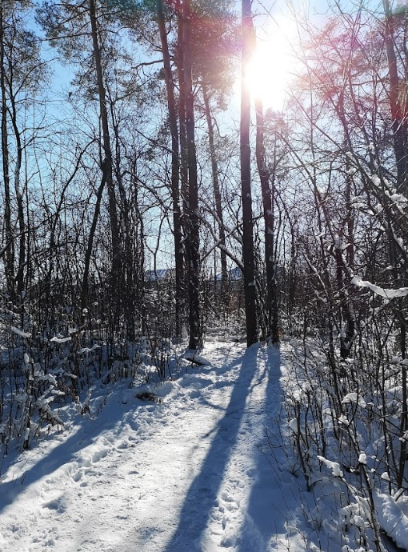
Scripture: John 12:44-50 CEV https://www.biblegateway.com/passage/?search=John+12%3A44-50&version=CEV
Reflection from Rev. Heather Leffler
At times throughout history, seeing Jesus as the light of the world has blinded Christians to God’s kingdom where all people belong. Leading Christians to separate ourselves from nonbelievers, other Christians and people of other faiths; and worse to use his message to justify wars, slavery, residential schools and other harms in the name of the Light of the World and Prince of Peace. Yet these final public words of Jesus invite us to reclaim his wonderful words as Christians. They encourage us to right wrongs that have been done when we have associated light and white as good and from God, and dark and black as evil.
Jesus words are for those of us who have come to know God through him. They are not intended for us to use them against others. He came to save all people of the world not to be the judge. If he is not the judge, Jesus frees us from judging and condemning others or forcing our beliefs on them.
What Jesus offers – when we accept the call to follow him – is that his teachings to love God, ourselves, our neighbours and even our enemies become the touchstone for our lives. When we fall short, he offers us forgiveness. When we let them be the light that guides us, we experience the fullness of life God intends for us.
This is not easy. It means when I am hurt, frustrated or angry with someone, I am still called to see them as beloved by God. I may need to step back from a relationship with them, but I am not free to slander or condemn them. If I can engage with patience and respect, I often find a precious child of God in the other. More than once when my first reaction was to keep a new acquaintance at arm’s length, they turned up again and again in my life. Over time I have come to recognize this as the Spirit inviting me to see past our differences and my initial judgments. I have gained respected colleagues and close friends in the ones I could have rejected.
Jim Strathdee’s echo of Jesus’ words in his familiar hymn brings me hope and joy.
'I am the light of the world!
You people come and follow me!'
If you follow and love you'll learn the mystery
of what you were meant to do and be.
To free the prisoner from all chains,
to make the powerful care,
to rebuild the nations with strength of good will,
to see God's children everywhere!
Jim Strathdee 1967 Words © 1969 Desert Flower Music. Reprinted under OneLicense.net #A-717908
Contemplation and Conversation
Where have I experienced the Spirit nudging me into a relationship that surprised me?
Prayer
May the light of Jesus show me where love will help me recognize God’s children everywhere. Amen.
Whether you are at home trying to help slow the spread of the virus,
working to help care for those who are impacted most by COVID-19
or working to keep some normalcy in this time,
may you know God’s deep and abiding love in your life.
Know you are a valued part of our Rockwood and Stone United Church families.

Further Conversation … Would you like to talk more about today’s reflection? Email Heather at hleffler@rogers.com. Following worship next Sunday, she will invite others to join you in a Zoom break out room to share in further conversation.

Our Rockwood Stone Family
If you missed today’s worship service, email rockwoodstoneuc@gmail.com for a YouTube link.

From Ione Cox
Dear Ione;
Peace to you. I am writing to share with you Peaceful Sky, a song for peace, which I wrote and dedicate to the people of Ukraine. Please feel free to share this song and video with your pastor, in hopes that it might be shared with your congregation at an upcoming church service or through your weekly email communications to your congregation.
The video was produced by Rev. Steve Rothery from Knox Presbyterian Church, Milton, Ontario and contains images of the people and places in the Ukraine.
Let us share this prayer for peace. For peace comes in small pieces.
The YouTube link for Peaceful Sky is https://www.youtube.com/watch?v=ucFajFOIS54 .
Blessings,
Father Mark Curtis

United Church of Canada from Moderator Richard Bott, April 1, 2022
Pope Francis has spoken words of apology from deep in his heart.
Now comes the hard work of helping those words to be the impetus for changed action - including what was called for in the Truth and Reconciliation Commission - that his apology be delivered here, in Canada. The United Church recognizes how important this is for Indigenous members of the Roman Catholic Church and other Christian denominations, and Indigenous people who are not a part of the church... especially residential school survivors, intergenerational survivors, and their communities.
As one who is a member of The United Church of Canada, a part of the body of Christ who has been working on our own journey of repentance and right relations for a number of years, I hope that my brother Francis would learn something quickly that it has taken me many years to understand - every step that is taken in the work of truth, of repentance, of reparation, of building right relationship is a *first* step.
As I have each day since hearing they would go to the Vatican, I will continue to pray for the Indigenous delegates who travelled to meet with Pope Francis, who again shared their stories of trauma caused by Christian community and Canadian government. I give thanks for their willingness to speak, and for all of the work that Indigenous people and communities have done to show people like me - colonizer-descendants - what we have done, and what the institutions of which we are a part continue to do.
I will pray that not only Pope Francis, not only the Roman Catholic Church, but all of us who are part of the evil upon evil that has been poured on the Indigenous peoples of these lands will take this moment as another first step.
And I will pray that this first step - and every next first step - will help us all to go in a good way.

A gift of belonging to a church is that the practice of gathering together for worship … to pray, sing, listen to scripture and share how God touches our lives – helps us grow in deeper relationship to God and each other. With COVID-19 keeping us at home and physically distant from our Stone or Rockwood families, we are missing each other. We are offering this practice of sharing beyond Sunday morning to deepen our connection. Each week you will be offered a picture, a scripture and a question for contemplation, as well as a short reflection for you to contemplate, have conversation with people in your life and/or join an online conversation on our Rockwood Stone Facebook page.

