Contemplation and Conversation: 4th Sunday of Easter, May 8, 2022
Scripture: John 10:22-30 NRSV https://www.biblegateway.com/passage/?search=John%2010:22-30&version=NRSVUE
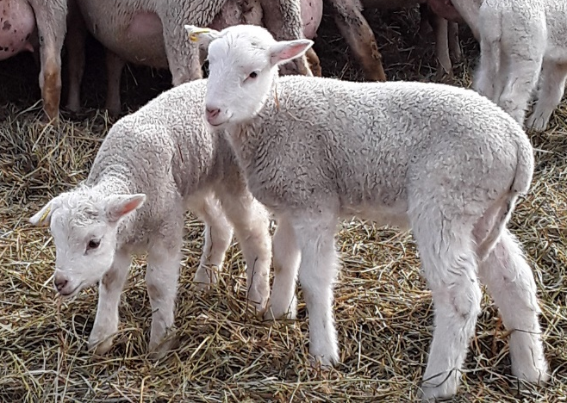
From Rev. Heather Leffler:
Jesus was walking in the temple when a group of Jewish people came and asked him to tell them plainly that he was the Messiah. Jesus knew their hearts. They hadn’t come to honour God or follow Jesus. They had come to trap Jesus and arrest him.
These Jewish leaders believed they were being faithful to God. They were sure that Jesus was going to stir up trouble and they were so concerned with protecting the peace they had with the Romans that they couldn’t recognize Jesus as the son of God.
Jesus’ concern was for the people who could hear him and believed. He didn’t have time for people who were so busy protecting the way things were that they couldn’t see the new possibilities God was opening up. As we begin to see life through new lenses – white privilege, anti-racism, inclusion for all people, sometimes it is easier to hide behind the way things have always been. Sometimes it can be frightening to imagine the new world the Spirit is calling us to. Yet hearing Jesus’ words to love God and love our neighbours assures us that if we respond in love God’s kingdom will come.
Contemplation and Conversation
What is the Spirit inviting me to let go of, so I can change directions?
Prayer
Jesus, open my heart to see where you are calling me to new possibilities. Amen.
Whether you are at home trying to help slow the spread of the virus,
working to help care for those who are impacted most by COVID-19
or working to keep some normalcy in this time,
may you know God’s deep and abiding love in your life.
Know you are a valued part of our Rockwood and Stone United Church families.

Further Conversation … Would you like to talk more about today’s reflection? Email Heather at hleffler@rogers.com. Following worship next Sunday, she will invite others to join you in a Zoom break out room to share in further conversation.

Our Rockwood Stone Family
If you missed today’s worship service, email rockwoodstoneuc@gmail.com for a YouTube link.
Thank you to Jean Haws for sharing her pictures and reflection on where she feels God's presence in her life and to Heather Blair for her gift of music. If you missed today’s Offering Praise you can view it here https://youtu.be/faDzDJoEgd4

United Church of Canada From Moderator Richard Bott, May 5, 2022
We recognize,
God of all life, all people, all places;
that many of us continue to not understand issues of mental health— our own, and that of others’.
For so many broken reasons stigma is placed upon folks living with mental health difficulties, building walls of isolation, rather than the support and love of beloved community;
the support and love of radical belonging;
the support and love that Jesus exemplified,
over and over and over again.
Open our hearts, open our arms, open the ways to knowledge and comprehension— that all your beloved children would find safe home, here.
Now.
Always.
We ask this in the name of the One whose hands and heart always reach out, Jesus, the Christ. Amen.

A gift of belonging to a church is that the practice of gathering together for worship … to pray, sing, listen to scripture and share how God touches our lives – helps us grow in deeper relationship to God and each other. With COVID-19 keeping us at home and physically distant from our Stone or Rockwood families, we are missing each other. We are offering this practice of sharing beyond Sunday morning to deepen our connection. Each week you will be offered a picture, a scripture and a question for contemplation, as well as a short reflection for you to contemplate, have conversation with people in your life and/or join an online conversation on our Rockwood Stone Facebook page.

