Contemplation and Conversation: 6th Sunday of Easter, May 22, 2022
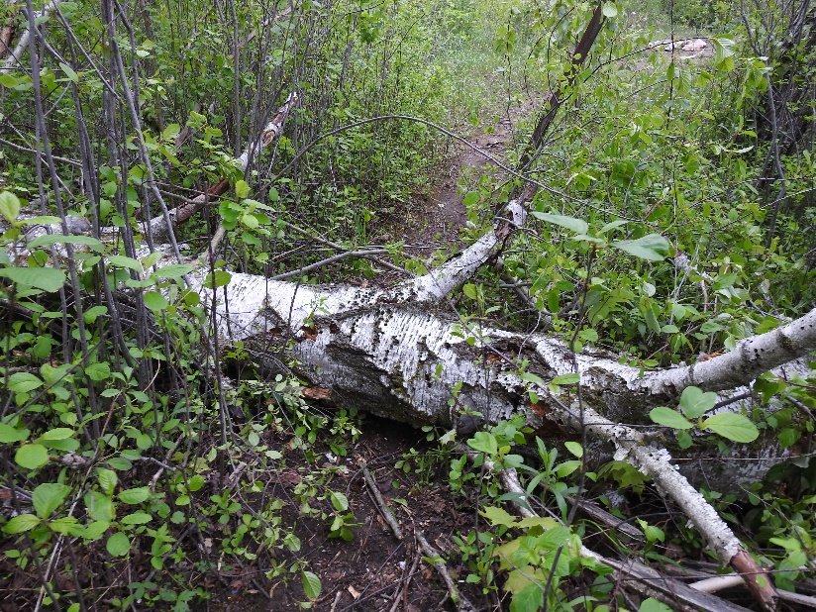
Scripture: Psalm 67 NRSV https://www.google.com/amp/s/www.biblegateway.com/passage/%3fsearch=Psalm%2b67&version=NRSVUE&interface=amp
From Rev. Heather Leffler:
We long for God’s grace to shine on us today. The challenges and struggles seem never ending. We thought we would be through the pandemic by now but the health, physical, emotional, economic and other challenges continue ... continued protests ... war in Ukraine with impacts reverberating around the world... people we care about not well ... and now a devasting storm. Where is God? Where is God’s grace and blessings?
And yet listen to the stories of people coming to the aid of family, neighbours, friends and strangers … checking in on each other … taking ladders and tools to friends … helping to cleanup yards … cutting trees … sharing hot meals when a loved one is sick. These for me are signs of God’s grace and blessing. Through people who reach out in love and prayer, I know God’s love in the most challenging times.
Contemplation and Conversation
Where do you see God’s blessing?
Prayer
Holy Mystery, thank you for your love that shines through your people.
May we reflect your deep and abiding love to others
through our prayers, words and actions. Amen.
Know you are a valued part of our Rockwood and Stone United Church families.

Further Conversation … Would you like to talk more about today’s reflection? Email Heather at hleffler@rogers.com. Following worship next Sunday, she will invite others to join you in a Zoom break out room to share in further conversation.

Our Rockwood Stone Family
If you missed today’s worship service, email rockwoodstoneuc@gmail.com for a YouTube link.
Thank you to Tammy and Heidi Smits for share their gift of music, and Lisa Leffler, Liz Guthrie, and Marianne Poschung for sharing their beautiful photography for this week’s offering praise: https://youtu.be/MpRuMrQKQKc

United Church of Canada from Moderator Richard Bott, May 14, 2022
You may be tired;
you may be frustrated;
you may be stressed, or anxious,
challenged, isolated, or confined;
you may be feeling small or forgotten,
sad, sore, or numb;
you may be one of these things,
or some of them,
all of them or none...
but, hear this -
in the midst of all of that,
you are most definitely one thing more.
You are loved.
You are loved by a Love that is forever,
a Love that will never let you go,
a Love that loves regardless of "worth,"
regardless of "name," or "face," or "standing."
Oh, friend...
no matter what, remember -
you
are
loved.

A gift of belonging to a church is that the practice of gathering together for worship … to pray, sing, listen to scripture and share how God touches our lives – helps us grow in deeper relationship with God and each other. We are offering this practice of sharing beyond Sunday morning to deepen our connection. Each week you are offered a picture, a scripture and a question for contemplation, as well as a short reflection for you to contemplate, have conversation with people in your life and/or join an online conversation on our Rockwood Stone Facebook page.

