Contemplation and Conversation: 4th Sunday after Pentecost, July 3, 2022
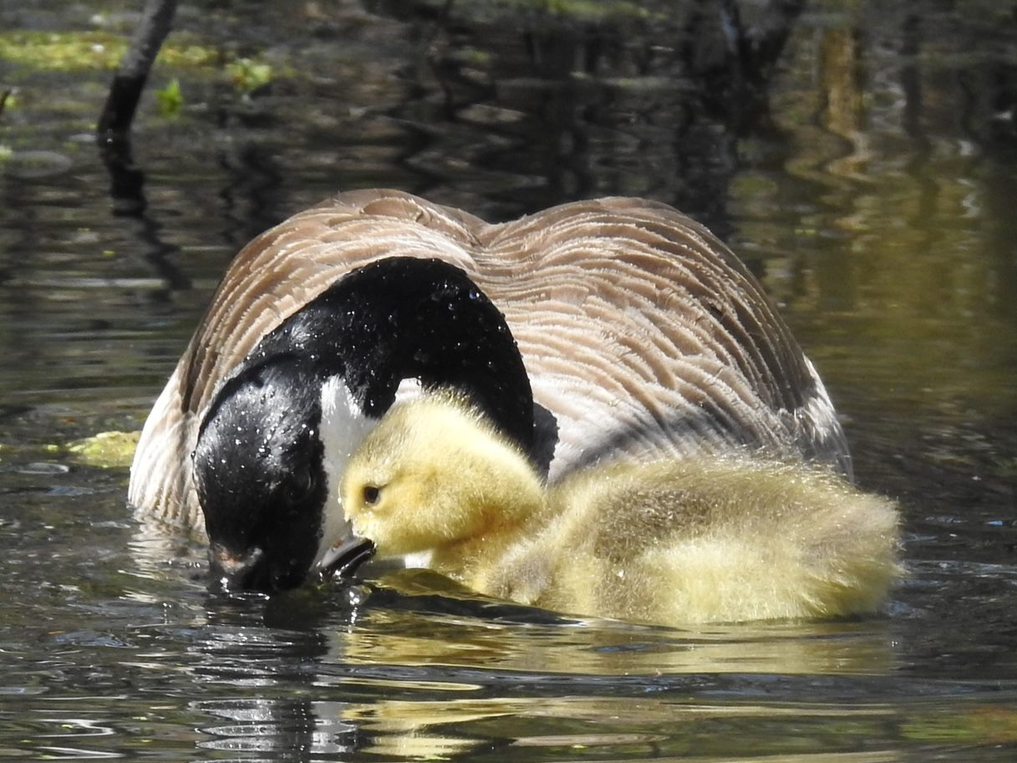
Scripture: Galatians 6:1-16 NRSVUE
https://www.biblegateway.com/passage/?search=Galatians+6%3A1-16+&version=NRSVUE
From Barb Eley:
Paul certainly packs a great deal into his letters! He gives warnings, but like any good teacher also lays out positive actions. He doesn’t just tell us what to avoid, but what we need to do. The loving care in the words about helping to restore someone “in a spirit of gentleness” is wonderful. How much easier is it to hear and accept the Word of God when it is spoken in a gentle voice.
He warns us more than once not to be deceived, either in thinking we are more than we are or in thinking that God is not aware of all we say and do. It is important to see ourselves with clear eyes, and that will make it possible for us to truly “do good to all”.
Paul finishes the letter in his own hand, and deals with a complex issue very simply. Quarrelling over details of the law is not what is important. All that matters is the new creation found in following our Lord Jesus Christ.
Contemplation and Conversation
When have you found yourself restored to Christ in a spirit of gentleness? Have you been able to do this for someone else?
Prayer
Lord, let your love restore me, so that I will not grow weary and will continue to endeavour to do good to all. Let me find your peace and mercy as I walk the path you have shown me. Amen.
Know you are a valued part of our Rockwood and Stone United Church families.

Further Conversation … Would you like to talk more about today’s reflection? Email Heather at hleffler@rogers.com. Following worship next Sunday, she will invite others to join you in a Zoom break out room to share in further conversation.

Our Rockwood Stone Family
If you missed today’s worship service, email you can watch it on our Rockwood Stone YouTube page.
With Sympathy
John Arbuckle
(b April 23 1921, d July 1, 2022)
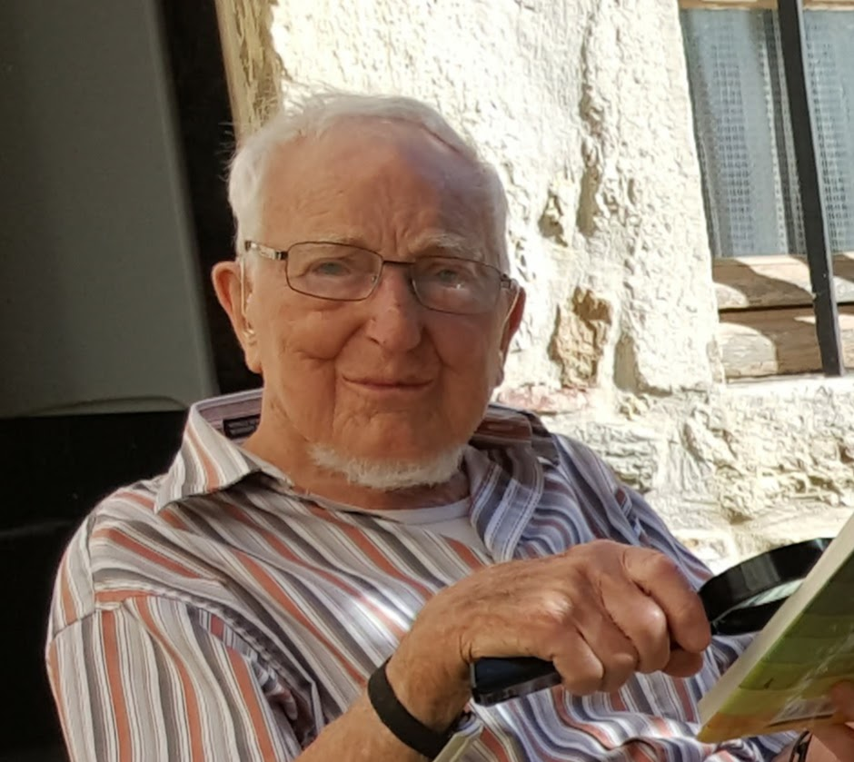
John Arbuckle, 101 years of age, died peacefully in his sleep on the morning of July 1st, 2022. John is predeceased by his wife, Anne Françoise Arbuckle in 2017 and is survived by his daughter, Christine Arbuckle (Paul Berger), grandson John Dermody (Gina Nguyen), grandson Eric Dermody (Tess Daunt), daughter, Sophie Arbuckle (Arie Braude), and granddaughter Shira Braude.

John was born in Campbeltown, Scotland and served in the Royal Signal Corps under Lord Mountbatten (Battenberg) from 1943 to 1947. This was a combined Brit & American campaign in the Far East (India, Ceylon and Singapore) plus Occupation in Germany. Upon discharge, he attended the University of Glasgow and obtained a degree in French and German. He became a schoolteacher and taught in Scotland for a few years before moving to the Montreal Protestant School board in 1953. He subsequently went to teach in a one room schoolhouse in Bear Creek, Sask. A later stint moved him to secondary school where he taught French, German, Latin and Elements of Cree. He later took his MA in Linguistics at the University of Alberta where he met his wife Anne Françoise Michot. They were married June 10, 1961. Together they moved to Ithaca, NY where they both attended Cornell University in the School of Modern Languages, himself as a PhD student. In 1963, he won a Fulbright Scholarship to study dialects in various areas of India. In his prime, John could speak, read and write 7 languages including Hindi.

In 1973, John and Francoise moved to Sudbury, Ontario to teach at Laurentian University, School of Translators and Interpreters. They remained in Sudbury as active members of the community and their church, St Andrews, until 2015 when they moved in with their daughter, Christine, in Rockwood, ON.

John was an avid volunteer throughout his lifetime including volunteering for the Multicultural Society, the India Canada Association, where he was President for many years, and teaching English as a second language to many including the refugees from Vietnam.

Over the last few years, John has attended Rockwood United Church in person and later over Zoom. The family would like to thank the church, the minister, Heather Leffler, and the combined congregations of Rockwood and Stone for the tremendous care shown to John. As well, the family would like to thank our caretakers, Debbie B. and Cara B., who took such good care of John and stepped up care seamlessly as he needed it. Thank you also to our medical team, East Wellington Family Health Care, the LHIN and the homecare staff at Paramed with a special callout to Anne Marie R.
Here are the funeral details for John that could be announced and placed in Contemplation and Conversation.

Resting at Gilbert MacIntyre and Son Funeral Home, Hart Chapel, 1099 Gordon St., Guelph where the family will receive friends and relatives for visitation on Monday, July 4, from 9:30am - 10:00am followed by a service in the Hart Chapel beginning are 10:00am. Reception to follow in the Hart Fellowship Lounge. All are welcome to live stream the service on the internet via ZOOM. For the link to worship go to https://memorials.gilbertmacintyreandson.com/john-arbuckle/4969475/index.php?_ga=2.104744515.2526220.1656806049-1545025364.1655507683
United Church of Canada
A Prayer for Canada Day
Creating God,
As we mark the anniversary of the Confederation of Canada,
we remember and give thanks
for the people who have been the stewards of this land
since time immemorial,
and commit ourselves to the work of justice, healing, and reconciliation.
Together we dream about the country that we hope to become,
a country where all are free to be their best selves.
Amen.
https://united-church.ca/prayers
A gift of belonging to a church is that the practice of gathering together for worship … to pray, sing, listen to scripture and share how God touches our lives – helps us grow in deeper relationship with God and each other. We are offering this practice of sharing beyond Sunday morning to deepen our connection. Each week you are offered a picture, a scripture and a question for contemplation, as well as a short reflection for you to contemplate, have conversation with people in your life and/or join an online conversation on our Rockwood Stone Facebook page.

