Contemplation and Conversation: 5th Sunday after Pentecost, July 10, 2022
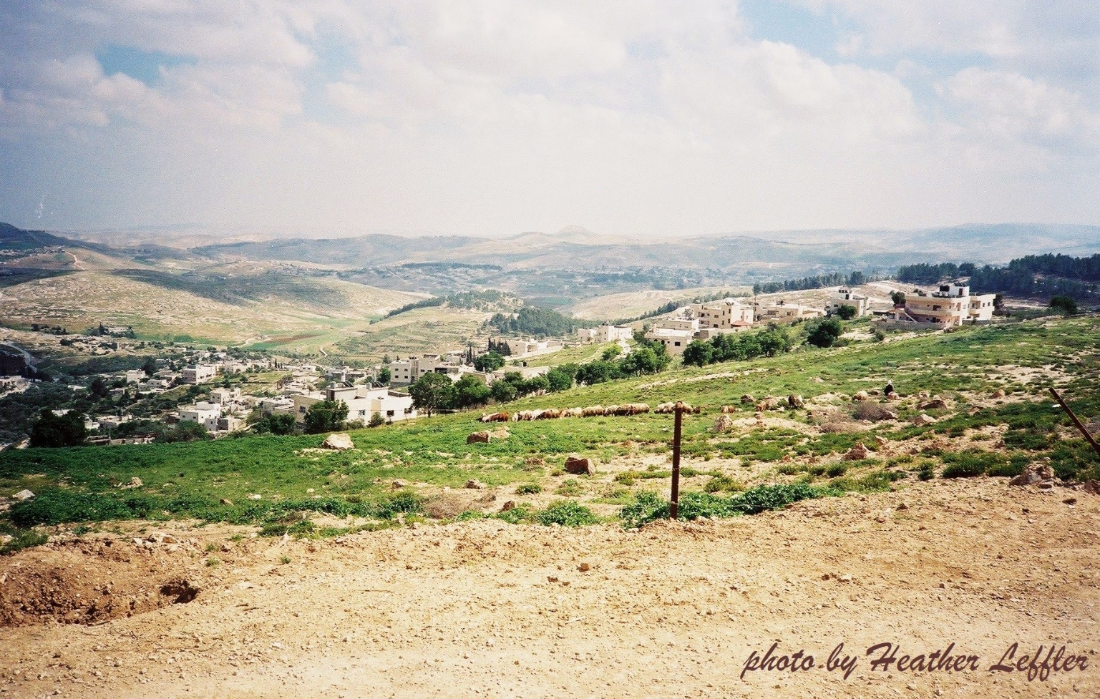
Scripture: Luke 10:25-37 NRSVUE
https://www.biblegateway.com/passage/?search=Luke+10%3A25-37++&version=NRSVUE
From Brian Mack:
In a homily that I listened to from St. Cecilia in Boston in late May, Fr. John Unni, began his message with the words: “We must link 2000 years ago to today.” I have thought a lot about those words in the last six weeks and they came readily to mind when I was reading the story of the Good Samaritan.
The steeply descending road from Jerusalem to Jericho where one may fall victim to “robbers” is very much a part of our back roads, villages, and cities today. Imagine that you are the person laying in the ditch beside the road in the prosperous and progressive nation we call Canada. The beating that you have received may have come at the hands of car jackers intent on stealing your prized possession. The blows that have reigned down upon you may be traced back to your residential school experience. Your feelings of being despised may flow from the constant reminders that you don’t live up to societal expectations and are homeless. Your angst may be a product of the fact that you don’t feel safe because of your sexual orientation, the color of your skin, or the faith you practice. Physical or psychological challenges may have weighed you down and you can’t find the energy to raise yourself up from the ditch. Your anxiety may come from your perceived shame of being a victim of food insecurity due to rampant inflation and having to step into a food bank facility for the first time. Your constant feeling of worthlessness, as an immigrant, may stem from the words of hatred that you have been subjected to as you seek to make your way in Canadian society.
Who is my neighbor? If Jesus were asked that question on July 10th, 2022, by a prosecuting lawyer, imagine the parable that he would use in response. In offering a modern-day story, I have no doubt that Jesus would lift up all those who are marginalized, facing persecution, and living without hope some 2000 plus years after his original telling of the Good Samaritan parable. Thanks be to God.
Contemplation and Conversation
When have you been laying hurt in a ditch? Who reached out to you in love?
Prayer
Holy One, as we go about our busy lives, help us to be more aware
of those around us as we travel the modern-day road from Jerusalem to Jericho.
If we are a victim of robbers, help us to recognize those who might unexpectedly assist us.
When we see someone in the ditch, help us to love our neighbors as ourselves. Amen
Know you are a valued part of our Rockwood and Stone United Church families.

Further Conversation … Would you like to talk more about today’s reflection? Email Heather at hleffler@rogers.com. Following worship next Sunday, she will invite others to join you in a Zoom break out room to share in further conversation.

Our Rockwood Stone Family
If you missed today’s worship service, email you can watch it on the Rockwood Stone YouTube page

United Church of Canada
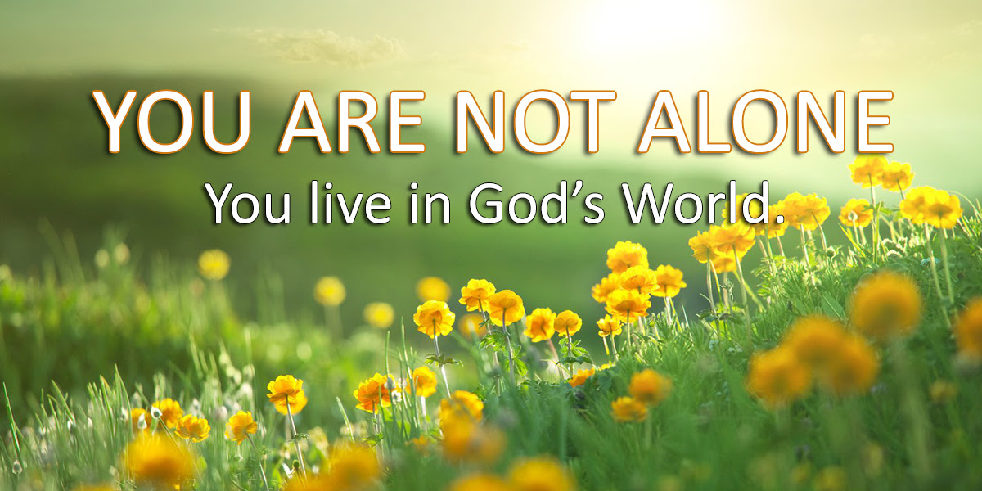
Western Ontario Waterways Regional Council State of the Church
from the desk of President Mark Laird
We are not alone; we live in God’s world. Specifically, we live within the bounds of Western Ontario Waterways Regional Council, and we are not alone. There are close to 150 United Churches within our bounds, and I thank God for everyone. I want to send a "thank you" on behalf of the Covenant Commission for the record number of Annual Reports that communities of faith have sent in this year. These reports give helpful information to the commission and allow them to see trends which can help to inform decision making.

This year, (as I’m sure has been the case for the last 2 years) a trend that has been noticed is that
congregations are weary, and ministry personnel are stressed.

I don’t know when the official end to the pandemic will be, but I think it's important to acknowledge where we are now. It has been over 2 years of learning: how to do church differently, adjusting on the fly, trying to find the spirit at work, saying goodbye to loved ones in a way that felt different and sometimes without closure. Congregations have closed, not because of the pandemic, but it was the proverbial final straw. I know that personally I have had to learn tech and stretch myself farther than what I was taught at school.

....... | But I know that I am not alone. | .......

The United Church of Canada is celebrating 97 years this year …. and those who have come before us faced challenges as well. I can’t imagine being a church leader during the depression or WWII just to name two such challenges. The church, its congregations and its leaders have gone through a lot in our history together and the spirit has always led us through to the other side. Maybe not always how we thought it would lead us or how we wanted to be led, but there has always been new life.

We are a resurrection people, and resurrection means new life, not the same life continued (to quote some brilliant theme of a not-too-distant WOW meeting).

So, know that you are not alone. We have all experienced the pandemic together, yes, in different ways, but we all have had to adapt and feel the spirit reaching out anew.

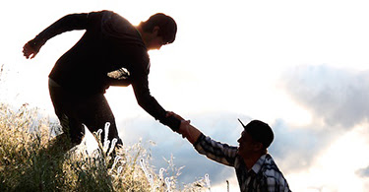
I encourage you to take the summer to see this newness, explore what has changed in your local context that is worth keeping. What aspects of your faith, your spirituality that needed to be changed due to the pandemic are worth keeping around?

Enjoy the warm summer months, perhaps find the time and space to have some outdoor gatherings, if inside-in person still seems like a stretch for your community of faith. Explore creation, explore your faith, explore where the spirit has led us and where it might be leading us into the future.

These last couple of years we have been focusing our education at the regional council level on unsettling our world views - which has been incredibly important.

....... | It is also important to be inspired,  to spend time together and to lift each other up. | .......

We hope to hald some events in the fall that can do just that. In the meantime, call your neighbouring community of faith and ask them how they are. Talk to your clergy friends, have a coffee together outside. Reach out to each other and know that:

.................. | You are not alone,  you live in God’s world,  who has created and is creating,  who reconciles and makes new,  ever working by the Spirit ……. you are not alone,  and thanks be to God. | ..................

Blessings,

Mark Laird
President, Western Ontario Waterways Regional Council

A gift of belonging to a church is that the practice of gathering together for worship … to pray, sing, listen to scripture and share how God touches our lives – helps us grow in deeper relationship with God and each other. We are offering this practice of sharing beyond Sunday morning to deepen our connection. Each week you are offered a picture, a scripture and a question for contemplation, as well as a short reflection for you to contemplate, have conversation with people in your life and/or join an online conversation on our Rockwood Stone Facebook page.

