Contemplation and Conversation: 6th Sunday after Pentecost, July 17, 2022
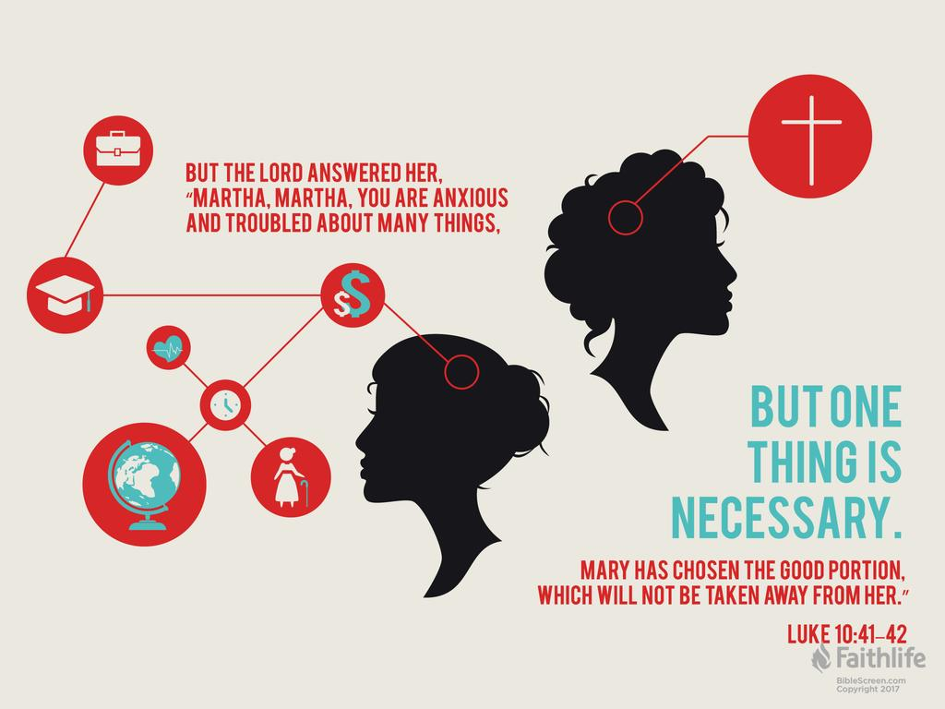
Scripture: Luke 10:38-42 NRSVUE
https://www.biblegateway.com/passage/?search=Luke+10%3A38-42&version=NRSVUE
From Tammy Smits:
There are those bible stories that are so familiar, we rarely stop and think about them anymore. The story of Martha serving Jesus while Mary sits and absorbs his teachings is such a passage - only 4 short verses commending Mary for her attention to Jesus while Martha is rebuked for being distracted, stressed and frustrated that she is doing all the work.
As our calendars fill up again with post-COVID activities: family gatherings and big weddings that were missed for long years, concerts and sporting events, vacations, volunteering and working in-person, it is easy to get wrapped up once again in the hustle and bustle of life.
Added to our personal agendas are the collective societal issues blasted by the media for our constant consideration: elections and their implications, rising food, housing and fuel prices, severe weather events due to climate change, supply chain uncertainties, and war in Ukraine that leave us worrying with no sense of control over the outcomes.
The frenzy of activity and uncertainty can leave us feeling like Martha, who was “…worried and troubled over so many things…”. She is not just admonished for her complaints about working, but for her inability to realize that Jesus and his message were the top priority. Mary was wise enough to recognize that focusing on Jesus was of the utmost importance, despite societal pressure as a woman to behave differently.
When life is spinning too quickly and worries cloud our minds, like Mary, we need to remember to focus on Jesus and his message that He is the “one thing that is needed”. Everything else is secondary.
Contemplation and Conversation
How do you find time to make God your priority when it seems like everything else is in the way?
Prayer
Dear God,
Help us to remember to focus on You, especially when life is difficult, and we are torn in many directions. Help us to remember You are the strength we need, and You never let us down. Amen.
Know you are a valued part of our Rockwood and Stone United Church families.

Further Conversation … Would you like to talk more about today’s reflection? Email Heather at hleffler@rogers.com. Following worship next Sunday, she will invite others to join you in a Zoom break out room to share in further conversation.

Our Rockwood Stone Family
If you missed today’s worship service, email you can watch it on YouTube
Thank you to everyone who joined us for Stone’s first hybrid service and for the people on Zoom who persevered through our technical challenges (like misplacing the cord for our good microphone!)
Our Outreach Partners
Anishnabeg Outreach is looking for volunteers to help weed their garden on Thursday, July 21 from 9am-12pm (see attached poster for details).

United Church of Canada
From Moderator Richard Bott


The UCW (United Church Women) has been a vital group in every congregation with whom I've served, and as I was growing up.
I remember not only their amazing service to the congregation and the wider community, but also the depth of their biblical and scriptural exploration, and their support of women's discipleship and leadership in the life of The United Church of Canada (and, in fact, growing Jesus' disciples throughout the whole congregation, through their love, guidance, strength - and seemingly neverending meals that fed the body and soul!)
Today, as the national UCW gathers to celebrate 60 years of life and community and ministry, I celebrate all that they have been, are, and will be.
Alleluia, loving God - ALLELUIA!
For all the saints
whose labour still goes on,
for all the ones who,
right from dawn to dawn,
live out Christ's love,
stand in the face of what's wrong;
hallelujah, hallelujah!
Decisions made,
in learning, work, or play;
attest to Christ's life,
each and every day;
as stewards, disciples,
we walk on Jesus' Way -
hallelujah, hallelujah!
So let us go,
as people of Christ's peace;
to feed and to heal,
and from bondage help release,
all those in need;
by our witness, life increase -
hallelujah, hallelujah!
Tune: Sine Nomine (For All the Saints) - 10 10 10 with hallelujah
A gift of belonging to a church is that the practice of gathering together for worship … to pray, sing, listen to scripture and share how God touches our lives – helps us grow in deeper relationship with God and each other. We are offering this practice of sharing beyond Sunday morning to deepen our connection. Each week you are offered a picture, a scripture and a question for contemplation, as well as a short reflection for you to contemplate, have conversation with people in your life and/or join an online conversation on our Rockwood Stone Facebook page.

