Contemplation and Conversation: 7th Sunday after Pentecost, July 24, 2022
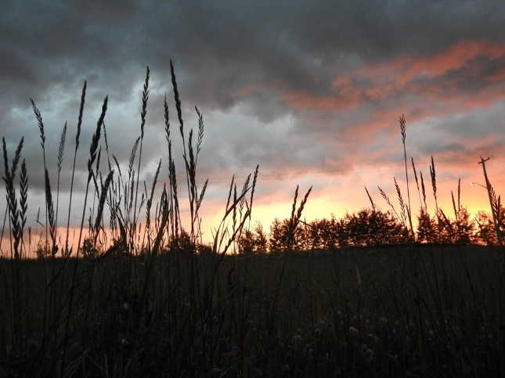
Scripture: Luke 11:1-13 CEV https://www.biblegateway.com/passage/?search=Luke%2011%3A1-13&version=CEV

From Rev. Heather Leffler:
I remember being so embarrassed as a Sunday School teacher, and later as a new minister, leading the Lord’s Prayer and forgetting where I was. A wise colleague shared that sometimes when we pray, the familiar words wash over us like waves washing up on the shore making it easy to lose our place. We can trust that the Spirit prays through us in these times.
I also appreciate the other times, when we hear this familiar prayer in a new way and find ourselves drawn closer to the One who is Holy Mystery and Wholly Love. My spiritual director told me this week that she heard a Catholic priest after praying these familiar words, say he would like us to stop using the King James Version of our Lord’s prayer because God would never lead us into temptation. The One who loves and forgives us is much more likely to keep us from temptation as the Contemporary English Version of Matthew 6:13 says, than to lead us into it.
Whatever version of the prayer Jesus taught us, there is nothing more precious than saying or singing it with our church family. I especially love to hear the words echo as we pray together on Zoom. Whenever and wherever we think, say or sing our prayers, Jesus assures us that God is ready to give the Holy Spirit to us when we ask. May we give thanks to God and ask for what we, others and the earth need, trusting that God hears all our prayers spoken and unspoken and answers in love.
Contemplation and Conversation
Who or what is the Spirit inviting you to pray for today?
Prayer
Loving Parent, we give thanks for the gift of knowing Jesus
and the blessing of being part of your church.
Help us to make prayer as much a part of our lives as breathing,
so that you can use us to bring healing and hope to your world. Amen.

Know you are a valued part of our Rockwood and Stone United Church families.

Further Conversation … Would you like to talk more about today’s reflection? Email Heather at hleffler@rogers.com or start a conversation on our Facebook page.

Our Rockwood Stone Family
If you missed today’s worship service, email rockwoodstoneuc@gmail.com for a YouTube link.
Diane May is in rehab at St. Joseph’s Hospital Guelph and would love some phone calls. Her number is 519-824-6000 Ext 2919 (her room number as well).
From the May Family: The One and Only Diane May
As we were unable to celebrate Diane’s 80th in a deserving way, we decided to take an alternative route to remind Diane how loved and cherished she is. This survey will be sent out to friends, family, and neighbours (who we are thankful to consider both friends and family as well!!) and all answers will be displayed in a presentation for Diane to view! If you experience any difficulties understanding, answering, or submitting the questions, please feel free to contact Jordan (Andy's girlfriend) by call or text at 647-923-7564. We can’t wait to share this project with Diane (and all of you who are interested in the results) and learn a little more about her along the way!
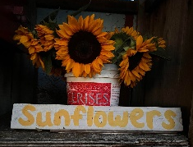
https://l.facebook.com/l.php?u=https%3A%2F%2Fdocs.google.com%2Fforms%2Fd%2Fe%2F1FAIpQLSf0GbSQX1vyhSjAg49dK9tz524vngBGIXOJPlLg4fuNgy8dyw%2Fviewform%3Ffbclid%3DIwAR3gcWk0eYM2iLgXyDw2SCxAP8XiUwSNnosQXvlDrQnpLgs16RGfrbDy9UA&h=AT3ubWRYp8aJcP3ulFPJPKkDegWsxtRNMYm28CPbpk8iLVHv7VsjQI6GLNX4Da9YfpEdLs6m3c7EFeLlM6qlZbsNCmDYUBurAQhR_tj1Vto73wXFqqaBlX4msQpaKW09N8KcVrFQsZN8kXSJSso
Also, Jordan is once again asking for donations for her sunflowers to go to the Indian Residential School Survivor Society (IRSSS) https://www.irsss.ca/. The booth is at the end of Tim and Kirsten’s lane 5209 Eramosa 4th Line.

United Church of Canada
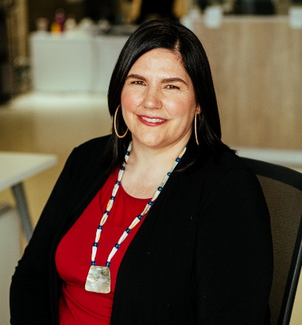
July 23, 2022
The United Church of Canada has elected the Rev. Dr. Carmen Lansdowne, Kwisa’lakw(opens in a new tab), 47, as its 44th Moderator. She will be the church’s spiritual leader for the next three years.
Ordained in 2007, the Rev. Dr. Lansdowne is only the second Indigenous person to be elected Moderator, following the Very Rev. Stan McKay, who served as Moderator 1992‒1994. A member of the Heiltsuk First Nation, she was born in Alert Bay, British Columbia, and has been a lifelong member of the United Church. She is committed to an Indigenous way of being in the world.
In articulating her vision for The United Church of Canada, the Rev. Dr. Lansdowne speaks of a church committed: “To build new connections and rebuild old ones. To work towards social change that sees a world cared for, and human dignity honoured. To walk together every day in repentance and reconciliation. To march and fight and change unjust systems together. To pray together. To sing together. To discern together.”
The Rev. Dr. Lansdowne holds a PhD from Graduate Theological Union in Berkeley, California. In addition to her theological contributions as a writer and speaker, she has served the church in a variety of roles locally, nationally, and with the World Council of Churches. As Moderator, she will be on leave from her position as Executive Director of First United Church Community Ministry Society, which serves the people of Vancouver’s Downtown Eastside.
General Secretary the Rev. Michael Blair spoke of “great excitement across the church” at the election of the Rev. Dr. Lansdowne, saying, “She embodies the deep spirituality, bold discipleship, and daring justice to which the church aspires.” The Rev. Dr. Lansdowne was uncontested in the Moderator election.
At this moment of transition, the United Church also expresses its sincere gratitude to outgoing Moderator the Right Rev. Dr. Richard Bott, who served the church with grace during an extraordinary and extended period. Of the transition, the Rev. Dr. Bott said: “I look forward to supporting our new Moderator as she leads the church in this critical time. A powerful voice, Moderator-elect Lansdowne will bring lived experience, wisdom, and an abundance of gifts to lead needed transformation in the church and the world.”
Meeting online for the first time in its 97-year history, the church’s General Council 44will install the new Moderator at its closing worship service on August 7, 2022. This worship service will be livestreamed across the country, with an in-person event held at Canadian Memorial United Church in Vancouver at 1 p.m. PT.
For more about General Council 44, go to https://generalcouncil44.ca/.
For further information: Aaron Gallegos, agallegos@united-church.ca .

A gift of belonging to a church is that the practice of gathering together for worship … to pray, sing, listen to scripture and share how God touches our lives – helps us grow in deeper relationship with God and each other. We are offering this practice of sharing beyond Sunday morning to deepen our connection. Each week you are offered a picture, a scripture and a question for contemplation, as well as a short reflection for you to contemplate, have conversation with people in your life and/or join an online conversation on our Rockwood Stone Facebook page.

