Contemplation and Conversation: 8th Sunday after Pentecost, July 31, 2022
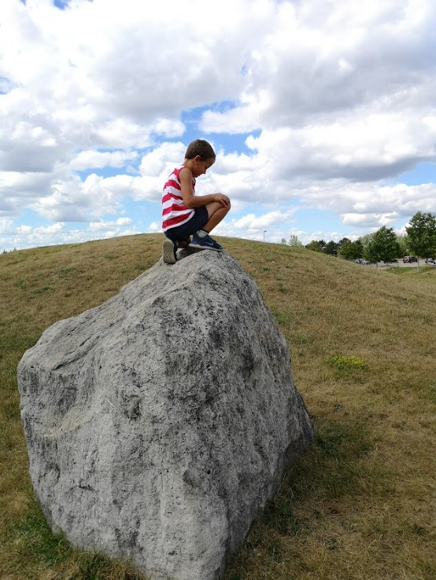
Scripture: Luke 12:13-21 NRSVUE https://www.biblegateway.com/passage/?search=Luke%‌2012%3A13-21&version=NRSVUE
¹³ Someone in the crowd said to him, “Teacher, tell my brother to divide the family inheritance with me.” ¹⁴ But he said to him, “Friend, who set me to be a judge or arbitrator over you?” ¹⁵ And he said to them, “Take care! Be on your guard against all kinds of greed, for one’s life does not consist in the abundance of possessions.” ¹⁶ Then he told them a parable: “The land of a rich man produced abundantly. ¹⁷ And he thought to himself, ‘What should I do, for I have no place to store my crops?’ ¹⁸ Then he said, ‘I will do this: I will pull down my barns and build larger ones, and there I will store all my grain and my goods. ¹⁹ And I will say to my soul, Soul, you have ample goods laid up for many years; relax, eat, drink, be merry.’ ²⁰ But God said to him, ‘You fool! This very night your life is being demanded of you. And the things you have prepared, whose will they be?’ ²¹ So it is with those who store up treasures for themselves but are not rich toward God.”
From Rev. Heather Leffler:
Working hard and storing grain for the winter is a good thing, isn’t it? Shouldn’t we all save for the future so we can go to school, buy a home, support our children, have enough in retirement, support our church and other needs in the community?
As I read the parable of the rich man, I find myself looking at my life and asking what is enough? I am grateful for my work. It is a gift to serve with you. There are times when I find it hard to take a break because there are so many things I want to do.
Thursday my daughter phoned to say our oldest grandson needed a break from his brothers and wanted to come for the night. I set aside my to do list. We went for ice cream, watched a movie, played chess (and I finally won a game), tried Mr. Beast burgers and went to the park and threw frisbees while everyone else had a nap. I love my work, but it was a gift to take a break and spend time with John. As I reflected on the parable of the rich man, I realized again how important balance is in life.
Jesus urges us to balance our work, play and worship so that we can enjoy the fullness of life the Creator has given us.
Contemplation and Conversation
Where might Jesus be inviting you to pause and take time for something different in your life?
Prayer
Holy One, help us know what is enough. Teach us to balance our work, play and worship
so that we can enjoy the fullness you long for us. Amen.
Know you are a valued part of our Rockwood and Stone United Church families.

Further Conversation … Would you like to talk more about today’s reflection? Email Heather at hleffler@rogers.com. Following worship next Sunday, she will invite others to join you in a Zoom break out room to share in further conversation.

Our Rockwood Stone Family
If you missed today’s worship service, email rockwoodstoneuc@gmail.com for a YouTube link.

Stone Foodgrains Growing Project
It is almost time for the zucchini contest judging, which will be held August 14 following worship (11 am). Just two more weeks to water and tend to your entries!
Please bring your zucchini(s) for the heaviest and longest categories. If you can't attend, please drop off at church front step, labelled with your name, or take a picture with measurements, and send to Lisa Leffler at lleffler@live.ca
We will have zucchini muffins/loaves and beverages for refreshments. Come and enjoy some outdoor fun and share how your sunflowers and pumpkins are doing in this challenging summer for gardeners and farmers.
The giant pumpkin, and tallest sunflower models will be returning to the church parking lot to promote our project and they will be joined by an enormous zucchini as well. Stay tuned!

United Church of Canada: Gifts with Vision at Work in Ukraine
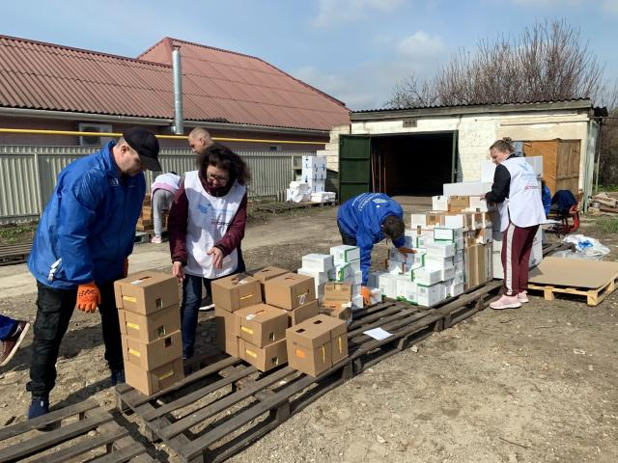
Published On: June 13, 2022
During peaceful times Kharkiv has a population of 1.5 million people—larger than Calgary and just a bit smaller than Montreal. But since the Russian invasion in February, half of those people have fled the city for safer places. Those who are still in Kharkiv are the people who can’t leave: because they have nowhere to go, because they’re unable to travel, or because they’re taking care of others who must stay.
Grocery stores in Kharkiv are closed, public transit has stopped running, there is no electricity or running water, and many roads and buildings are unsafe. Although the daily Russian air raids have ended there are still intermittent rocket attacks and people still spend time in shelters. Add to this the fact that most people who are still there live in poverty or are disabled, and it’s clear that those who are left in Kharkiv are the ones least able to survive without help.
ACT Alliance member Hungarian Interchurch Aid has recently been able to bring relief shipments to volunteers in Kharkiv, like Sergei Babin. Babin and his team are providing those who are unable to leave the city with food and other items they need.
“We are grateful for any kind of help, as the people of Kharkiv have been suffering from this serious humanitarian crisis for many weeks now,” he says.
Providing emergency food and hygiene kits(opens in a new tab) is one way your generous support of Mission & Service partners is helping support Ukrainian refugees.
Thank you for your compassion.

A gift of belonging to a church is that the practice of gathering together for worship … to pray, sing, listen to scripture and share how God touches our lives – helps us grow in deeper relationship with God and each other. We are offering this practice of sharing beyond Sunday morning to deepen our connection. Each week you are offered a picture, a scripture and a question for contemplation, as well as a short reflection for you to contemplate, have conversation with people in your life and/or join an online conversation on our Rockwood Stone Facebook page.

To put a shortcut to Zoom on your computer’s desktop:

- Highlight the Zoom link below by clicking and holding your left your mouse button and dragging your mouse to the end of the link https://us02web.zoom.us/j/6995074926?pwd=eTk1T1d0V2NXVVNxazlEcGpuL3JpUT09
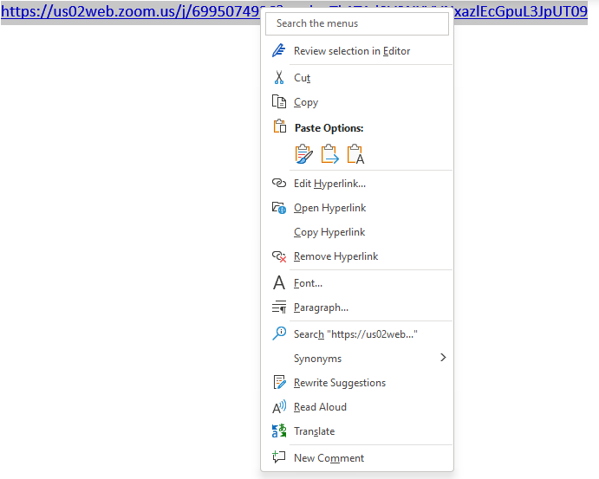
- Right click and elect Copy Hyperlink.
- Go to a blank space on your desktop and right click.
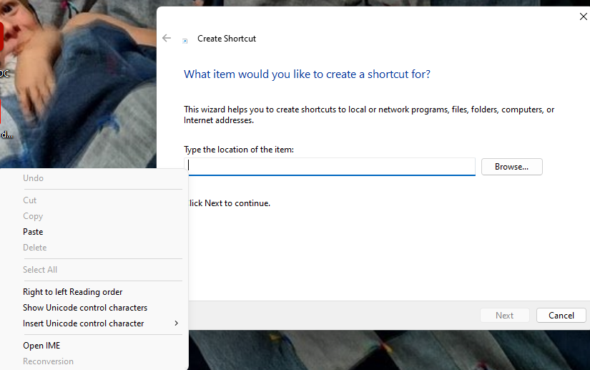
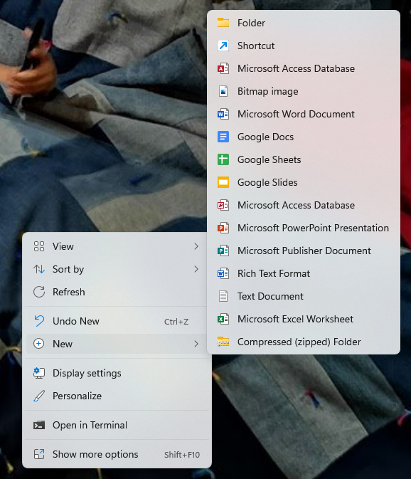
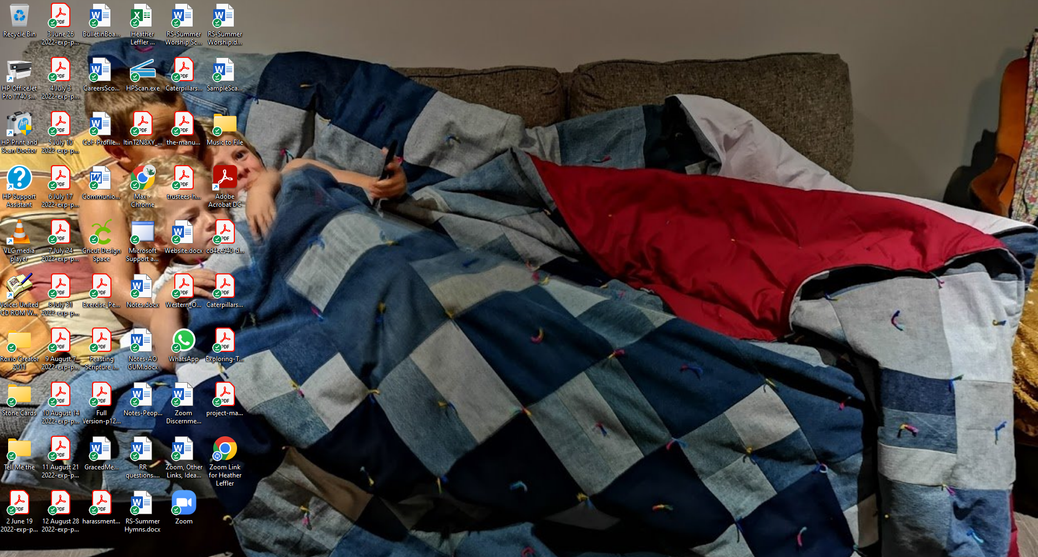
- Left click on New and Shortcut.
- Right click under Type the location of the item:
- Select paste.

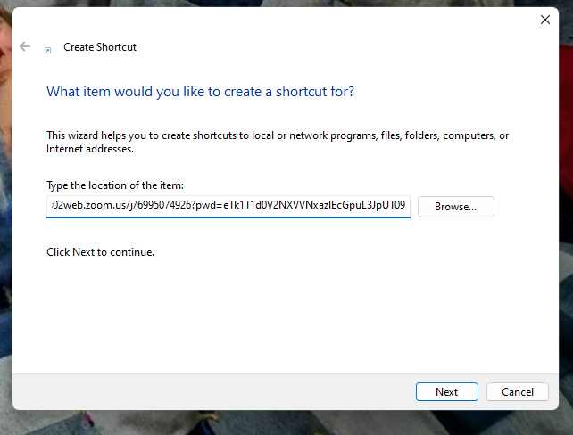
- Left click Next.
- Type Zoom Link for Rockwood Stone and click Finish.

- Zoom Link will be on your desk top and can be clicked anytime.
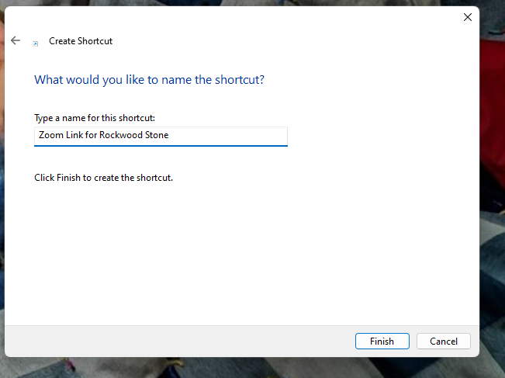
For other ways to create a link to Zoom, in your browser search for how to put a link for Zoom on your device.

