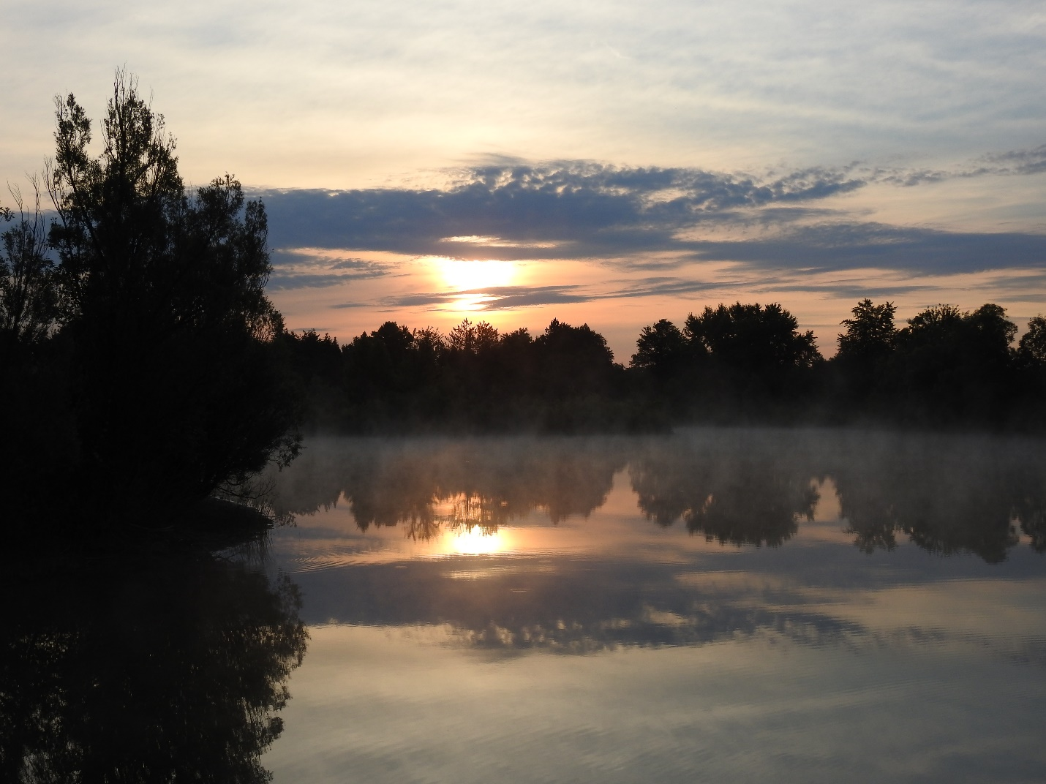
Contemplation and Conversation: 9th Sunday after Pentecost, August 7, 2022
Scripture: Hebrews 11:1, https://www.biblegateway.com/passage/?search=Hebrews+11%3A1-3%2C+8-16&version=NRSVUE
¹ Now faith is the assurance of things hoped for, the conviction of things not seen. ² Indeed, by faith our ancestors received approval. ³ By faith we understand that the worlds were prepared by the word of God, so that what is seen was made from things that are not visible.
⁸ By faith Abraham obeyed when he was called to set out for a place that he was to receive as an inheritance, and he set out, not knowing where he was going. ⁹ By faith he stayed for a time in the land he had been promised, as in a foreign land, living in tents, as did Isaac and Jacob, who were heirs with him of the same promise. ¹⁰ For he looked forward to the city that has foundations, whose architect and builder is God. ¹¹ By faith, with Sarah’s involvement, he received power of procreation, even though he was too old, because he considered him faithful who had promised. ¹² Therefore from one person, and this one as good as dead, descendants were born, “as many as the stars of heaven and as the innumerable grains of sand by the seashore.”
¹³ All of these died in faith without having received the promises, but from a distance they saw and greeted them. They confessed that they were strangers and foreigners on the earth, ¹⁴ for people who speak in this way make it clear that they are seeking a homeland. ¹⁵ If they had been thinking of the land that they had left behind, they would have had opportunity to return. ¹⁶ But as it is, they desire a better homeland, that is, a heavenly one. Therefore God is not ashamed to be called their God; indeed, he has prepared a city for them.
From Rev. Heather Leffler:
What a gift to have faith. Abram and Sarai entered into a covenant with God. They were given new names Abraham and Sarah and knew God’s presence wherever they went. God took them to the promised land and gave them their son Isaac in their old age. They trusted that God was with them in life, in death and life beyond death.
In a world where so many people are alone and lonely, afraid that someone will steal their possession or in their poverty they won’t be able to feed their family, we have been gifted with faith. Through prayer and worship, we are invited to recognize God’s Spirit that is with us just as God was with Abraham. Making a difference in our community and world through our partners enriches our lives and helps bring about God’s kingdom. May we all share our faith with others, confident that our lives are richer as followers of Jesus.
Contemplation and Conversation
Who might you share the story of your faith with?
Prayer
God of Abraham and Sarah, we give thanks for our communities of Rockwood and Stone.
Help us share our faith, so that others might know the gift of knowing you through Jesus. Amen.
Know you are a valued part of our Rockwood and Stone United Church families.

Further Conversation … Would you like to talk more about today’s reflection? Email Heather at hleffler@rogers.com. Following worship next Sunday, she will invite others to join you in a Zoom break out room to share in further conversation.

Our Rockwood Stone Family
If you missed today’s worship service, email rockwoodstoneuc@gmail.com for a YouTube link.
Offering Praise from Mike Bascom
In 2001, I felt it during a basketball game ocean-side in Vancouver BC. In 2003, I felt it during a basketball game in March.
After a car accident late in 2003, I have not felt it since.
Now, our son Matthew is playing baseball, and this morning, by the grace of God, I feel it again. It fills our house with hope, with energy, with a slight tingle of nervousness, with anticipation, with eagerness, with joy.
It is, of course, big game energy.
How many times have we awakened in the cool and quiet of the morning earlier than we would otherwise? But this is not like waking up early for school. With tousled hair and sleepy eyes we rise slowly and gently into the early morning - but there is a willingness to do so. As the sleep begins to leave our bodies, energy begins to flood in.
Quietly we prepare. A small breakfast. Time to put on our equipment and uniform. Time to check our gear. Backpack: check. Glove: check. Bat: check. Baseball cleats: check. Water bottle: check.
Advice from Mommy and Daddy: we love you, have fun, do your best.
Uniform check: socks, pants, belt, shirt, hat. All correct. Later the dirty uniform will be worn as a badge of honour. For now, it must be just right. Get those cleats tied up.
Practice swings. Fielding drills. Performed in the living room, of course. Getting ready.
Big game energy.
The car is packed. Food and refreshments for the day. Everything we will need.
Grandma (doo-aah) stops by. Her grandson looks mighty fine in his uniform. She can feel it too. Perhaps, she has felt it before.
Big game energy.
Our house is peaceful and quiet. It will be fine to return to rest there later.
For now, there is a game to play. No finer day than this.
With humility, respect and gratitude, we go to play. God has given us a precious gift. A moment in the sun. We walk tall to the car.
Big game energy.

Join us for Faith, Food, Friendship and Fun on Friday, August 19 at 6 pm, on the lawn at Rockwood. Join us for dinner, activities, conversation, a craft, and casual time of worship.
Contact Heather at hleffler@rogers.com or 519-265-7385 by the Wednesday, August17. Please bring a lawn chair. Everyone is welcome.
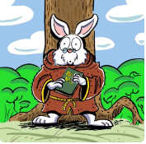
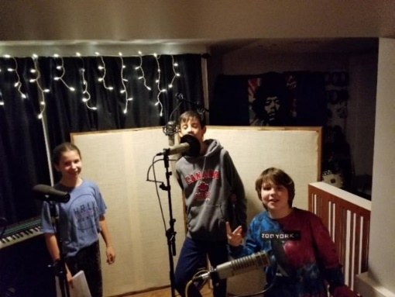
United Church of Canada
Podcast Invites Children to Engage Deep Spiritual Questions
One of a stellar lineup of exciting projects to receive funding
Published On: July 19, 2022
Are you a parent or grandparent with children home for summer vacation? Looking for healthy, screen-free, and imaginative ways to engage them and nurture their Spirit at the same time?
The Scribblers Story https://sites.google.com/view/scribblersstory/home a new Christian children’s podcast, just might be the answer.
The podcast takes a creative approach to encourage children to explore their imagination and faith without using screens. Described as “Narnia with kid actors and a soundtrack,” the adventurous storyline released in 15-minute episodes every Monday through the summer, takes children on a purposeful and fun journey to engage with deep spiritual questions.
“Especially over the past few years, children have been spending more time on screens. Podcasts and audiobooks inspire the use of imagination and creativity in children, and are more portable than TV shows and movies. Perfect for bedtime or car rides!” says Amy Van Wensem, the show’s Executive Producer.
Not only are the podcasts convenient, portable, and allow listeners to relax or multi-task while tuning in on their own time, they also give blossoming young actors like Paige, Isaac, and Jakob (pictured above), an opportunity to grow their faith and skills in a professional, exciting environment.
Supported by Vision Fund https://united-church.ca/community-and-faith/being-community/children-and-youth/vision-fund and Embracing the Spirit https://united-church.ca/community-and-faith/being-community/embracing-spirit grants, The Scribblers Story is one of a stellar lineup of exciting projects to receive funding. Both grant programs are designed to inspire innovation and are supported by generous gifts to Mission & Service https://united-church.ca/donate .
Best of all, The Scribblers Story is a free resource for children and families, and it’s available on Spotify, Apple Podcasts, iHeart, and Buzzsprout. Please share it widely with your communities and networks!
And, as always, thank you for supporting innovative ministry projects through Mission & Service.

Anishnabeg Outreach Update from Steven Jackson
Hi All,
At AO, we try to build programs that have positive and long-term impact for Indigenous people. Our penultimate goal is to provide processes and programs that enable healing and employment. We believe healing and employment will lead to the achievement of reconciliation. Typically, we try to ameliorate one or more of negative impacts related to reconciliation or intergenerational trauma. We are incredibly thankful when organizations or individuals support us, partner with us or help us deliver the services and solutions we create. We are incredibly thankful when we are funded or partially funded to build a program or deliver a program that moves the needle on reconciliation. However, most of what we build, is built off the sides of our desks and without any funding. We believe once we demonstrate impact, funding will eventually flow. And in the meantime, delivering life changing programs and services is incredibly rewarding and fulfilling for the AO team.
It has been a couple of months since we were recognized as the top not for profit in the region and provided update on new developments at AO. The Indigeneers and Indigeneers in training (summer students) have been very busy over the summer months developing new programs and solutions. Students gifted to us by the federal Canada Summer Jobs program have been a godsend. Our talented students have helped us build so much goodness this summer which will have impacts far beyond just Indigenous people in need.
Reconciliation Spirit Garden
Our partnerships with St Mary’s Catholic Church and the Hamilton Catholic Diocese has resulted in a 10 acre garden project in Breslau. Our elder has named the garden Eminidowang Kitigaan (Ahe-men-ni-duh-wung Kit-ah-gawn) which means Spirit Garden for Everyone. For us, this is a land base where we can begin the work of reconciliation and where reconciliation-based partnerships will take root, grow and flourish. This year we planted ancient Indigenous squash provided by our partner, the Ken Seiling Museum that were previously grown by Indigenous people living in the region hundreds of years ago. We also planted pumpkins and other food bearing plants. Perhaps the most important part of the garden is the traditional medicines we began propagating to ensure there would be ample smudge medicines for all Indigenous people living in the region as we deal with another year of Covid and hyper inflation. Our garden has been supported by RBC, Enbridge, Neighbourhood Group of Companies, Woodland Christian School, churches, clubs and many more individuals who have come out to help plant and weed our communal garden. A couple of weeks ago, a few companies helped us weed the garden to provide light to the plants. In two short weeks, the plants have thrived and now some of the pumpkins have grown to more than a food in size. The food when harvested will support the more than 1,000 people on our Spirit Bundle program which provides food and clothing support for Indigenous families impacted by reconciliation and the pandemic. We welcome companies coming to our land and helping us grow food for Indigenous people in need around the region. A simple way to build reconciliation-based solutions and partnerships. If anyone wishes to support our garden, please come out and help us weed any Friday morning in the month of August.
Here are a recent sampling of articles and stories about our garden:
Nurturing relationships and reconciliation: Growing garden brings together Indigenous community and Catholic church https://kitchener.ctvnews.ca/nurturing-relationships-and-reconciliation-growing-garden-brings-together-indigenous-community-and-catholic-church-1.6003149
Breslau garden growing for reconciliation https://kitchener.ctvnews.ca/video?clipId=2491100
Waterloo Region reconciliation garden bringing Indigenous community and Catholic church together in healing https://www.therecord.com/local-new-hamburg/life/2022/07/25/waterloo-region-reconciliation-garden-bringing-indigenous-community-and-catholic-church-together-in-healing.html
New Tutoring and Sports Programs
Thanks to a grant from the Hallman Foundation, we will be developing a pilot tutoring program for Indigenous youth living in the region. Our team will be launching the program this fall to help support Indigenous youth achieve academic success. We are also partnering with Carizon, WRDSB and others to deliver tutoring from a variety of our partner sites in order to help marginalized students who are struggling with academics during the pandemic. We believe this program will help ameliorate the 500% higher dropout rate for Indigenous students.
We also recently partnered with Westmount Golf and Country Club during their hosting of the Women’s Junior Amateur tournament. At a clinic for the youth in our program, we were introduced to Golf Canada and have now partnered with them. This fall, we will add their First Tee program to our ever-expanding offering of sports programming. This program will be similar to the program we run with the Blue Jays. We have also created a number of partnerships with Churches and community centres to create additional program/gym space for our expanding sports programs. We are now running sports programming five nights a week. In the fall we will offer a comprehensive sports and tutoring program for Indigenous youth.
Here is an article about our golf partnership with Westmount: https://explorewaterloo.ca/2022/07/back-into-the-swing-of-things-the-canadian-womens-amateur-golf-championship-in-waterloo-region/
New STEM Camp
Through our partnership with Creative Encounters and UGuelph, this is the second year we offered a STEM Camp for Indigenous youth. Last summer, we needed to offer the camp virtually by providing online programming and camp in a box bundles. This year we provided our camp in person. We had 40 youth at our centre of healing this week participating in a variety of activities. On Friday, APTN will create a news story on this camp and the camp will culminate with a celebratory carnival. One of our new partners (Chef On Call) is catering a final lunch for the participants. I am so thrilled our team has been able to provide a free in-person STEM day camp to Indigenous youth this year.
New Second and Third Centres of Healing
I am also extremely thrilled to announce our Second Centre of Healing which is located in Guelph and in partnership with Trinity United Church has received its first funding. The funding and partnership will enable us to launch a much-needed spirit bundle program in Guelph. Last year our Waterloo Region-based spirit bundle program donated out approximately a million dollars worth of goods and supplies to Indigenous families in need. We hope to grow our fledgling Guelph program to the same level of capacity in the next couple of years. We are working on funding for our third centre of healing which is located in North York. We hope this centre will become our centre for reconciliation training for corporate Canada.
Continuing Vaccinations for Indigenous people
We have also committed to continue to offer Covid vaccinations and boosters at our safe facility to all Indigenous age groups until at least the end of the year and hopefully beyond.
New Virtual Indigenous Museum
A few months ago we began a small partnership with Dragen’s Lab (UW) to create a mobile 3D printer site. This partnership has expanded significantly since then. The Ken Seiling Museum offered us the opportunity to scan Indigenous artifacts for our virtual museum. We more recently partnered with the Royal Ontario Museum and have gained access to their Indigenous collection, same for McGill University Museum and we are now in discussions with a collective of museums on the east coast. Our goal is to scan all Indigenous artifacts and make them available for printing or VR (virtual reality) viewing. Our hope is to partner to develop curriculum for some of these artifacts so students can learn Indigenous history and STEM differently. Soon, if not already, we will have the largest virtual collection of Indigenous artifacts in the world. We also view this as the way of the future for museums to make their collections accessible to all. We are very excited as these partnerships continue to evolve.
New Virtual Resource Development
My team has been very busy building a number of virtual resources for Indigenous and other marginalized people in need. They have continued to develop content for all of our various programs and partnerships. The AONest (our learning management system) continues to grow at an exponential rate as new cultural and language-based programming is put online for Indigenous people to access. My team are developing 120 best-practice life skills courses organized into 12 modules for Monica’s Place. These virtual life skill courses will also be relevant and useful to a wide variety of agencies who need to provide life skills courses for their client groups. These courses should be ready for use in the early fall. My team are also nearing completion on our comprehensive reconciliation training course. We have dramatically expanded the course offering to create a virtual train the trainer approach and to move into just in time training for a variety of situations that occur throughout the lifecycle of businesses talent management processes. We anticipate launching this comprehensive suite of courses this fall. Perhaps the most important work my team has been developing is related to the creation of virtual supports for mental health programming. We hope to have the entire suite of courses completed late fall which will enable participants to heal from a variety of mental health issues. We believe healing is the first step towards being able to achieve reconciliation.
As always, we continue to develop new programming and partnerships to help support Indigenous and other marginalized people living in the region. Thanks to everyone who has supported us or partnered with us to move the needle on reconciliation or to help those who have been marginalized.
Stephen Jackson, M.A.Sc.
CEO Anishnabeg Outreach Employment and Training Inc.
226-972-1900
https://www.facebook.com/anishnabegoutreach
https://twitter.com/anishnabeg
https://www.instagram.com/anishnabegoutreach/
www.aocan.org

A gift of belonging to a church is that the practice of gathering together for worship … to pray, sing, listen to scripture and share how God touches our lives – helps us grow in deeper relationship with God and each other. We are offering this practice of sharing beyond Sunday morning to deepen our connection. Each week you are offered a picture, a scripture and a question for contemplation, as well as a short reflection for you to contemplate, have conversation with people in your life and/or join an online conversation on our Rockwood Stone Facebook page.

