Contemplation and Conversation: 10th Sunday after Pentecost, August 14, 2022
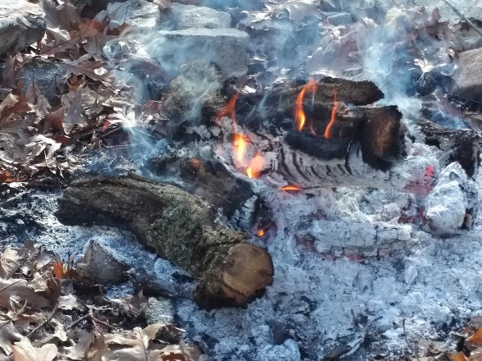
Scripture: Luke 12:49-56 NRSV https://www.biblegateway.com/passage/?search=luke+12%3A49-56&version=NRSVUE
From Rev. Heather Leffler:
For me, Jesus has always been friend who came to teach us to love and bring the peace that passes all understanding. If it weren’t for the discipline of the lectionary, I would quietly skip over this passage. Why would Jesus say that he has come to cast fire on the earth? Why would he want to divide families? How can the kingdom come if people are divided parents against children, and children against parents?
As I reflected on the Jesus words today, trying to see our world through his eyes, I discovered gift in this challenging passage. In a world where political leaders create their own “truths” manipulating their followers into seeing neighbours as enemies … where nurses, doctors and other front-line workers are exhausted and experiencing burn out while being attacked by folk who are angry, afraid and frustrated at not receiving the care that they or their loved ones need … where husbands and sometimes wives have come from violent homes or struggle with addictions and take their pain and anger out on those they love … where banks, companies, industries and even governments choose policies and practices that strengthen the bottom line for share holders instead of putting people and our planet first – in this world, Jesus’ cleansing fire and division are vital. His words urge us to listen to the people who don’t have enough … are overworked and under compensated … experience discrimination and violence and to stand up to those, even in our family or church, who make choices that do harm. He urges us to risk choosing the path that brings healing and hope, even if there is a personal cost for us. Most of all for me, the fire he speaks of is symbolic of the refiners’ fire that burns away our sins and past practices so that we can move forward rebuilding loving relationships with all people and the earth. We may need to step away from people we love because of words, actions or inactions that are hurtful for a time. We can trust that they and we are held in the love and forgiveness of Jesus.
Contemplation and Conversation
Where might Jesus be calling you to separate yourself from situations or people?
Prayer
Faithful Friend, sometimes it is hard to hear your words.
Help me trust that beyond their challenge, we can find healing and hope. Amen.
Know you are a valued part of our Rockwood and Stone United Church families.

Further Conversation … Would you like to talk more about today’s reflection? Email Heather at hleffler@rogers.com. Following worship next Sunday, she will invite others to join you in a Zoom break out room to share in further conversation.

Our Rockwood Stone Family
If you missed today’s worship service, email rockwoodstoneuc@gmail.com for a YouTube link.
Thank you for your patience us as we continue to work on our hybrid service. Using a mobile hot spot for Zoom at Stone means that there will be a weaker connection.

United Church of Canada from Past Moderator, Richard Bott, August 7 at 8:18
Well, friends, in not too many hours, I get to close this chapter of my life and ministry, and start a new one. At 1 pm Pacific, we begin the worship gathering where the Rev. Dr. Carmen Lansdowne will be installed as the 44th Moderator of The United Church of Canada. https://youtu.be/k1kOHvWec40
After so many "historic firsts" - a United Church Moderator serving a four-and-a-bit year term, in the midst of a global pandemic, requiring the successful completion of a fully online gathering of the General Council – I am more than ready to take the Moderator's stole off my shoulders, and place it on our newest Moderator's shoulders!
It has been a joy meeting with you in this space. The church has been gracious to let me keep the previous posts up, and switch the purpose of this page towards my liturgical (and other!) writing and consulting life. After a bit of rest, my website will be redesigned and up once again.
Thank you, friends, for journeying with me, this past "quadrennium". It has been a joy and a wonder to meet you in this place.
Let me finish with the same words that I started my term as the 43rd Moderator...
Christ within you,
the hope of glory to come.
Go into the world with a daring
and a tender love.
For the world needs it -
and so do we!
Go in peace, and,
in all that you do, do it for love,
and by the power of the Holy Spirit.
And remember this –
the peace of Christ holds us,
the love of the Creator enfolds us,
and the wings of the Holy Spirit carry us,
this day,
and forevermore.
Amen,
Amen,
and Amen!
from Moderator Carmen Lansdowne, August 11, 2022
I am bathing in the warmth of all of your best wishes, blessings, and prayers as I begin to take on this role as Moderator. I am feeling immense gratitude for the installation service on Sunday and all who played a part, sharing so generously through gifts, words and music. The Spirit was moving through and among in powerful ways. We felt the presence of not only all those in the church but those of you joining from all across the country. Check out this brief photo gallery at https://generalcouncil44.ca/.../photos-installation ... to catch a glimpse or watch it on The United Church of Canada YouTube channel. Feeling strengthen by your wonderful support.

A gift of belonging to a church is that the practice of gathering together for worship … to pray, sing, listen to scripture and share how God touches our lives – helps us grow in deeper relationship with God and each other. We are offering this practice of sharing beyond Sunday morning to deepen our connection. Each week you are offered a picture, a scripture and a question for contemplation, as well as a short reflection for you to contemplate, have conversation with people in your life and/or join an online conversation on our Rockwood Stone Facebook page.

