Contemplation and Conversation: 11th Sunday after Pentecost, August 21, 2022
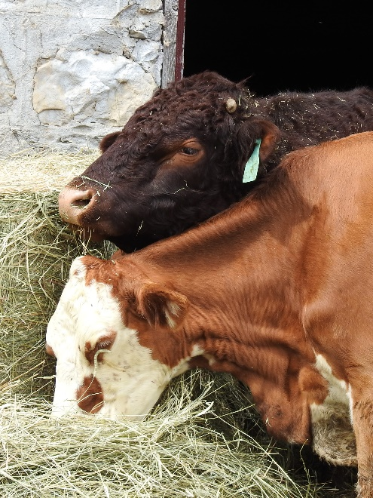
Scripture: Luke 13:10–17 NRSVUE
https://www.biblegateway.com/passage/ ?search=Luke+13%3A10%E2%80%9317&version=NRSVUE
From Lisa Leffler:
Jesus was raised in the Jewish tradition. He knew all of the laws and rules that were set in place to help people follow God’s law – and he followed many of them. But when the woman who was bent over for eighteen long years came to him on the Sabbath for healing, he did not hesitate. He chose love over rules and healed her immediately. Jesus used this healing as an opportunity to invite people into a new way of being. A way that puts the needs of people ahead of systems and political structures.
Jesus saw the pain and discomfort that the woman was experiencing and knew he had to take action. That pain and discomfort would not have only been physical but also emotional. In a culture that valued health and wholeness and considered illness and disability a punishment for sin the woman who was bent over was likely ostracized and pushed to the margins of society.
Although most of us don’t have the ability to provide physical healing like Jesus did, this story invites us to look to the margins of society for the places where we can rebuild community and practise healing love.
Contemplation and Conversation
Where do we marginalize people in our community because of illness or (dis)ability?
Where is God calling you to provide healing and hope?
Prayer
Guided by the Spirit we are called to be healing presence in the world.
Grounded in God’s love we look for the places where we can offer healing and hope.
Emboldened by the stories of Jesus we walk a path of radical love.
God is with us every step of the way. We are not alone. Thanks be to God. Amen.
Know you are a valued part of our Rockwood and Stone United Church families.

Further Conversation … Would you like to talk more about today’s reflection? Email Heather at hleffler@rogers.com. Following worship next Sunday, she will invite others to join you in a Zoom break out room to share in further conversation.

Our Rockwood Stone Family
If you missed today’s worship service, email rockwoodstoneuc@gmail.com for a YouTube link.
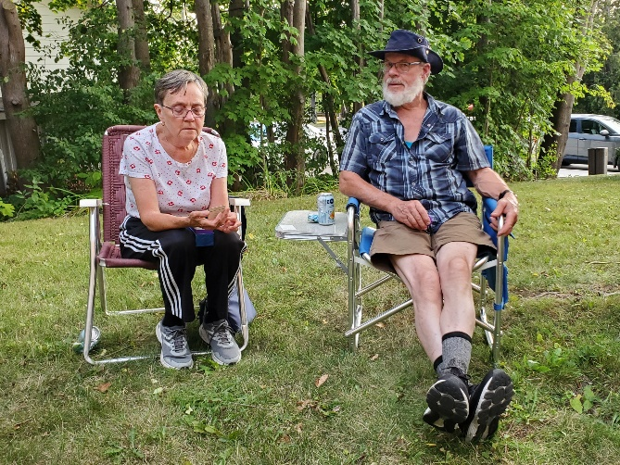
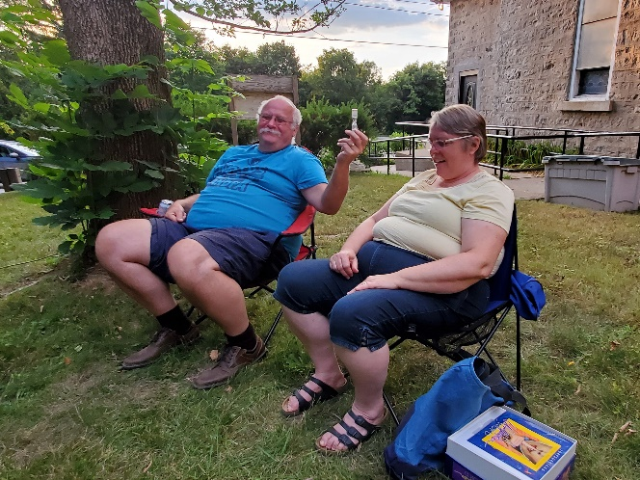
For Offering Praise we shared pictures from the Zucchini Weigh Off. You can see them in the service or on YouTube here: https://youtu.be/LXapOBRX0fw
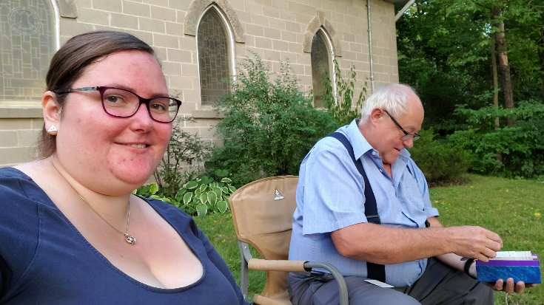
Thanks to everyone who came out for Faith, Food Friendship and Fun at Rockwood. This month featured a rematch of Unspoken word where sadly Brian, Heather and Cees were unable to defeat the reigning champions Lisa, Ollie and John. Watch your announcements for September’s date to join in the fun!

United Church of Canada
“Since, then, we have such a hope, we act with great boldness.” (2 Corinthians 3:12)
The United Church of Canada is a community of hope, a vibrant and vital church with both purpose and vision. We live in a time of rapid change in religious life, great inequities between peoples, and collective harm to our earth community. As church, we have been complicit in injustice. And yet we have this hope. We believe we continue to be called to witness in love and justice to the liberating, healing Christ risen in this place and time. Together, we strive towards repentance, repair, and right relations with all peoples and the planet. Our call and vision statement speaks to how we boldly embody the Christian story in this time, filled with the certainty of resurrection and hope for new life.
Living purposefully into this call and vision anticipates becoming what Dr. Martin Luther King Jr. and others called the Beloved Community—the ever inbreaking, ever transforming, ever reconciling realm of God, realized in our time.
Call
The United Church of Canada Call reflects the core of our purpose, sharing who we seek to be in “such a time as this” (Esther 4:15).
Deep Spirituality
Bold Discipleship
Daring Justice
Vision
The United Church of Canada vision reflects what the church aspires to be over a 5- to 10-year span.
Called by God, as disciples of Jesus, The United Church of Canada seeks to be a bold, connected, evolving church of diverse, courageous, hope-filled communities united in deep spirituality, inspiring worship, and daring justice.

A gift of belonging to a church is that the practice of gathering together for worship … to pray, sing, listen to scripture and share how God touches our lives – helps us grow in deeper relationship with God and each other. We are offering this practice of sharing beyond Sunday morning to deepen our connection. Each week you are offered a picture, a scripture and a question for contemplation, as well as a short reflection for you to contemplate, have conversation with people in your life and/or join an online conversation on our Rockwood Stone Facebook page.

